Math 48A, Exam 3
Preparations for Math 48B

This list of to-do items and exam questions are designed to support students who are going to continue on after Math 48A into Math 48B. To my knowledge, the following people in our class will be moving on together: Sophia, Lily, Yasin, Jordyn, Ryan, Jayden, Curtis, Lamin, and Katrina. Please connect with each other and encourage each other to complete the items below as you get ready to thrive in Math 48B. Si se puede.

1. BUILD STUDY SUPPORT SYSTEMS

The first set of problems is designed to help you build your support network as get you ready for your spring quarter 2021. Math 48B content builds on the Math 48A material that we studied. In order to prepare for our Math 48B course, please complete each of the following to-do items before the first day of spring quarter 2021:

  - Sign up for Foothill College’s Pass the Torch Program (45-minute process)

  - Read About the Pass the Torch Program

  - Read about the Pass the Torch Study Teams

  - If you are interested in one-on-one tutoring, complete the Pass the Torch Enrollment Form

  - Complete the Pass the Torch Member Contract Agreement Form

  - Get in contact with other Math 48A students who will be going onto Math 48B

- There are at least nine other students from our Math 48A course in winter 2021 who will be going on to Math 48B. These people include Sophia, Lily, Yasin, Jordyn, Ryan, Jayden, Curtis, Lamin, and Katrina.

- Please share your phone numbers and find ways to be in daily contact. I expect you all to text with each other and support each other in the learning process. Remember, this is not a competition. Each of you knows how to work hard and can succeed. When you work together as a team to support each other’s learning, you lighten the load for others.

- Be careful to maintain your own academic integrity and take full responsibility for your own work. The point of the team-work structure is to realize you’re not alone and to help support each other as you work to meet this challenge.

  - Use Virtual Tutoring Sessions on a weekly basis

- Watch the How to Access Tutoring YouTube video (5 minutes)

- Make a commitment to drop in for tutoring by Thursday 4/8/2021 of week 1 in spring 2021.
- Make a commitment to visit drop-in tutoring at least two days per week for at least 45 minutes per day. You might coordinate with one or more of your friends from our Math 48A so that the two of you can attend tutoring as a team. This way you can help each other and ask questions of the tutor as a team. I would recommend to schedule two individual drop-in tutoring sessions and one team tutoring session.

  - Review your tutoring schedule:

- On a weekly basis, I recommend that you set up as many hours as you can to learn with tutors. If you follow all the steps above, you will have the following sessions:

    - Two hours (one hour on two separate days) of individual tutoring with your Pass the Torch leader

    - At least 60 minutes of individual tutoring in the STEM Center

    - At least 30 minutes of group tutoring in the STEM Center

    - Access to each other via text and phone call to support your needs and stay on track.

- Remember that 1 hour of studying with a tutor is like spending 3 hours studying by yourself. I like to say that for a 5-unit math class, I want to spend at least 5 hours studying with a tutor per week. That is in addition to the 5 – 10 hours I might spend studying by myself for that class.

2. PLAN TO SUCCEED IN SPRING 2021

  - Finish the Study Skill Activity 1: Create Your Weekly Schedule (120-minute process)

  - Watch our Introduction to Study Skills Activity 1 Video (19m, 03s – 24m, 12s)

  - Download the Study Skills Activity 1 Handout (.pdf)

  - Download the Blank Weekly Schedule Template (.docx)

  - Complete all 14 steps in Study Skills Activity 1 Handout to create your weekly schedule in spring quarter 2021. Make sure your first draft of your weekly schedule is ready for use before the start of classes in spring quarter 2021 on Monday 4/5/2021.

  - Make sure to block time for your Pass the Torch meetings as well as your visits to the STEM Center tutoring so that you protect that time as adamantly as you protect your in-class work.

  - As soon as you get your course syllabi in week 1 of spring quarter 2021, add your course office hours on that weekly schedule. This is an additional source of help you can use to get guidance in your class.

  - Finish the Study Skill Activity 2: Create Your Term Calendar (120-minute process)

  - Download the Study Skills Activity 2 Handout (.pdf)

  - Download the Blank Spring 2021 Academic Calendar Template (.pdf)

  - Complete all 8 steps in Study Skills Activity 2 Handout to create your term calendars for spring quarter 2021. Make sure your first draft of your spring 2021 calendar is ready for use before the start of classes in spring quarter 2021 on Monday 4/5/2021.

  - As soon as you get your course syllabi in week 1 of spring quarter 2021, add all dates for your quizzes and exams on your calendar. Also add any important due dates for term papers, projects, and other important academic dates that you will need to stay aware of throughout spring 2021.

3. PRACTICE FUNCTION NOTATION

Let $f\left(x\right)= x^{2}-3x+4$.

3A. Find the value of $f\left(2\right)$.
3B. Find the value of $f\left(2+h\right)$.
3C. Find the average rate of change between points $(2, f\left(2\right))$ and $(2+h, f\left(2+h\right))$
3D. For any constant $a$, find the average rate of change over interval $(a, f\left(a\right))$ and $(a+h, f\left(a+h\right))$

4. SOLVE QUADRATIC EQUATIONS

Consider the following quadratic equation:

$$x^{2}+6x=16$$

4A. Solve this equation by using the standard form and factoring.

4B. Solve the equation

$$x^{2}+6x=16$$

using the method of completing the square.

4C. Use our graphical method to solve the equation $x^{2}+6x=16$

Input | Output
$$x$$
$$-10$$
$$-9$$
$$-8$$
$$-7$$
$$-6$$
$$-5$$
$$-4$$
$$-3$$
$$-2$$
$$-1$$
$$0$$
$$1$$
$$2$$
$$3$$
$$4$$
$$5$$
$$6$$
$$7$$
$$8$$
$$9$$
$$10$$
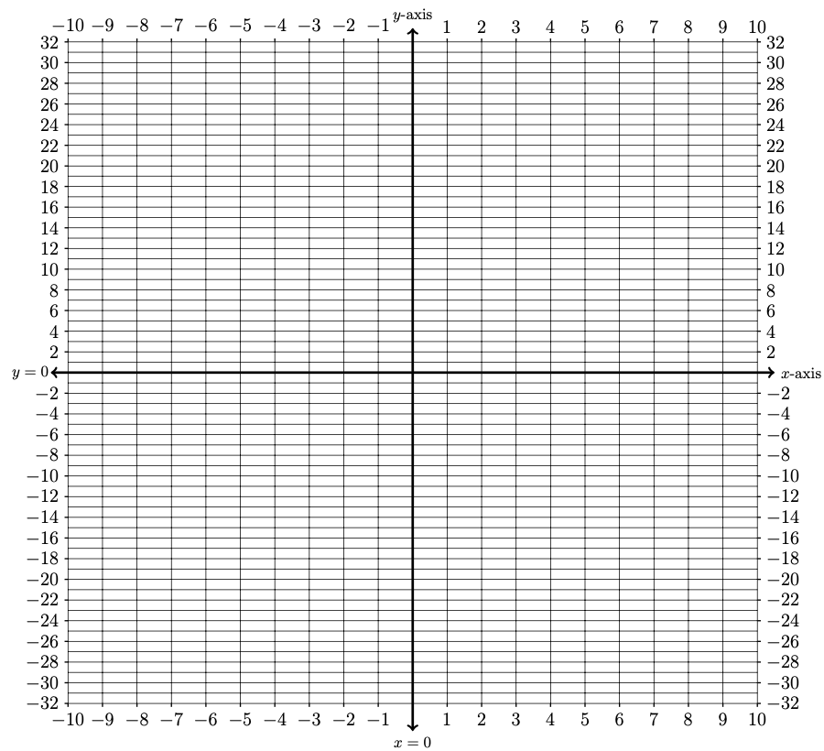
5. GRAPHING PIECEWISE FUNCTIONS
Consider the piecewise function below:

$$f(x)=\left\{\begin{matrix}16-2x & \begin{matrix}\text{if } & x<-1\end{matrix} \\ x^{2}-4 & \begin{matrix}\text{if} & -1≤x<3\end{matrix} \\ 6 & \begin{matrix}\text{if } & 3≤x\end{matrix}\end{matrix}\right.$$

Using this description, fill out the table of values below and then graph the function

Input | Output
$$x$$
$$-6$$
$$-5$$
$$-4$$
$$-3$$
$$-2$$
$$-1$$
$$0$$
$$1$$
$$2$$
$$3$$
$$4$$
$$5$$
$$6$$
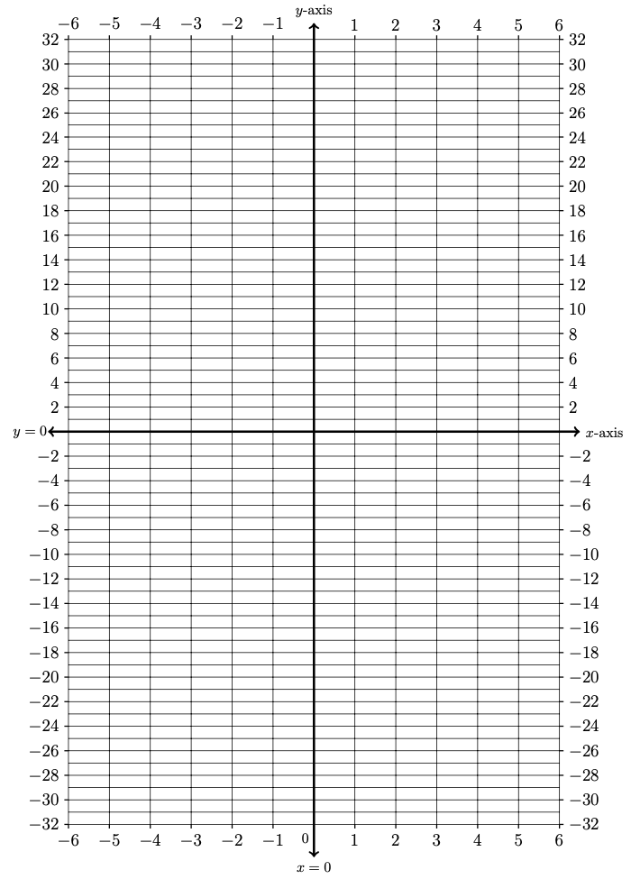
6. ANALYZE THE GRAPH OF A PIECEWISE FUNCTIONS

The following is a graph of a piecewise defined function $g(x)$.

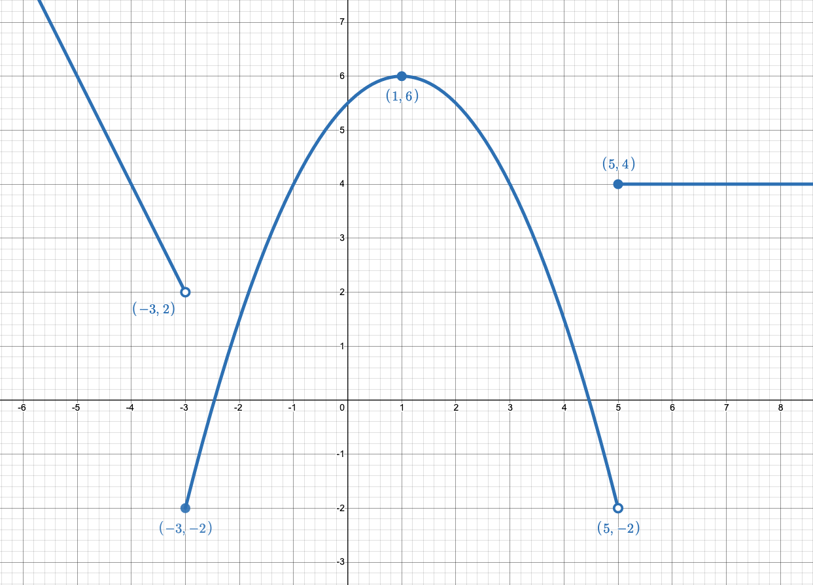

Find the formula (rule) for each part of the function and the $x$-values for which it applies. Explain your reasoning.

$$g\left(x\right)=\left\{\begin{matrix}\begin{matrix} \\ \end{matrix} & \begin{matrix}\text{if} \\ \end{matrix} \\ \begin{matrix} \\ \end{matrix} & \begin{matrix}\text{if} \\ \end{matrix} \\ & \begin{matrix}\text{if} \\ \end{matrix}\end{matrix}\right.$$

7. PRACTICE FACTORING USING THE AC-METHOD
Use the AC-Method to factor each of the polynomials given below. For a reminder about using the AC Method to factor a quadratic polynomial, check out the Factoring Review Sheet.

7A. $12x^{2}+5x-2$
7B. $9x^{4}+6x^{3}-3x^{2}$

8. PRACTICE FACTORING DIFFERENCES OF SQUARES
Remember the difference of square formula is given by:
$$\left(a^{2}-b^{2}\right)=\left(a-b\right)\left(a+b\right)$$

Factor each of the polynomials given below. Use the difference of squares formula.

8A. $y^{2}-64$
8B. $4m^{2}-9$
8C. $9x^{2}-16$

9. TRANSFORMATIONS OF GRAPHS

Below is a graph of a function $f\left(x\right)$.

9A. Sketch a graph of $g\left(x\right)=2f\left(-x\right)$.

9B. Explain, in words, the effect of each transformation in the new function $g\left(x\right)=2f\left(-x\right)$
9C. Sketch a graph of $h\left(x\right)=3-f\left(x+2\right)$.

9D. Explain, in words, the effect of each transformation in the new function $h\left(x\right)=3-f\left(x+2\right)$
10. FIND COMPOSITION OF FUNCTIONS

Let $f\left(x\right)= x^{2}-3$ and $h\left(x\right)= 2x+1$. Find each of the following:

10A. $\left(h∘f\right)(3)$

10B. $f\left(h\left(x\right)\right)$

11. SOLVE EQUATIONS ALGEBRAICALLY

Solve each of the following equations. Show your work.

11A. $2+3\left|x-2\right|=11$

11B. $1+\sqrt{3x-5}=x$

12. FIND THE INVERSE FUNCTION

Use algebra to find the inverse of the following functions.

12A. $f\left(x\right)= \frac{4x-2}{3x+1}$

12B. $g\left(x\right)= \frac{6-x}{5}$

13. GRAPH USING VERTEX FORM OF QUADRATIC
Consider the standard form for a quadratic function:

$$f\left(x\right)=x^{2}-8 x + 8$$

13A. Convert $f\left(x\right)$ into vertex form.

For $f\left(x\right)=x^{2}-8 x + 8$ from problem 13A above:
13B. Sketch a graph of $f\left(x\right)$ using the vertex form.
13C. Find the min/max value of $f\left(x\right)$
13D. Find the domain and range of $f\left(x\right)$

