Math 48A, Exam 2
Lessons 4, 5, 6, 7, and 8

1. IDENTIFY LINEAR FUNCTIONS USING EQUATIONS

Which of the following equations represent linear functions?

  - $3y=5x-2$ ______ linear function ______ not a linear function

  - $y=x^{2}-7$ ______ linear function ______ not a linear function

  - $y=\frac{2}{x}-5$ ______ linear function ______ not a linear function

  - $y^{2}=4x-7$ ______ linear function ______ not a linear function

2. IDENTIFY LINEAR FUNCTIONS USING A TABLE

Below are tables for two different functions. One of these tables has points from a linear function, and the other does not.

$$x$$ | $$f\left(x\right)$$ |  | $$x$$ | $$g(x)$$
- 8 | 2 |  | - 6 | 14
- 4 | 4 |  | - 4 | 10
-1 | 6 |  | - 1 | 4
1 | 8 |  | 1 | 0
2 | 10 |  | 2 | -2

2A. Which function is linear? Explain your reasoning.

2B. Write an equation for the linear function. Justify your answer.

3. EVALUATE FUNCTIONS USING GRAPHS

Below are graphs of functions $f(x)$ and $g(x)$.

$f(x)$ $g(x)$

Use the graphs above to evaluate each of the following:

$f(-1)$ $g\left(2\right)$

Challenge Problems: Use the graphs to evaluate each of the following:

$f(g\left(0\right))$ g$(f\left(5\right))$

4. SOLVE ABSOLUTE VALUE EQUATIONS ALGEBRAICALLY

Consider the following absolute value equation:

$$\left|2x-4\right|-5 = 1$$

Solve this equation using an algebraic method (not graphically). Hint: you might check your work by solving problem 5A below and looking back at this problem.

5. SOLVE ABSOLUTE VALUE EQUATIONS GRAPHICALLY
5A. Consider the following absolute value equation:

$$\left|2x-4\right|-5 = 1$$

Use the left-hand side (LHS) and right-hand side (RHS) of this equation to a table of values and draw the resulting graph on the axes below. Then, solve this equation using the information in your graph.
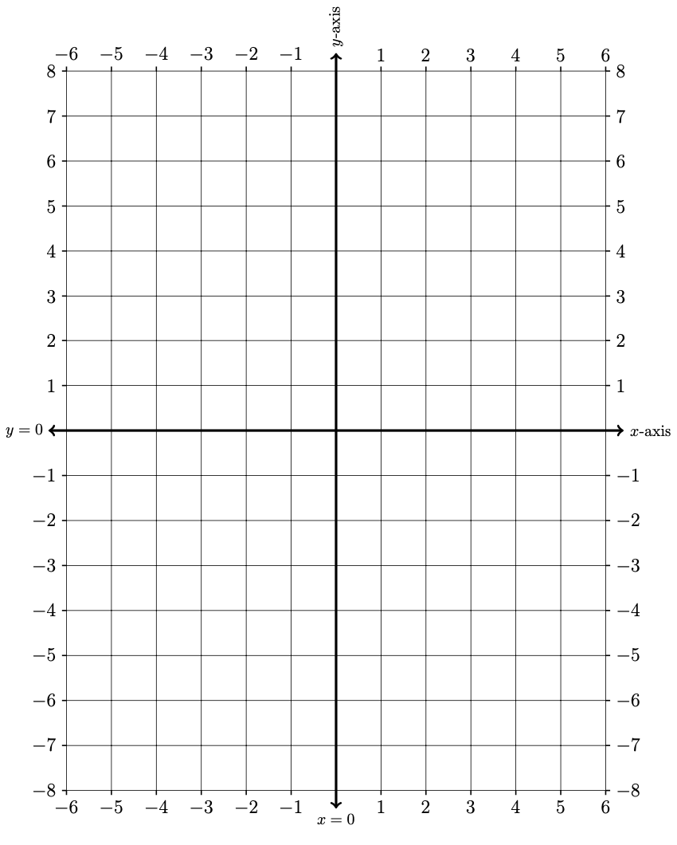
$$x$$ | LHS | RHS
$$-6$$
$$-5$$
$$-4$$
$$-3$$
$$-2$$
$$-1$$
$$0$$
$$\frac{ 4 }{5}$$
$$1$$
$$2$$
$$3$$
$$4$$
$$5$$
$$6$$

5B. Redraw your graph from problem 5A in the axes below. Then consider the absolute value inequality:

$$\left|2x-4\right|-5 ≥ 1$$

Using your graph, identify all $x$-values that solve this equation.

6. ANALYZE THE GRAPH OF A FUNCTION

Below is a graph of a function $f(x)$.

Use the graph to answer each of the following questions about the function $f$. For some of your answers you may need to approximate the value. Please give a decimal approximation using your best judgment based on the graph.

6A. What is $f(-5)$? 6B. What is $f(0)$?

6C. Find the $x$ values for which $f\left(x\right)= 0$.

6D. Find the $x$ values for which $f\left(x\right)≤3$. 6E. Find the $x$ values for which $f\left(x\right)>9$

7. ANALYZE THE GRAPH OF A FUNCTION

Below is a graph of a function $k\left(x\right).$ Use the graph to answer the questions about the function.

7A. At what point(s) does $k(x)$ have a local maximum?

7B. On what interval(s) is $k(x)$ decreasing.

7C. Find the average rate of change of $k(x)$from $x= 0$ to $x=3$.

8. EVALUATE FUNCTIONS

For all problems below, let $f\left(x\right)= x^{2}-x+3$.

8A. Evaluate $f(3)$

8B. Evaluate $f(-5)$

8C. If $f\left(x\right)= x^{2}-x+3$, then evaluate $f(2a)$

8D. If $f\left(x\right)= x^{2}-x+3$, then evaluate $f(a+h)$

9. FIND PIECEWISE FUNCTIONS (CHALLENGE PROBLEM)

The following is a graph of a piecewise defined function $g(x)$. Find the formula (rule) for each part of the function and the $x$-values for which it applies. Explain your reasoning.

$g\left(x\right)=\left\{\begin{matrix}\begin{matrix} \\ \end{matrix} & \begin{matrix}\text{if} \\ \end{matrix} \\ \begin{matrix} \\ \end{matrix} & \begin{matrix}\text{if} \\ \end{matrix} \\ & \begin{matrix}\text{if} \\ \end{matrix}\end{matrix}\right.$

