Math 48B, Quiz 2, Lessons 3 – 6: Polynomial Division and Zeros of a Polynomial

In your first draft solutions to this quiz, I encourage you to take extra space and make your work very easy to read. I might encourage you to write one solution per page. I want to focus your mind here on two goals. First, this is designed to help build understanding of the material. Second, as you write your solutions, think about creating a document that you can look back on and understand years into the future. In this way, your solutions can become a so-called second brain where you store math knowledge for future reference. For more about ideas on how to format your solutions, please take a look at Jeff’s Conquering College Study Skills Activity 5.

1. REVIEW : REMAINDERS AND LONG DIVISION

1A. For each of the following expressions in column 1 of the table below, write the solutions to the division problem in column 2. Then, write this solution as a multiplication problem in column 3. The first row is done for you.

Column 1:  Expression | Column 2:  Division Problem | Column 3  Multiplication Problem
$$\frac{ 31 }{5}$$ | $$\frac{ 31 }{5}=6+ \frac{1}{5}$$ | $$6∙5+1=31$$
$$\frac{ 31 }{7}$$
$$\frac{ 45 }{4}$$
$$\frac{ 45 }{6}$$

1B. For each entry in the table above from Problem 1A, develop a verbal (using both abuelita and nerdy language), visual, and symbolic representation of the work you used to solve each problem. I encourage you to use about one page per problem. For an example of how to develop verbal, visual, and symbolic representations, take a look at our Lesson 3 solutions or the LiveStream recording from that day’s class.

2. REVIEW : LONG DIVISION

Describe in words, using both abuelita (intuitive) and nerdy (formal) language, the connection between the following two formulas:

Division Formula | Multiplication Formula
$$\frac{N }{D}=q + \frac{r}{D}=q \text{R} r$$ | $$D ∙ q + r=N$$

3. REVIEW : LONG DIVISION

Solve each of the following problems using long division. Use all three of the remainder notations to state your results. Also, do your best to use sentences to explain what you are doing.

3A. $\frac{ 761 }{3}$ 3B. $\frac{ 373 }{9}$

4. POLYNOMIAL DIVISION

Use polynomial long division to solve each of the following problems. Then, write the solution of each problem in two different forms, given by the equations below.
Division Equation | Multiplication Equation
$$\frac{N(x)}{D(x)}=q\left(x\right)+\frac{r(x)}{D(x)}$$ | $$N(x)=D\left(x\right)∙q(x) \text{+} r(x)$$

4A. $\frac{ x^{3}-4x^{2}-19x-14 }{(x-7)}$ 4B. $\frac{ 9x^{3}-x+2 }{(3x-1)}$

5. ZEROS OF A POLYNOMIAL

Construct a polynomial $P\left(x\right)$ that has four zeros at $-1, 0, 2$, and $\frac{1}{2}$. Create both forms of this polynomial: the complete factorization form and also the standard form. When looking at the standard form, make sure that the degree three term $x^{3}$ has a coefficient of $a_{3}=3$. Using Desmos.com, create a graph to confirm that your polynomial has the desired zero points.

6. FIND THE FORMULA FOR A POLYNOMIAL

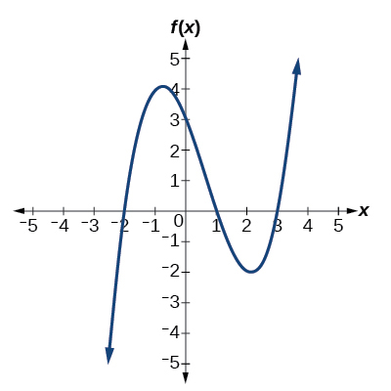
Use the graph below to write a formula for a polynomial function of least degree whose graph looks like the curve given in this figure. Use Desmos.com to confirm your conjecture. In other words, graph the formula you create to make sure your work aligns with the graph below. Then, discuss how this problem is related to the polynomial division problems given above.

