Math 48B, Lesson 9: Rational Functions, Part 1
In Math 48B Lessons 8, 9, and 10, we study rational functions in the form:
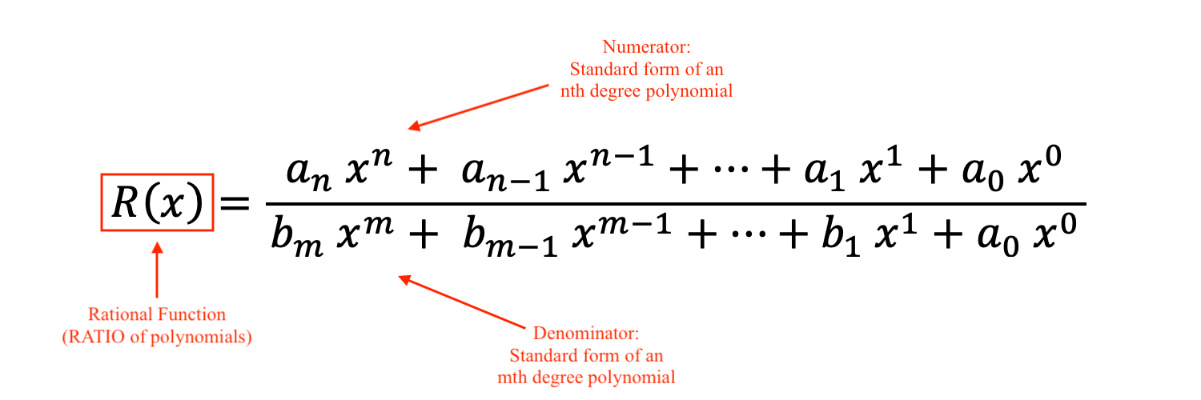
To begin our exploration, we explore some fundamental properties of division.

1. WHAT ARE RULES OF FRACTIONS?
Recall each of the following rules for fractions:

Divide zero by a number: $\frac{ 0 }{K}$

Division by zero: $\frac{ K }{0}$

Divide an expression by itself: $\frac{ A }{A}$

Multiplication of Fractions: $\frac{ A }{B}∙\frac{C}{D}$

Division of Fractions: $\frac{A}{B}÷\frac{C}{D}$

1B. Let’s explore the following patterns for positive real numbers:

$$\frac{ 1 }{\text{HUGE NUMBER}}=\text{tiny number}$$

To do so, let $f\left(x\right) = \frac{1}{ x }$ and fill out the table below.

Input | Output
$$x$$ | $$f\left(x\right)=\frac{1}{ x }$$
$$10$$
$$100$$
$$1,000$$
$$10,000$$
$$100,000$$
$$1,000,000$$
$$10,000,000$$

1C. Look back at your table from problem 1B. Now look at the notation below:

$$\lim_{x→∞}{f\left(x\right)}=0^{+}$$

Please describe using VANVS how the notation is related your table. In other words, what ideas are captured in this notation?

1D. Let’s explore the following patterns for positive real numbers:

$$\frac{ 1 }{\text{tiny number}}=\text{HUGE NUMBER}$$

To do so, let $f\left(x\right) = \frac{1}{ x }$ and fill out the table below.

Input | Output
$$x$$ | $$f\left(x\right)=\frac{1}{ x }$$
$$\frac{1}{ 10 }$$
$$\frac{1}{ 100 }$$
$$\frac{1}{ 1,000 }$$
$$\frac{1}{ 10,000 }$$
$$\frac{1}{ 100,000 }$$
$$\frac{1}{ 1,000,000 }$$
$$\frac{1}{ 10,000,000 }$$

1E. Look back at your table from problem 1B. Now look at the notation below:

$$\lim_{x→0^{+}}{f\left(x\right)}=+∞$$

Please describe using VANVS how the notation is related your table. In other words, what ideas are captured in this notation?

1F. Below is a table of symbols, known as arrow notation. Look over this table:

Symbol | How to read this?
$$x→a^{-}$$ | $x$ approaches $a$ from the left
$$x→a^{+}$$ | $x$ approaches $a$ from the right
$$x→-∞$$ | $x$ approaches negative infinity  $x$ decreases without bound
$$x→+∞$$ | $x$ approaches negative infinity  $x$ increases without bound

For each of these symbols, draw a diagram to describe the relationship being

2. GRAPH THE SIMPLEST RATIONAL FUNCTION?

Consider the rational function $f\left(x\right) = \frac{1}{ x }$
- Fill in the table below
- Plot these points on the axis provided
- Interpolate between the points you plotted to create the graph of this function
- Find the domain and range for this function.
Use Desmos.com to confirm you graph.

Input | Output
$$x$$ | $$f\left(x\right)=\frac{1}{ x }$$
$$-3$$ | .
$$-2$$
$$-1$$
$$-\frac{1}{ 2 }$$
$$-\frac{1}{ 3 }$$
$$0$$
$$\frac{1}{ 3 }$$
$$\frac{1}{ 2 }$$
$$1$$
$$2$$
$$3$$
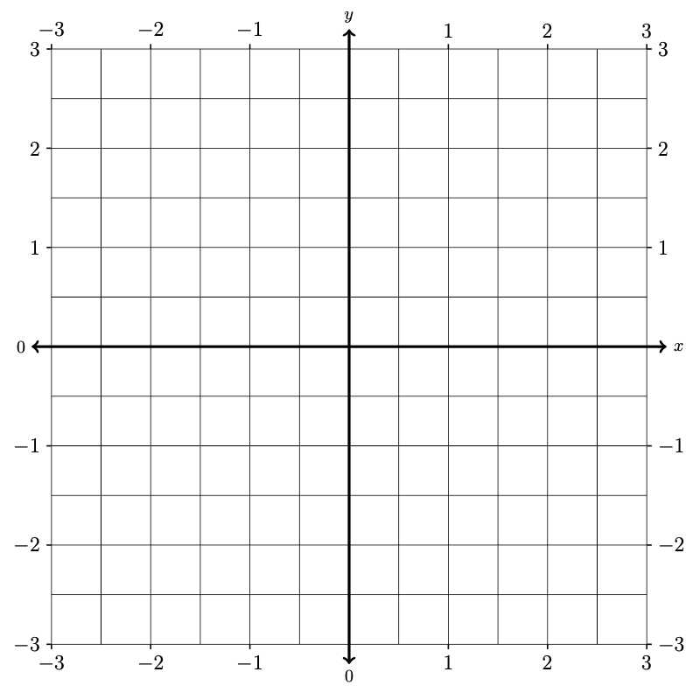

2B. Go back to the graph you created in Problem 2A above. Then answer each of the following questions using that graph. Identify where these symbols show up on the graph and what they mean in terms of the behavior of our function.

$$\lim_{x→-∞}{f\left(x\right)}$$

$$\lim_{x→0^{-}}{f\left(x\right)}$$

$$\lim_{x→0^{+}}{f\left(x\right)}$$

$$\lim_{x→-∞}{f\left(x\right)}$$

2C. Take a look at the definitions below

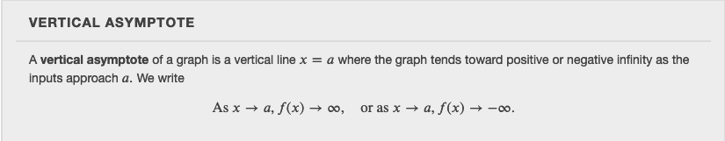

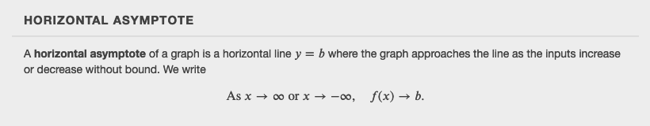

How do these definitions relate to the graph you made in Problem 2A and the notation you explored in problem 2B?

3. GRAPH A RATIONAL FUNCTION

Use Desmos.com to graph the rational function

$g\left(x\right) = \frac{3}{ x + 2 }$.

Identify the vertical and horizontal asymptotes of this graph. Write your results using the notation we are developing and explain what this notation means. Then use transformations to connect function $g\left(x\right)$ to the function $f\left(x\right) = \frac{1}{ x }$. Also, find the domain and range for this function.

4. GRAPH ANOTHER RATIONAL FUNCTION

Use Desmos.com to graph the rational function

$$h\left(x\right) = \frac{2x+5}{ x-3 }$$

Identify the vertical and horizontal asymptotes of this graph. Write your results using the notation we are developing and explain what this notation means. Then use transformations to connect function $h\left(x\right)$ to the function $f\left(x\right) = \frac{1}{ x }$. Also, find the domain and range for this function.

6. GRAPH ANOTHER RATIONAL FUNCTION

Use Desmos.com to graph the rational function

$$R\left(x\right) = \frac{2x^{2}-4x+5}{ x^{2}-2x+1 }$$

Identify the vertical and horizontal asymptotes of this graph. Write your results using the notation we are developing and explain what this notation means. Explore methods to find the horizontal and vertical asymptotes using algebra and make connections between your findings and the graph you create. Then, find the domain and range for this function.

