Math 48B, Lesson 8: Rational Functions, Part 1

In Math 48B Lessons 8, 9, and 10, we study techniques to find the zeros of a polynomial by factoring that polynomial into a form:
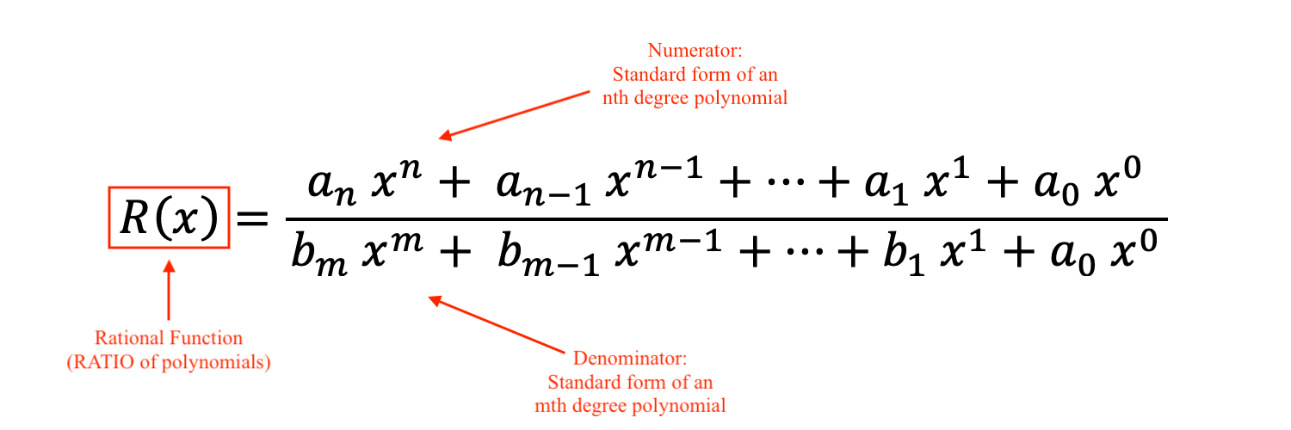
To begin our exploration, we explore some fundamental properties of division.

1. WHAT IS MULTIPLICATION?

1A. Use abuelita language (simple language that your grandma would understand) to describe what you see in multiplication problems below:
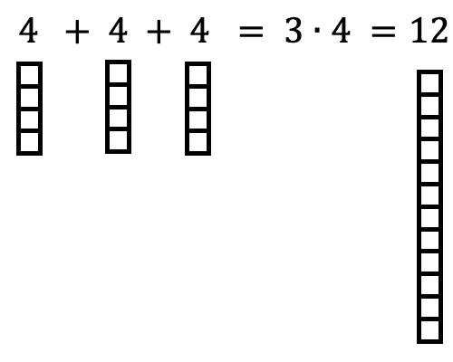

1B. Use abuelita language (simple language that your grandma would understand) to describe what you see in multiplication problems below:
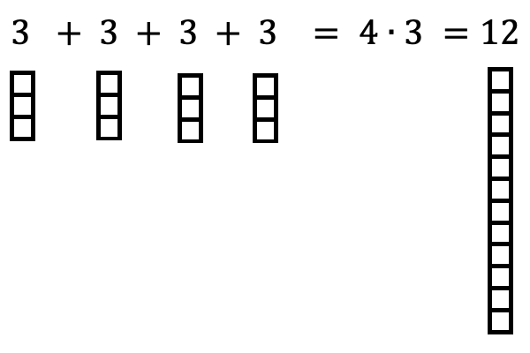

1C. Using your work in problems 1A and 1B above, develop a verbal and visual interpretations of the symbols written in the multiplication problems:

$$D ∙ q=N$$

2. WHAT IS DIVISION?

2A. Develop a visual representation for the division problems you see below. Then, describe what you’ve done in each problem using abuelita language. In this work, make explicit connections to Problem 1A above.
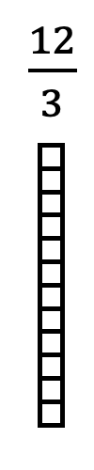

2B. Develop your own visual and verbal representations to describe the division problem below. In this work, make explicit connections to Problem 1B above.

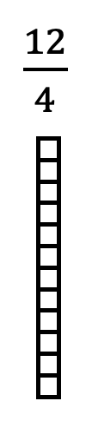

2C. Using your work in problems 2A and 2B above, develop verbal and visual interpretations of the symbols written in the division problem below. Then make explicit connections between this division problem and the corresponding multiplication problem you did in Problem 1C.

$$\frac{N}{q}=D$$

2D. Consider the two problems below.
Division Problem | Multiplication Problem
$$\frac{N}{q}=D$$ | $$D ∙ q=N$$

Explain why the two problems are different versions of the same relationship. How can we transform any division problem into a related multiplication problem?

3. WHAT IS GOING ON WHEN WE DIVIDE BY ZERO?

3A. Consider the following division problem:

$$1÷0=\frac{ 1 }{0}=D$$

Translate this problem into the corresponding multiplication problem (like you did in problem 2D above. What do you notice? Given your observation, what is your answer to this division problem?

3B. Suppose that $N∈R$ is any nonzero real number, with $N≠0$. Consider the following division problem:

$$N÷0=\frac{ N }{0}=D$$

Translate this problem into the corresponding multiplication problem (like you did in problem 2D above. What do you notice? Given your observation, what is your answer to this division problem? Put this observation into a full sentence to describe your findings.

3C. Consider the following division problem:

$$0÷0=\frac{ 0 }{0}=D$$

Translate this problem into the corresponding multiplication problem (like you did in problem 2D above. What do you notice? Given your observation, what is your answer to this division problem? Put this observation into a full sentence to describe your findings.

3D. Look back on your work on problems 3A, 3B, and 3C above. Now, suppose that Suppose that $K∈R$ is any real number (i.e. $K$ might be nonzero or it may be zero). Consider the following division problem:

$$K÷0=\frac{ K }{0}=D$$

What is your answer to this division problem? Come up with at least three different ways to remember your work here.

4. WHAT HAPPENS WHEN WE DIVIDE SOMETHING BY ITSELF?

Suppose that $A∈R$ is any real number. Consider the fraction

$$\frac{ A }{A}$$

What is this fraction equal to? When is that true? Why is that true?

5. HOW DO WE MULTIPLY FRACTIONS?

5A. Consider the following multiplication problem:

$$4∙5$$

Develop a VANVS description of the answer to this multiplication problem. I’ve provided a visual below to help the development here.

5B. Consider the following multiplication problem:

$$\frac{ 3 }{4}∙\frac{ 1 }{ 5 }$$

Develop a VANVS description of the answer to this multiplication problem. I’ve provided a visual below to help the development here.

5C. Consider the following multiplication problem:

$$\frac{ 3 }{4}∙\frac{ 4 }{ 5 }$$

Develop a VANVS description of the answer to this multiplication problem. I’ve provided a visual below to help the development here.

5D. Look back at your answers to problems 5ABC. Now consider the multiplication problem:

$$\frac{A}{B}∙\frac{C}{D}$$

What is your answer to this problem? Come up with at least three different ways to remember your work here.

6. HOW DO WE DIVIDE FRACTIONS?

Develop a VANVS description of the answer to the division problem:

$$\frac{A}{B}÷\frac{C}{D}$$

What is your answer to this problem? Come up with at least three different ways to remember your work here. Note: I don’t have a good visual for this one. I would love to learn from you. Please share what you discover.

