Math 48B, Lesson 6: Zeros of Polynomials, Part 2

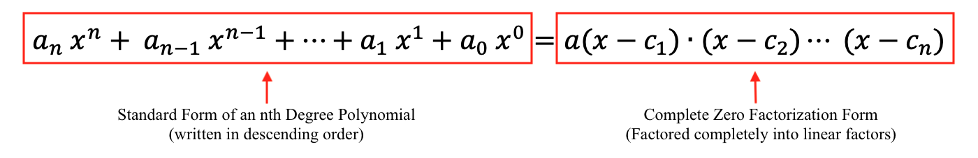
In Math 48B Lessons 3, 4, 5, and 6, we study techniques to find the zeros of a polynomial by factoring that polynomial into a form:
In this lesson, we continue our exploration from Lesson 4.

0. USE REMAINDERS TO FIND ZEROS

0A. Read the following theorem and “how to” sections:

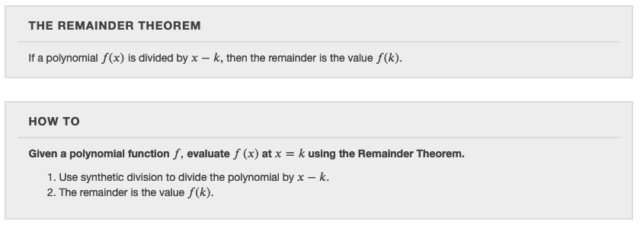
Look back at your work from Math 48A, Lesson 5. Now, translate these theorems into abuelita (intuitive) language. What, exactly, are is this saying about the zeros of a polynomial.

0B. Read the following theorem and “how to” sections:
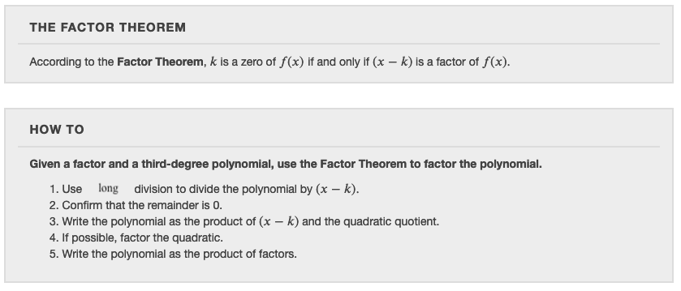
How are these sections related to your work on Problem 0A above?

1. CREATE A POLYNOMIAL WITH DESIRED ZERO VALUES

1A. Create a quadratic polynomial with two zero given by

$x= \frac{2}{5}$ and $x= -\frac{3}{4}$

1B. Put the quadratic function from Problem 1A above into standard from

$$P\left(x\right)= a_{2} x^{2}+ a_{1} x^{1}+a_{0} x^{0}.$$

List all possible factors of the coefficients $a_{2}$and $a_{0}$.

1C. What relationship do you notice between the rational zeros of this polynomial from Problems 1AB and the factors of the coefficients $a_{2}$and $a_{0}$.

2. USE DESMOS TO FIND THE ZEROS

2A. Use Desmos.com to find the zeros of the polynomial

$$P\left(x\right)={2x}^{3}+x^{2}-4x+1$$

If our goal is to find the zeros of this polynomial, how can we do that using the graph of our function.

2B. Put the quadratic function from Problem 2A above into standard from

$$P\left(x\right)=a_{3} x^{3}+ a_{2} x^{2}+ a_{1} x^{1}+a_{0} x^{0}.$$

List all possible factors of the coefficients $a_{2}$and $a_{0}$.

2C. What relationship do you notice between the rational zeros of this polynomial from Problems 2AB and the factors of the coefficients $a_{3}$and $a_{0}$.

3. INTERPRET THEOREMS ABOUT ZEROS

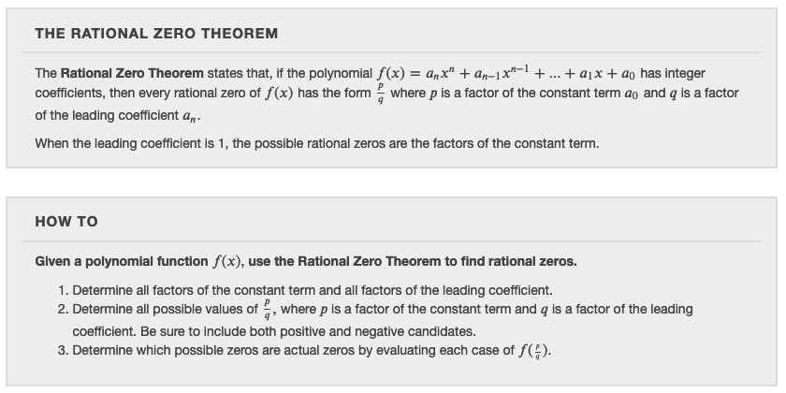
Read the theorem and “how to” section below.

Translate this theorem into abuelita language. What, exactly, is this theorem saying about the zeros of polynomials?

