Math 48B, Lesson 5: Dividing Polynomials, Part 1

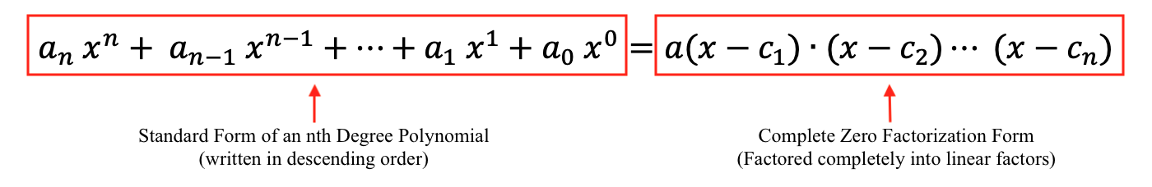
In Math 48B Lessons 3, 4, 5, and 6, we study techniques to find the zeros of a polynomial by factoring that polynomial into a form:
In this lesson, we continue our exploration from Lesson 4.

1. FIND ZEROS WITH POLYNOMIAL LONG DIVISION

1A. Please multiply and simplify the following polynomial expression:

$$P\left(x\right)=\left(x+2\right)\left(x-3\right)(x-5)$$

1B. Use the polynomial long-division algorithm from Lesson 4 to execute the following division problem:

$$\frac{N(x)}{D(x)}=\frac{ x^{3}-6x^{2}-x+30 }{(x+2)}=q(x) \text{R} r(x)$$

1C. Use Desmos.com to graph the polynomial

$$P\left(x\right)=x^{3}-6x^{2}-x+30$$

If our goal is to find the zeros of this polynomial, how can we do that using the graph of our function.

2. REMAINDERS AND POLYNOMIAL LONG DIVISION

Use the polynomial long-division algorithm from Lesson 4 to execute the following division problem:

$$\frac{N(x)}{D(x)}=\frac{ 3x^{2}-5x-17 }{(3x+1)}=q(x) \text{R} r(x)$$

3. DISCOVER THE REMAINDER THEOREM

3A. Consider the following two equations given below. Write your own verbal descriptions of these equations in both formal (nerdy) language and also intuitive (abuelita) language.

Division Equation | Multiplication Equation
$$\frac{N(x)}{D(x)}=q\left(x\right)+\frac{r(x)}{D(x)}$$ | $$N(x)=D\left(x\right)∙q(x) \text{+} r(x)$$

3B. Use the notation and terminology from Lesson 5, Problem 3A (page 5) above to write both division and multiplication equations for all of the polynomial division problems given below

Problem Number | Division Problem
Lesson 4, Problem 2 (page 2) | $$\frac{ 6x^{2}-26x+12 }{(x-4)}$$
Lesson 5, Problem 1B (page 2) | $$\frac{ x^{3}-6x^{2}-x+30 }{(x+2)}$$
Lesson 5, Problem 2 (page 4) | $$\frac{ 3x^{2}-5x-17 }{(3x+1)}$$
Lesson 4, Problem 4B (page 6) | $$\frac{ 2x^{4}-6x^{3}-26x^{2}+30x }{(x+3)}$$

3C. In the notation above, look for linear factors $D\left(x\right)=\left(x-c\right)$ of $N(x)$. What patterns do you notice about the relationship between the remainder and $N(c)$, the value of the function $N(x)$ where $x=c$?

4. CREATE POLYNOMIALS FROM KNOWN ZEROS

4A. Use polynomial long-division to find the quotient and remainder for the following problem

$$\frac{N(x)}{D(x)}=\frac{ x^{3}-6x^{2}-x+30 }{(x-5)}=q(x) \text{R} r(x)$$

4B. Use Desmos.com to find the zeros of $x^{3}-6x^{2}-x+30$. Then, using those results, produce the complete zero factorization for this polynomial.

4C. Use the graph below to write a formula for a polynomial function of least degree whose graph looks like the curve given in this figure. Then, discuss how this problem is related to the division problems given above.
