Math 48B, Lesson 4: Dividing Polynomials, Part 2

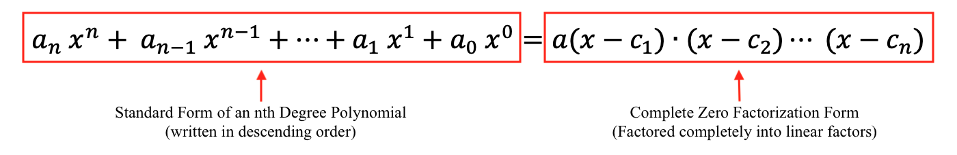
In Math 48B Lessons 3, 4, 5, and 6, we are going to learn how to find the zeros of a polynomial by factoring that polynomial into a form:
In this lesson, we continue our exploration from Lesson 3.

1. WHAT IS MULTIPLICATION?

Please multiply and simplify the following polynomial expression:

$$P\left(x\right)=\left(6x-2\right)\left(x-4\right)+4$$

2. WHAT IS DIVISION?

Use the same idea of the long-division algorithm from our previous life in mathematics to execute the following division problem:

$$\frac{N}{D}=\frac{ 6x^{2}-26x+12 }{(x-4)}=q \text{R} r$$

3. PRACTICE WITH POLYNOMIAL DIVISION

3A. Please multiply and simplify the polynomial expression given below. Identify the locations of the zeros of this polynomial. Then specifically identify where these zeros show up in either of the two forms of this polynomial (complete factorization and standard form).

$$P\left(x\right)=\left(x-1\right)\left(x-2\right)\left(x+3\right)$$

3B. Practice the polynomial long-division algorithm we explored above on the problem given below:

$$\frac{N}{D}=\frac{ x^{3}-7x+6 }{(x-2)}=q \text{R} r$$

4. MORE PRACTICE WITH POLYNOMIAL DIVISION

4A. Construct a polynomial $P\left(x\right)$ that has four zeros at $-3, 0, +1$, and $+5$. Create both forms of this polynomial: the complete factorization form and also the standard form. When looking at the standard form, make sure that the degree three term $x^{3}$ has a coefficient of $a_{3}=-6$. Using Desmos.com, create a graph to confirm that your polynomial has the desired zero points.

4B. Practice the polynomial long-division algorithm we explored above on the problem given below:

$$\frac{N}{D}=\frac{ 2x^{4}-6x^{3}-26x^{2}+30x }{(x+3)}=q \text{R} r$$

5. QUIZ PRACTICE PROBLEMS:

5A. Use polynomial long-division to find the quotient and remainder for the following problem

$$\frac{N}{D}=\frac{ 2x^{3}-7x^{2}+5}{(x-3)}=q \text{R} r$$

Factor this polynomial as much as possible.

5B. Divide $5x^{3}+3x^{2}-2x$ by $(x+1)$. Then find the zeros of this polynomial. Confirm your guesses about the locations of the zeros by graphing this polynomial on Desmos.com. Make a connection between the complete factorization form and the location of the zeros of this polynomial.

