Math 48B, Lesson 3: Dividing Polynomials, Part 1

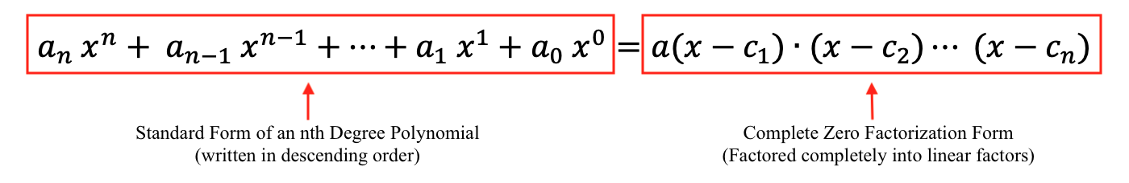
In Math 48B Lessons 3, 4, 5, and 6, we are going to learn how to find the zeros of a polynomial by factoring that polynomial into a form:
To start our exploration of this topic, we explore the topic of division and build visual, verbal, and symbolic representations for the division operation. The work we do in this lesson will support our work with polynomials in the coming lesson 4.

1. WHAT IS MULTIPLICATION?

1A. Use abuelita language (simple language that your grandma would understand) to describe what you see in multiplication problems below:

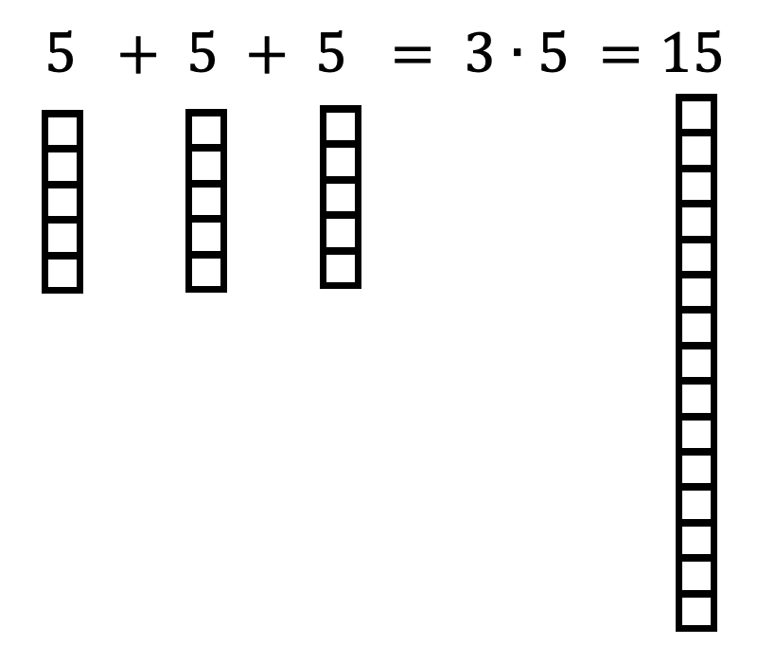
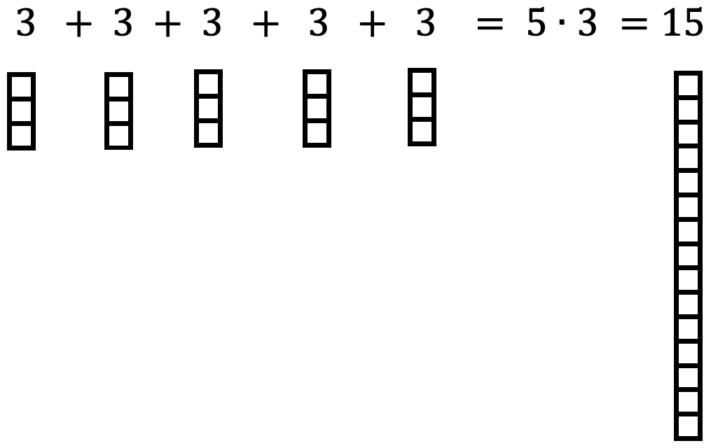

1B. Develop your own visual and verbal descriptions, like the one in problem 1A above, to describe BOTH of the multiplication problems below:

$$4∙6=6∙4$$

1C. Using your work in problems 1A and 1B above, develop a verbal and visual interpretations of the symbols written in the multiplication problems:

$$D ∙ q=N$$

2. WHAT IS DIVISION?

2A. Develop a visual representation for the division problems you see below. Then, describe what you’ve done in each problem using abuelita language. In this work, make explicit connections to Problem 1A above.

2B. Develop your own visual and verbal representations, like the work you did in problem 2A above, to describe BOTH of the division problems:

$\frac{24}{4}$ $\frac{24}{6}$

2C. Using your work in problems 2A and 2B above, develop verbal and visual interpretations of the symbols written in the division problem below. Then make explicit connections between this division problem and the corresponding multiplication problem you did in Problem 1C.

$$\frac{N}{D}=q$$

3. HOW DO REMAINDERS WORK?

3A. Use abuelita language (simple language that your grandma would understand) to describe what you see in multiplication problems below:

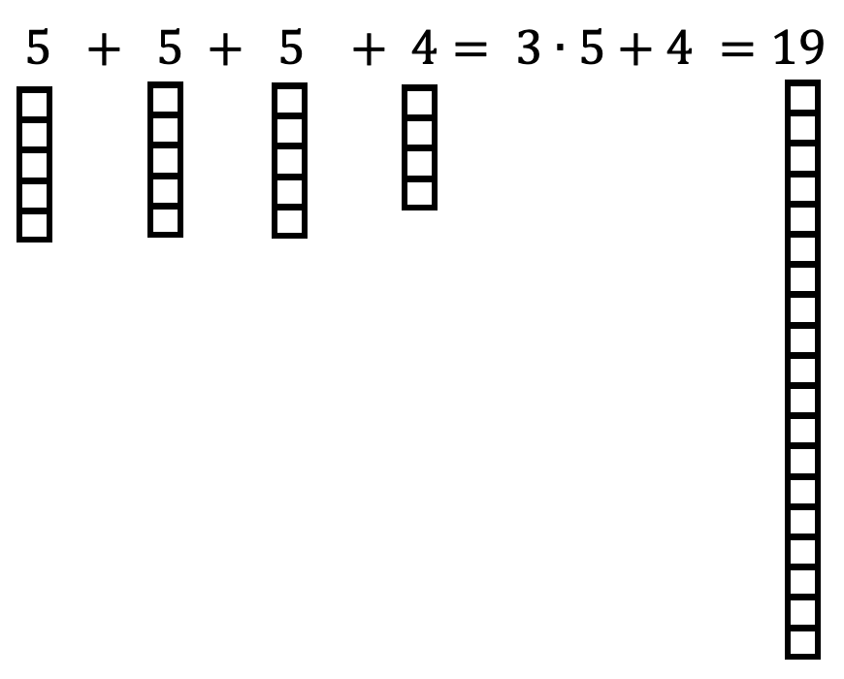
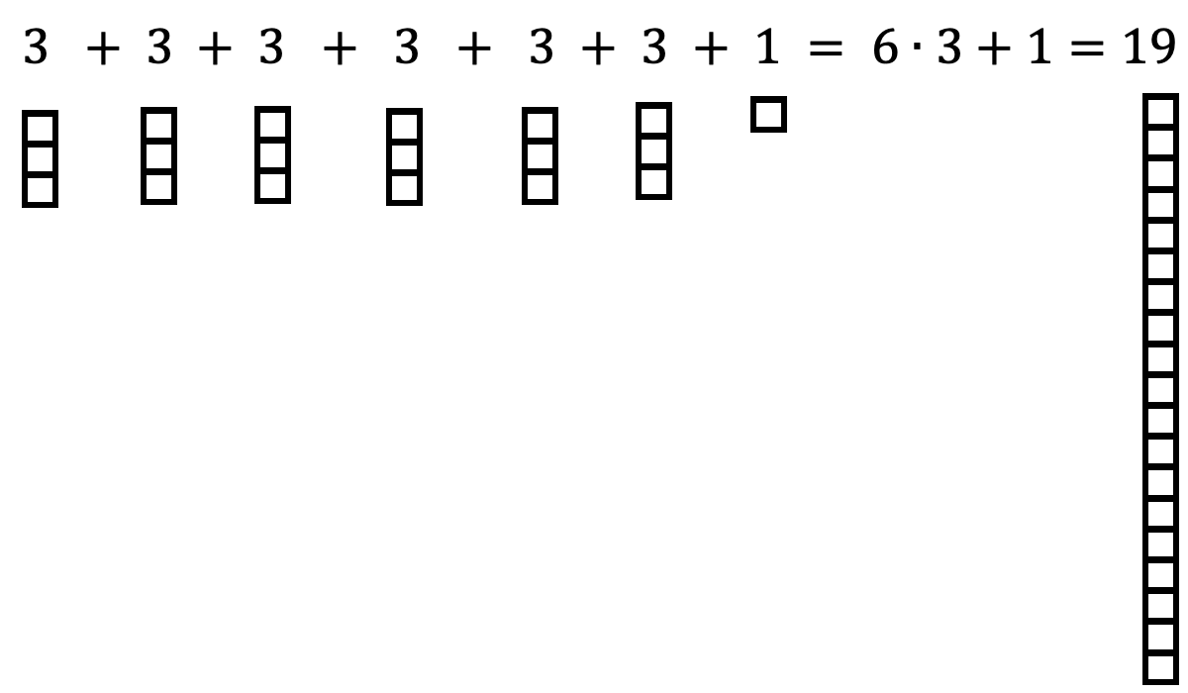

3B. Develop your own visual and verbal descriptions, like the one in problem 1A above, to describe BOTH of the multiplication problems below:

$7∙4+1=29$ $4∙6+5=29$

3C. Using your work in problems 3A and 3B above, develop a verbal and visual interpretations of the symbols written in the multiplication problems:

$$D ∙ q + r=N$$

4. HOW TO USE REMAINDER NOTATION?

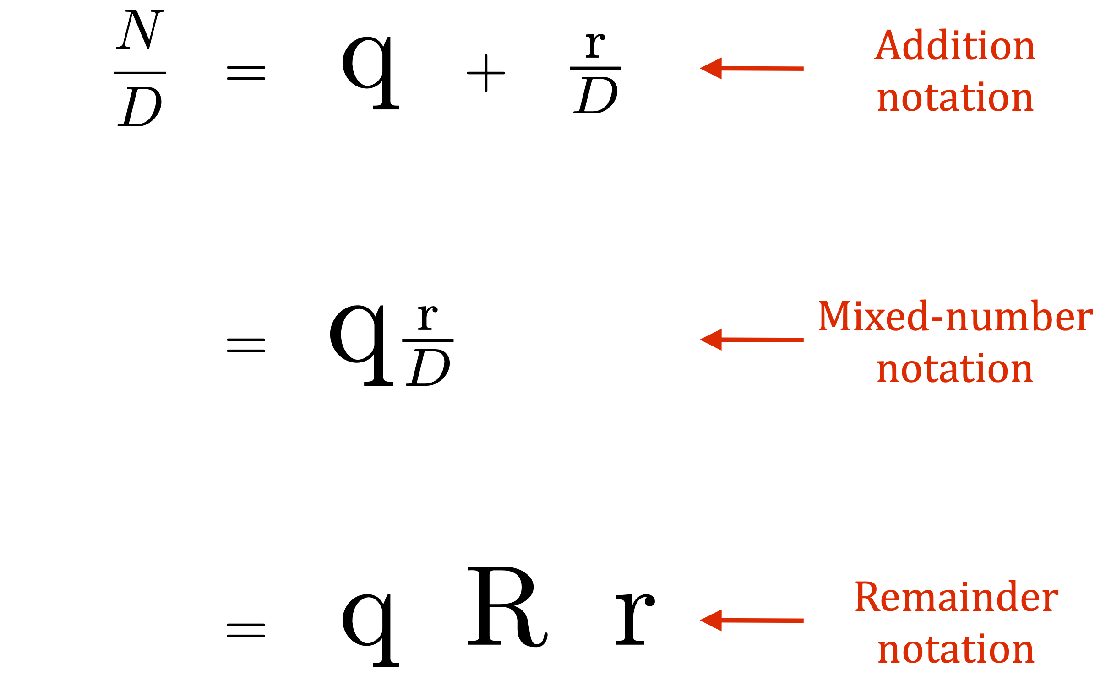
Take a look at the following notation:

This is called remainder notation.

4A. Use using this notation, develop a verbal, visual, and symbolic description for the solutions of each of the following division problems:
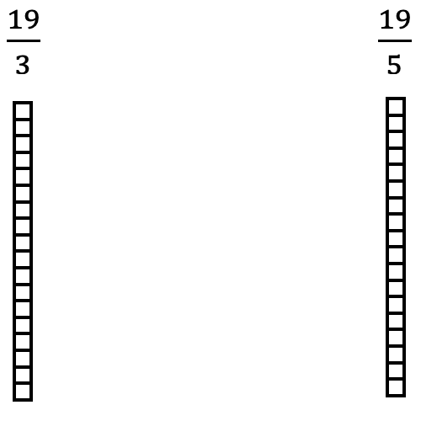

4B. Develop your own visual and verbal representations, like the work you did in problem 4A above, to describe BOTH of the division problems:

$\frac{29}{4}$ $\frac{29}{6}$

4C. Using your work in problems 4A and 4B above, develop verbal and visual interpretations of the symbols written in the division problem below. Then make explicit connections between this division problem and the corresponding multiplication problem you did in Problem 3C.

$$\frac{N }{D}=q + \frac{r}{D}=q \text{R} r$$

