Math 48B, Lesson 2: Graphs of Polynomial Functions

In this lesson, we make connections between the general form of a polynomial function of degree n, given by

$f\left(x\right)= a_{n} x^{n}+ a_{n-1} x^{n-1}+⋯+a_{1} x^{1}+a_{0} x^{0}$

and the graphs of such functions.

1. GRAPHING BASIC MONOMIALS

The simplest polynomial functions are monomials in the form
$$f\left(x\right)=x^{n}$$

Let’s use the graphing calculator on Desmos.com to complete the table below.

Polynomial | Degree | Shape of Graph | Notes
$$P\left(x\right)=x^{0}=1$$
$$P\left(x\right)=x$$

Polynomial | Degree | Shape of Graph | Notes
$$P\left(x\right)=x^{2}$$
$$P\left(x\right)=x^{3}$$
$$P\left(x\right)=x^{4}$$
$$P\left(x\right)=x^{5}$$

2. TRANSFORMATION OF MONOMIALS

Use Desmos.com to graph each of the following functions.

2A. $P\left(x\right)= -x^{3}$ 2B. $P\left(x\right)= {(x-4)}^{2}$ 2C. $P\left(x\right)= -\frac{1}{2}x^{4}+4$

Compare these graphs to the graphs you found in Problem 1 above. For each function, describe why what you are seeing makes sense. In other words, for the transformations you see in each graph, explain how these transformations relate to the definition of each function.

3. EXPLORE THE FEATURES OF GRAPHS
Use Desmos.com to graph each of the following two polynomials:

3A. $P\left(x\right)= {\left(x-2\right)}^{2} (2x+5)$ 3B. $P\left(x\right)= x^{6}-5x^{4}+4x^{2}$

On each graph, identify the following relevant features:

- $x$-intercepts (also known as the zeros of the graph)

- $y$-intercepts

- End behavior of output values of $P\left(x\right)$ as input $x→-∞$

- End behavior of output values of $P\left(x\right)$ as input $x→+∞$

- Local minimum values

- Local maximum values

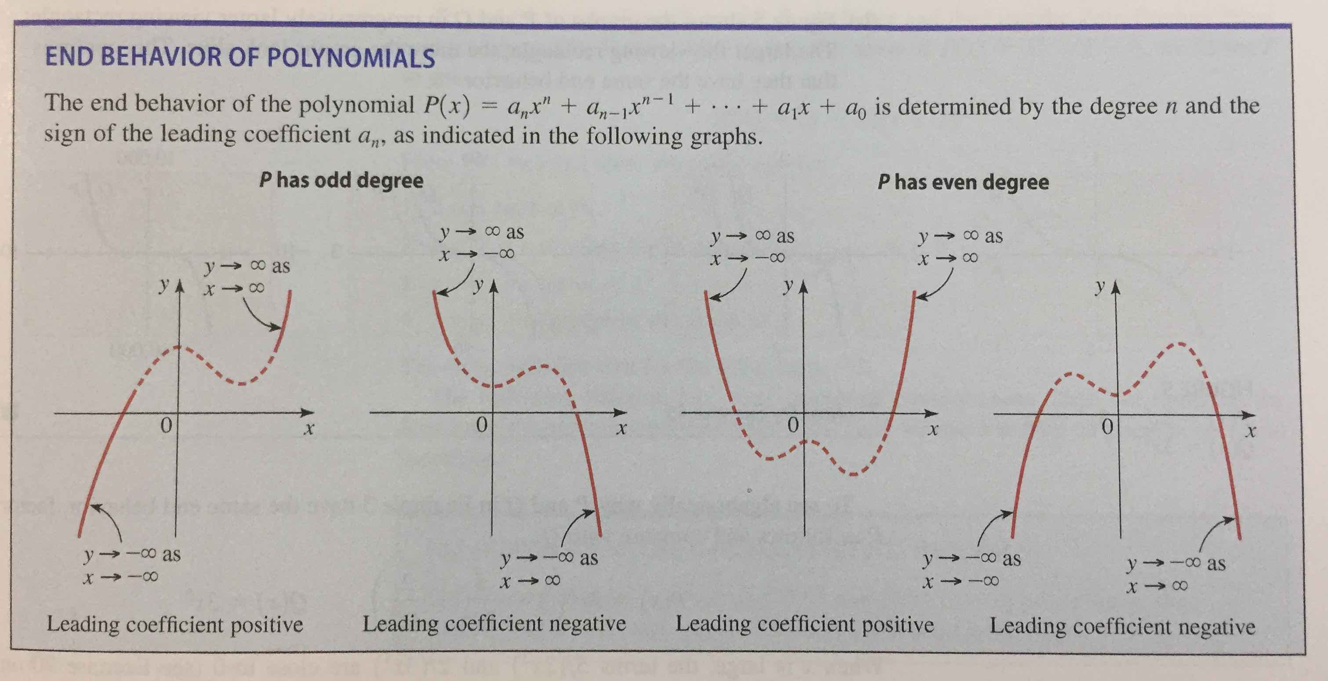
As you work to create and analyze your graphs, please read:

4. USE THE ZEROS TO GRAPH A POLYNOMIAL FUNCTION

Consider the following polynomial function:

$$P\left(x\right)=\left(x+2\right)\left(x-1\right)(x-1)$$

Find the zeros of this function. Then, Desmos.com to graph this polynomial and specifically identify the location of each zero that you find on the graph.

5. MORE ABOUT ZEROS OF A POLYNOMIAL FUNCTION

5A. Read the following statement about the real zeros of a polynomial
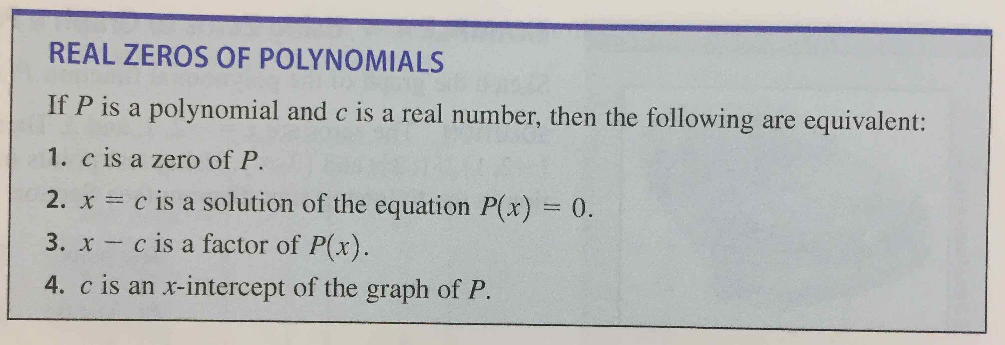

Translate this statement into abuelita language (simple words that you could use to explain the idea to your grandmother). Make sure to capture each of the ideas in full.

5B. Read the following theorem about the behavior of polynomial functions on either side of a zero:

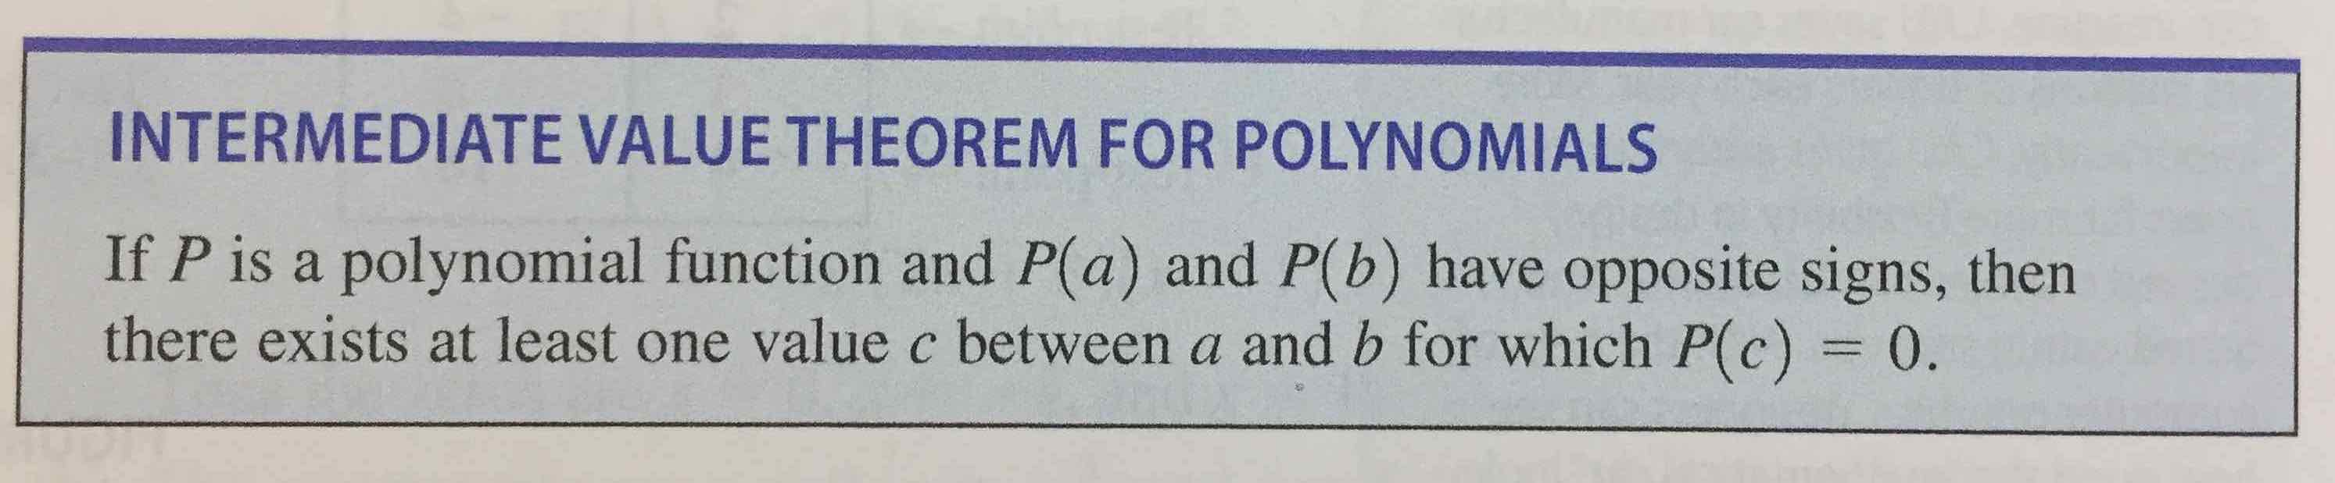
Look back on the work you did in problem 4. Using that work, restate this theorem using specific values for constants $a$, $b$, and $c$. Then, restate this theorem using abuelita language.

6. GRAPHING POLYNOMIAL FUNCTIONS

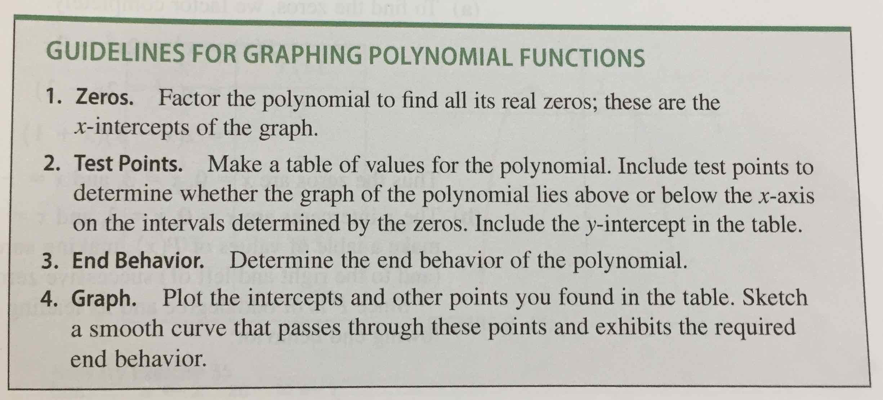
We have now explored a collection of tools we can use to graph polynomial functions. Let’s put these tools into action by creating some guidelines to produce such graphs by analyzing key features:

Combine your knowledge of Desmos.com with these guidelines to analyze the behavior of the following polynomial function:

$$P\left(x\right)= x^{3}-2x^{2}-4x+8$$

