Math 48B, Lesson 1: Polynomial Functions

In this lesson, we explore the general form of a polynomial function of degree n. Those functions take on the following format:

$f\left(x\right)= a_{n} x^{n}+ a_{n-1} x^{n-1}+⋯+a_{1} x^{1}+a_{0} x^{0}$

Our goal in this work is to get comfortable with this notation and the words we can use to describe this mathematical statement. To do that, we will build your understanding of each component piece of this notation slowly… Remember, math is done

1. ANATOMY OF A PURE POWER

1A. Consider the following equation:

$$b^{n}=a$$

Identify the names for each part of this equation and any special features of the notation that stick out in your mind.
Look back on your work from problem 1A above. For each of the following power expressions, evaluate the expression. Then, specifically identify the value of base $b$ and the value of power $n$
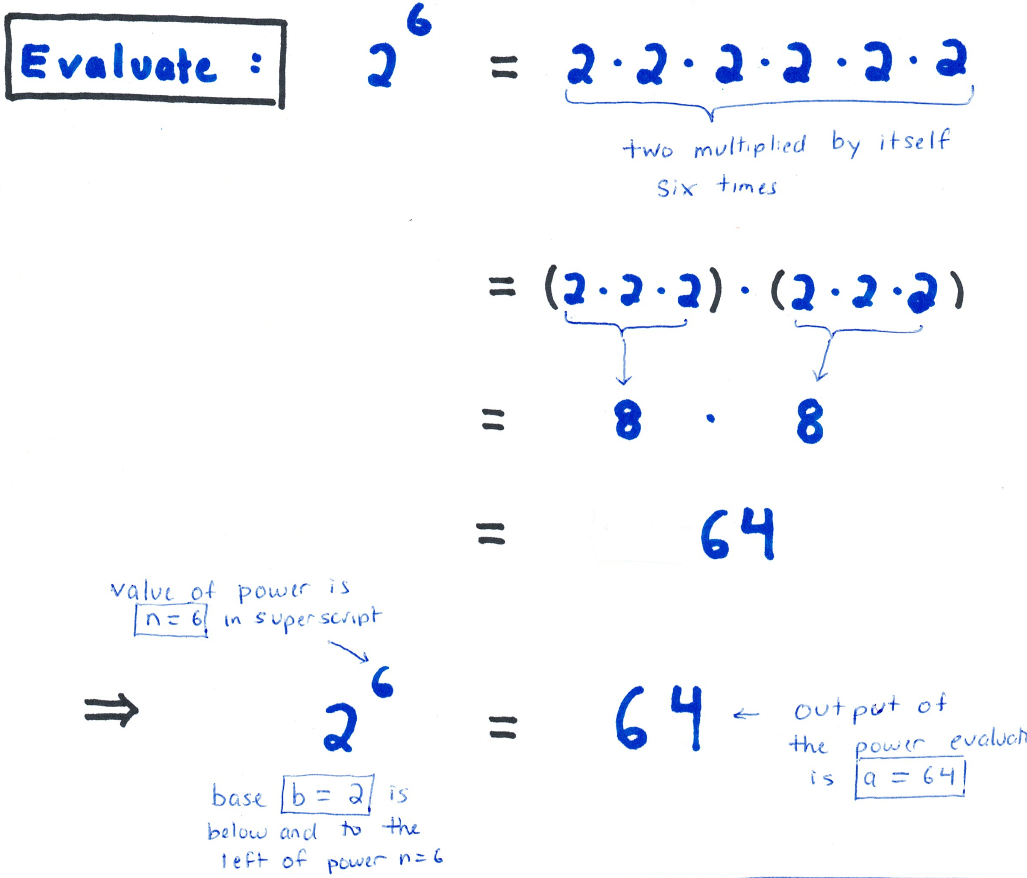
1B. $2^{6}$

1C. $3^{4}$

1D. $4^{1}$

1E. $5^{0}$

2. EXPLORE BEHAVIOR OF POWERS
2A. Please fill out the table below. Specifically identify patterns in your work. Work slowly and methodically on this problem. We’re going to use this work to create power rules and the work you do is going to be with us for the rest of this quarter (and many more years if you go on in your math career).

$$n$$ | $$2^{n}$$
$$-4$$
$$-3$$
$$-2$$
$$-1$$
$$0$$
$$1$$
$$2$$
$$3$$
$$4$$
$$5$$
$$6$$
$$7$$
$$8$$
$$9$$
$$10$$

2B. Using the table above, come up with a conjecture (a mathematical guess) about the following power expressions.

One as an exponent: $b^{1}$

Zero as an exponent: $b^{0}$

Negative exponent: $b^{-n}$

Hidden in the table from problem 2 above are other “laws of powers.” These are algebraic properties for taking powers of any base. In problem 3, we explore those laws in more detail.

3. EXPLORE THE LAWS OF POWERS
3A. How might we rewrite the product

$$x^{7}∙x^{3}$$

as a single variable $x$ raised to a single constant power. In addition to showing your work mathematically, explain your answer in using full sentences.

3B. Using your work in problem B above, make a conjecture about a more general rule we can apply when we multiply two power functions. In other words, if $x$ is a variable and $m,n$ are positive integers, how might we rewrite the product

$$x^{m}∙x^{n}$$

as a single variable $x$ raised to a power. Explain your answer in full sentences.

3C. Using your work in part A above, how might we rewrite the quotient

$$\frac{ x^{9} }{x^{4}}$$

as a single variable $x$ raised to a single constant power. In addition to showing your work mathematically, explain your answer in using full sentences.

3D. Using your work in problem D above, make a conjecture about a more general rule we can apply when we divide two power functions. In other words, if $x$ is a variable and $m,n$ are positive integers, how might we rewrite the quotient

$$\frac{ x^{n} }{x^{m}}$$

4. STATE THE LAWS OF POWERS
We just explored a bunch of “laws of powers.” These are algebraic properties that power expressions satisfy in the wild. Below are a review of these laws. For each law, write the complete statement in your own handwriting and make any notes for yourself that might help you remember in the future.

One as an exponent: $b^{1}$

Zero as an exponent: $b^{0}$

Negative exponent: $b^{-n}$

Product Rule: $b^{n}∙b^{m}$

Quotient Rule: $\frac{b^{n}}{b^{m}}$

The Power Rule: ${\left(b^{n}\right)}^{p}$
5. POWER FUNCTIONS (NOT EXPONENTIAL FUNCTIONS)
5A. Let’s explore power notation. How might we read the following statement:

$f\left(x\right) = { x}^{n}$ for $n ∈ N$
What does this notation mean? What are the special features of this notation?

5B. Consider complete the table below.
Power Function | Degree | How to read in English?
$$x^{0}=1$$ | $$0$$ | “$x$ to the power of zero equals one”  “any number $x$ raised to the zeroth power is one”
$$x^{1} = x$$
$$x^{2} = x∙x$$
$$x^{4} = x∙x∙x∙x$$

6. POLYNOMIAL FUNCTION

Let’s look at the general form of a polynomial function of degree $n$:

$$f\left(x\right)= a_{n} x^{n}+ a_{n-1} x^{n-1}+⋯+a_{1} x^{1}+a_{0} x^{0}$$

6A. Let’s explore this notation by looking at an example:

$$f\left(x\right)= 3x^{5}-5x^{4}+2x^{3}+x^{2}+11 x- 7$$

Make explicit connections between the general form and the polynomial given in this specific example.

6B. Let’s explore this notation by looking at an example:

$$f\left(x\right)= -12x^{6}+7x^{5}-x^{4}+4x^{3}+5x^{2}+x- 7$$

Make explicit connections between the general form and the polynomial given in this specific example. Then, describe each part of the notation using formal, nerdy math language.
6C. Let’s look back at the general form of a polynomial function of degree $n$.

Degree $0$ Polynomial: $P_{0}\left(x\right)= a_{0} x^{0}$

Degree $1$ Polynomial: $P_{1}\left(x\right)= a_{1} x^{1}+a_{0} x^{0}$

Degree $2$ Polynomial: $P_{2}\left(x\right)= a_{2} x^{2}+a_{1} x^{1}+a_{0} x^{0}$

Degree $3$ Polynomial: $P_{3}\left(x\right)= a_{3} x^{3}+a_{2} x^{2}+a_{1} x^{1}+a_{0} x^{0}$

Degree $4$ Polynomial: $P_{4}\left(x\right)= a_{4} x^{4}+a_{3} x^{3}+a_{2} x^{2}+a_{1} x^{1}+a_{0} x^{0}$

Degree $n$ Polynomial: $P_{n}\left(x\right)= a_{n} x^{n}+ a_{n-1} x^{n-1}+⋯+a_{1} x^{1}+a_{0} x^{0}$

In as much detail as you can, describe what you see in this general formula. Use simple, nontechnical words and also the nerdy math language to describe the parts of this formula that catch your eye.

6D. Complete the table below.
Polynomial | Degree | Leading Term | Constant Term
$$P\left(x\right)=8-3x$$
$$P\left(x\right)=x^{2}-x-2$$
$$P\left(x\right)=5x^{2}-10+x^{3}$$
$$P\left(x\right)=x+2-7x^{4}$$

