Math 48B, Lesson 14: Exponential Functions

In Math 48B Lessons 14, 15, 16, 17, and 18, we study logarithmic functions:

Logarithmic Form | Exponential Form
$$y=\log_{b}{(x)}$$ | $$x=b^{y}$$

To begin our exploration, let’s recall the rules of powers/exponents.

1. WHAT IS AN INVERSE FUNCTION?

1A. What does it mean for a function to be one-to-one?
1B. What is the horizontal line test?
1C. What is an inverse function?
1D. When do inverse functions exist?
1E. Assume we start with function $y=f(x)$ where every point on the graph of this function is given as $(x,y)$. How do we create the graph of the inverse function?
1F. Explain inverse function notation $f^{-1}(x)=y$.

2. WHAT IS THE INVERSE OF AN EXPONENTIAL FUNCTION?

2A. Graph of the exponential function $y=2^{x}$ below and then apply the horizontal line test to this function. What can you say about the existence of an inverse?

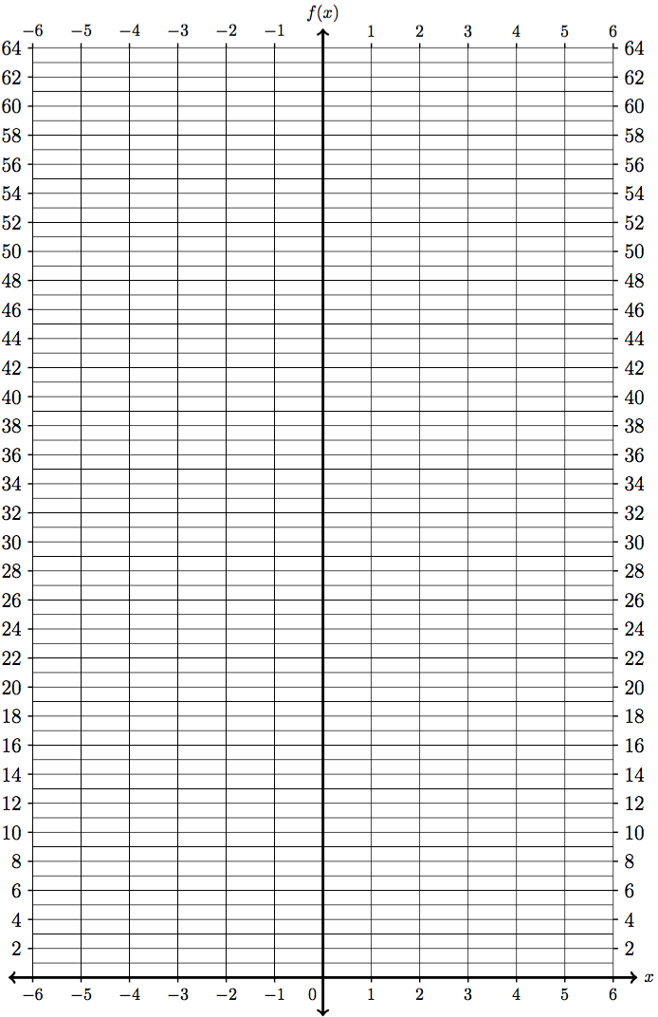
$$x$$ | $$y$$ | $$(x,y)$$
$$-4$$
$$-3$$
$$-2$$
$$-1$$
$$0$$
$$1$$
$$2$$
$$3$$
$$4$$
$$5$$
$$6$$

2B. Graph the inverse of the exponential function $y=2^{x}$ below and then apply the horizontal line test to this function. What can you say about the existence of an inverse?

$$y$$ | $$x$$ | $$(y,x)$$
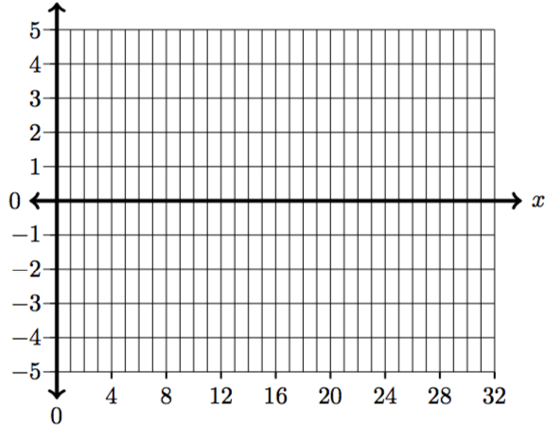

2C. Write the input-output relation for the inverse function from Problem 2B above. Then, translate this relation into logarithmic form. Finally, develop a verbal description for logarithmic functions.

3. HOW TO MOVE BACK AND FORTH FROM LOGS INTO EXPONENTS?

Consider the two equivalent forms for logarithmic functions:
Logarithmic Form | Exponential Form
$$y=\log_{b}{(x)}$$ | $$x=b^{y}$$

Write each of the following problems in both forms to find the desired output value.

3A. $y=\log_{10}{(1000)}$ 3E. $y=\log_{16}{(64)}$

3B. $y=\log_{3}{(81)}$ 3F. $y=\log_{27}{(9)}$

3C. $y=\log_{2}{( \frac{1}{32} )}$ 3G. $y=\log_{9}{(9^{5})}$

3D. $y=\log_{5}{( \frac{1}{125} )}$ 3H. $y=5^{\log_{5}{(y)}}$

4. WHAT ARE PROPERTIES OF LOGARITHMS?

Consider the two equivalent forms for logarithmic functions:
Logarithmic Form | Exponential Form
$$y=\log_{b}{(x)}$$ | $$x=b^{y}$$

Using these two equivalent forms, come up with formula to describe the properties of logarithmic functions in each of the following cases.

4A. $\log_{b}{(1)}$

4B. $\log_{b}{(b)}$

4C. $\log_{b}{(b^{x})}$

4D. $b^{\log_{b}{(x)}}$

5. WHAT DOES THE GRAPH OF A LOGARITHM LOOK LIKE?

Fill out the table for the logarithmic function $y=\log_{3}{(x)}$ below. The, use Desmos.com to create a graph and describe the relevant features of that graph including the domain, range, x-intercept, and the end behavior as $x→+∞$.

$$x$$ | $$y$$
$$\frac{1}{81}$$
$$\frac{1}{27}$$
$$\frac{1}{9}$$
$$\frac{1}{3}$$
$$1$$
$$3$$
$$9$$
$$27$$
$$81$$
$$243$$
$$729$$

6. HOW TO EVALUATE LOGARITHMS?

Consider the two equivalent forms for logarithmic functions:
Logarithmic Form | Exponential Form
$$y=\log_{b}{(x)}$$ | $$x=b^{y}$$

Use these two equivalent forms to evaluate each of the following logarithms.

6A. $y=\log_{10}{(100,000)}$ 6E. $y=\log_{64}{(8)}$

6B. $y=\log_{4}{(32)}$ 6F. $y=\log_{7}{(7)}$

6C. $y=\log_{5}{(1)}$

6D. $y=\log_{64}{(8)}$

