Math 48B, Lesson 12: Exponential Functions

In Math 48B Lessons 11, 12, and 13, we study exponential functions:

$$y=b^{x}$$

To begin our exploration, let’s recall the rules of powers/exponents.

1. WHAT ARE RULES OF POWERS/EXPONENTS?

Powers vs exponents: $y=x^{n}$ $y=b^{x}$

Product Rule: $b^{n}∙b^{m}$

Quotient Rule: $\frac{ b^{n} }{b^{m}}$

Zero Power: $1=\frac{ b }{b}=\frac{ b^{1} }{b^{1}}$

Negative Powers: $\frac{ 1 }{b^{n}}$

Power to a Power: ${\left(b^{n}\right)}^{p}$

2. WHAT IS EXPONENTIAL GROWTH?
2A. Fill in the table below. To the best of your ability, fill this table out by hand.

$$x$$ | $$f(x)=2^{x}$$ | $$g(x)=4^{x}$$ | $$h(x)=5^{x}$$ | $$j(x)={10}^{x}$$
$$-4$$
$$-3$$
$$-2$$
$$-1$$
$$0$$
$$1$$
$$2$$
$$3$$
$$4$$

2B. Graph the functions $f(x)$, $g\left(x\right),$ $h(x)$, and $j(x)$ from problem 2A above.

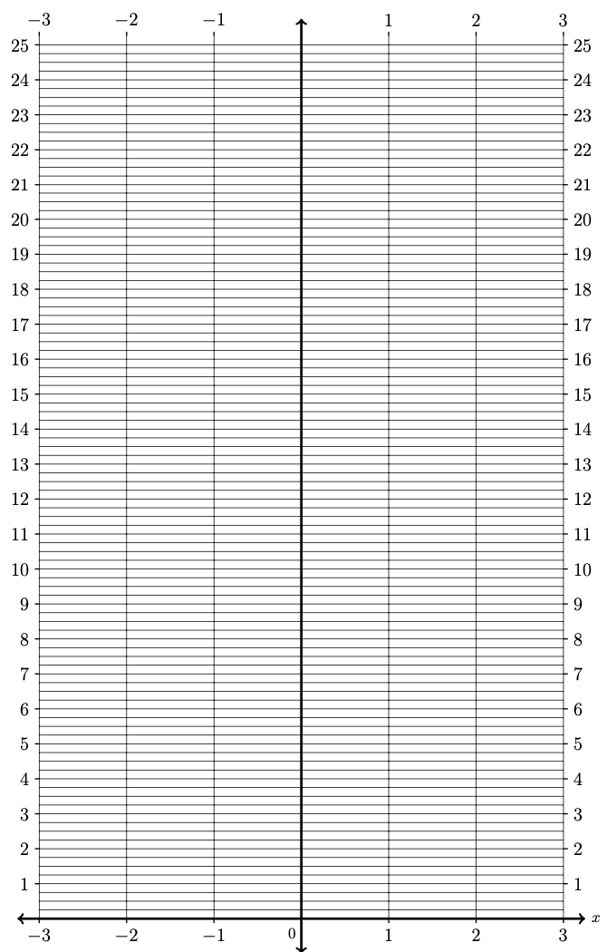

2C. Identify patterns in the graphs of the functions $f(x)$, $g\left(x\right),$ $h(x)$, and $j(x)$ from problems 2AB above. Make a conjecture about the general behavior of the graph of the function

$y=b^{x}$ for $1<b$

In your conjecture, identify the domain, range, y-intercept, and the end behavior as $x→-∞$ as well as $x→+∞$.

3. WHAT IS EXPONENTIAL DECAY?
3A. Fill in the table below. To the best of your ability, fill this table out by hand.

$$x$$ | $$F(x)={\left(\frac{1}{ 2 }\right)}^{x}$$ | $$G(x)={\left(\frac{1}{ 4 }\right)}^{x}$$ | $$H(x)={\left(\frac{1}{ 5 }\right)}^{x}$$ | $$J(x)={\left(\frac{1}{ 10 }\right)}^{x}$$
$$-4$$
$$-3$$
$$-2$$
$$-1$$
$$0$$
$$1$$
$$2$$
$$3$$
$$4$$

3B. Graph the functions $F(x)$, $G\left(x\right),$ $H(x)$, and $J(x)$ from problem 3A above.

3C. Identify patterns in the graphs of the functions $F(x)$, $G\left(x\right),$ $H(x)$, and $J(x)$ from problems 3AB above. Make a conjecture about the general behavior of the graph of the function

$y=b^{x}$ for $0<b<1$

In your conjecture, identify the domain, range, y-intercept, and the end behavior as $x→-∞$ as well as $x→+∞$.

4. TRANSFORMATIONS OF EXPONENTIAL FUNCTIONS?

4A. For exponential function $y=a∙b^{x-h}+k$, what do parameters $a$ ,$h$, and $k$ do to the graph of $y= b^{x}$?

4B. Test your hypothesis from Problem 4A above by graphing the function below.

x | $$f(x)= 2^{x}$$ | $$g(x)= 2^{x+2}$$
-4
-3
-2
-1
0
1
2
3
4
5
6
7
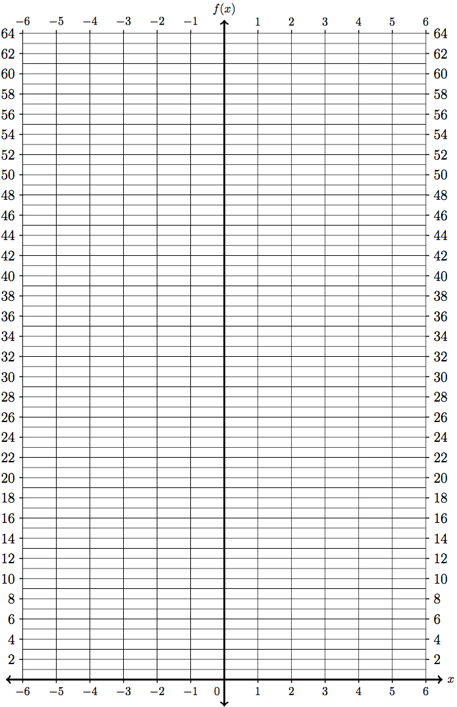

4C. Test your hypothesis from Problem 4A above by graphing the function below.

x | $$f(x)= 2^{x}$$ | $$g\left(x\right)=2^{x}+6$$
-4
-3
-2
-1
0
1
2
3
4
5
6
7

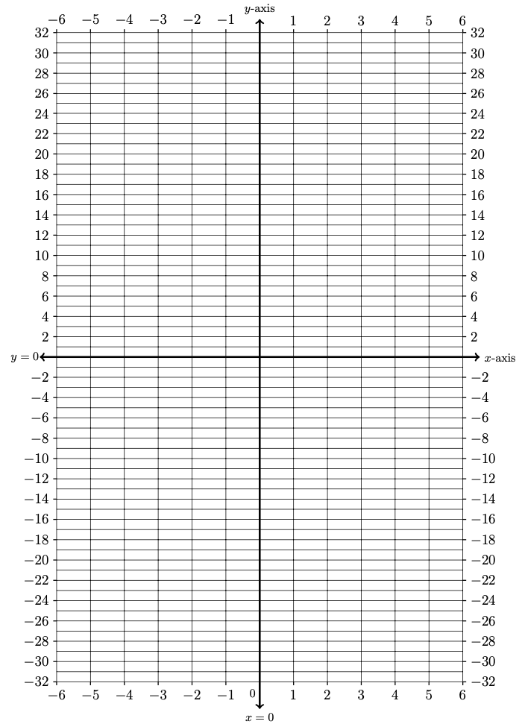
4D. Test your hypothesis from Problem 4A above by graphing the function below.

x | $$f(x)= 2^{x}$$ | $$g\left(x\right)=-2^{x}$$
-4
-3
-2
-1
0
1
2
3
4
5
6
7

4E. How is your work on problems 4ABC related to the general transformations:

$$g\left(x\right)=a f\left(x-h\right)+k$$

5. QUADRATIC VERSUS EXPONENTIAL GROWTH?
5A. Fill out the table below

x | $$f(x)= x^{2}$$ | $$f\left(x+1\right)-f(x)$$
0
1
2
3
4
5
6

5B. Fill out the table below

x | $$g(x)= 2^{x}$$ | $$g\left(x+1\right)-g(x)$$
0
1
2
3
4
5
6

5C. Graph $f(x)= x^{2}$ and $g(x)= 2^{x}$ below. What behavior do you notice? Which one is growing more quickly well as $x→+∞$.

