Math 48B, Lesson 11: Exponential Functions

In Math 48B Lessons 11, 12, and 13, we study exponential functions:

$${y= b}^{x}$$

To begin our exploration, we investigate exponential notation and how this differs from power notation.

1. WHAT IS POWER NOTATION?
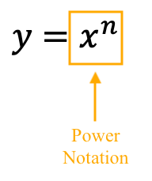
Explain power notation:

Where is input? Where is output? What do you notice about value in the superscript? What type of function(s) use power notation?

2. WHAT IS EXPONENT NOTATION?

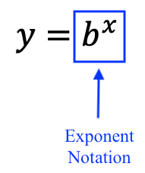
Explain exponent notation:

Where is input? Where is output? What do you notice about value in the superscript? What type of function(s) use power notation?

3. COMPARE AND CONTRAST POWER AND EXPONENT NOTATION?

What are the similarities and differences between power and exponent notations:

How do you know if you’re looking at a power function or an exponential function?

3. WHAT IS THE PRODUCT RULE OF POWERS/EXPONENTS?

Let’s explore the product rule of powers and exponents. Remember that superscript notation is used to count the number of times we multiply the base by itself. Starting with this definition, solve the problems below.

3A. $4^{7}∙4^{5}$ 3B. $2^{3}∙2^{8}$ 3C. $b^{6}∙b^{4}$

3D. Using what you learned in problems 3A – 3C, come up with a rule for the expression below. Describe your rule in VANVS (use language and notation).

$$b^{n}∙b^{m}$$

4. WHAT IS THE QUOTIENT RULE OF POWERS/EXPONENTS?
Let’s explore the quotient rule of powers and exponents. Remember that superscript notation is used to count the number of times we multiply the base by itself. Starting with this definition, solve the problems below.

4A. $\frac{ { 3}^{11} }{3^{6}}$ 4B. $\frac{ { 9}^{5} }{{ 9}^{12}}$ 4C. $\frac{ { b}^{10} }{{ b}^{3}}$

4D. Using what you learned in problems 4A – 4C, come up with a rule for the expression below. Describe your rule in VANVS (use language and notation).

$$\frac{ b^{n} }{b^{m}}$$

5. WHAT IS THE RULE FOR NEGATIVE POWERS/EXPONENTS?

5A. Using the quotient rule for exponents/powers, what do you notice about the following statement:
$$1=\frac{ b }{b}=\frac{ b^{1} }{b^{1}}$$

5B. Using the quotient rule for exponents/powers, what do you notice about the following statement:
$$\frac{ 1 }{b^{n}}$$

6. WHAT IS THE POWER RULE OF POWERS/EXPONENTS?
Let’s explore the power rule of powers and exponents. Remember that superscript notation is used to count the number of times we multiply the base by itself. Starting with this definition, solve the problems below.

6A. ${\left(5^{3}\right)}^{4}$ 6B. ${\left(\frac{ 1 }{{ 3}^{2}}\right)}^{6}$ 6C. ${\left({ b}^{3}\right)}^{2}$

6D. Using what you learned in problems 6A – 6C, come up with a rule for the expression below. Describe your rule in VANVS (use language and notation).

$${\left(b^{n}\right)}^{p}$$

7. WHAT IS EXPONENTIAL GROWTH?

7A. Exponential growth curve: Fill in the tables below and graph this function.

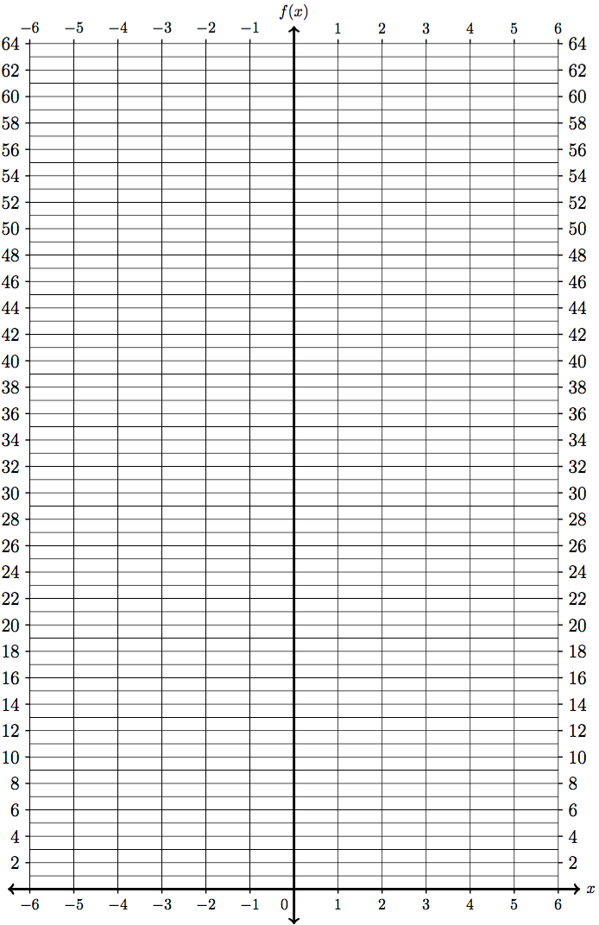
$$P$$ | $$f(x)=2^{x}$$
$$-4$$
$$-3$$
$$-2$$
$$-1$$
$$0$$
$$1$$
$$2$$
$$3$$
$$4$$
$$5$$
$$6$$
$$7$$
$$8$$
$$9$$
$$10$$

7B. Confirm your work using Desmos.com

