Math 48B, Lesson 10: Rational Functions, Part 2
In Math 48B Lessons 8, 9, and 10, we study rational functions in the form:
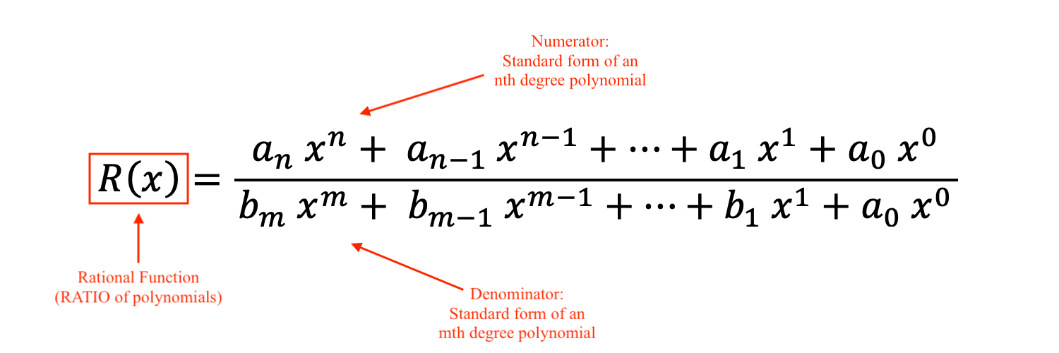
To begin our exploration, we explore some fundamental properties of division.
1. WHAT ARE RULES OF FRACTIONS?
Recall each of the following rules for fractions:

$\frac{ 0 }{K}$ $\frac{ K }{0}$

$\frac{ A }{A}$ $\frac{ A }{1}$

$\frac{ A }{B}∙\frac{C}{D}$ $\frac{A}{B}÷\frac{C}{D}$

$\frac{ 1 }{\text{HUGE NUMBER}}$ $\frac{ 1 }{\text{tiny number}}$

2. HOW TO GRAPH A RATIONAL FUNCTION?

Consider the instructions below.

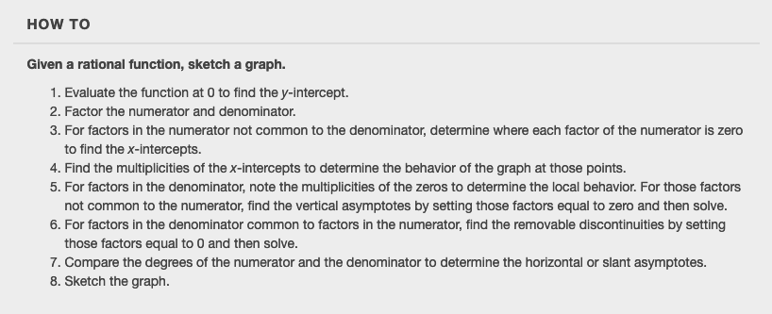

2A. Use these instructions to graph the following function:

$$R\left(x\right) = \frac{x^{2}-x-6}{ (x-2){(x+1)}^{2} }$$

Use Desmos.com as a tool to run your analysis.

2B. Use these instructions to graph the following function:

$$R\left(x\right) = 4+\frac{ x+3 }{ x^{2}-9 }$$

Use Desmos.com as a tool to run your analysis.

2C. Use these instructions to graph the following function:

$$R\left(x\right) = \frac{ 4x+2 }{ x^{2}+4x-5 }$$

Use Desmos.com as a tool to run your analysis.

