Jeff Anderson’s Exam 1 Corrections Form

The ability to thrive on timed, in-class exams is a learned skill. The more you practice, refine and improve your skill sets for in class exams, the better you will become. There are six phases to the process of test taking:

Phase 1: Early planning (Study Skills HW 1 & 2: Plan ahead and budget energy)
Phase 2: Daily study rituals (Study Skills HW 3: Focus on deep understanding)
Phase 3: Strategic practice (Study Skills HW 4: Focus on quick recall and problem solving)
Phase 4: The night before (Get sleep and plan to perform)
Phase 5: During the exam (Apply test-taking skills)
Phase 6: After the exam (Reflect via exam corrections and recalibrate)

Phases 2 – 6 are cyclical, meaning when you finish phase 6 you start back at phase 2. These phases also happened simultaneously. In other words, during the week(s) immediately prior to an exam, you will likely complete phase 2 for new content while you are working on phase 3 for older content. This is related to the plan-act-reflect cycles discussed in our syllabus:

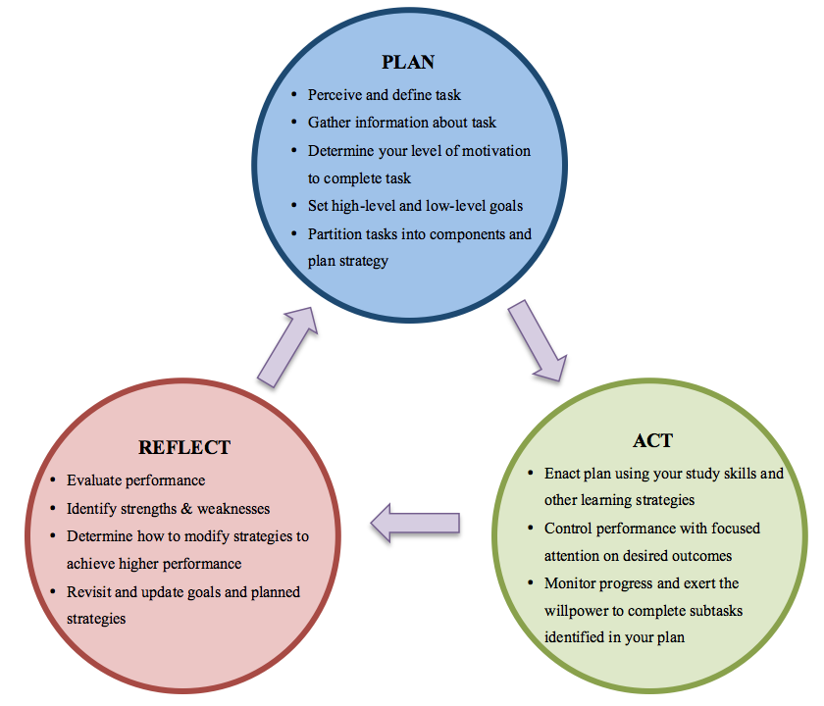

This exam correction activity is designed to help you reflect on your exam process. Remember, if you are really engaged with your learning, your work is NOT over after you submit your exam. Instead, after your instructor returns your graded work, you will want to budget time to look over your exam and reflect on your performance.

This exam corrections activity will lead you through a guided reflection process. As you complete these corrections, you will ask yourself a list of questions including: What happened? What did I do? How did that work out? In order to learn from your exam performance, you will want to:

- Identify the strengths and weaknesses of your performance

- For the things you did well, why were you able to achieve these? What study habits led you to these successes? How can you develop and maintain these study habits moving forward? How would you apply these study habits to succeed in future quarters with other professors?

- For the mistakes that you made, why did you make these mistakes? What study habits led you to fail on these problems? What underlying assumptions did you make prior to this exam that led you to these study habits? What changes are you going to make to improve your performance? Get detailed here.

Below is a detailed description of the exam corrections process.

How do I start my corrections? Complete the following two steps:

☐ STEP 1: REVIEW YOUR GRADED EXAM

- Identify all problems for which you did not get the correct answer (be careful, Jeff’s solution set might be filled with errors).
- DO NOT erase anything of the original exam.

☐ STEP 2A: FILL OUT TABLE 1: PERFORMANCE REVIEW

Find Table 1 on page 6 of this corrections activity.

Please focus on the left side of the table titled “Original Exam: To be completed by student” (Columns 1- 6);

For Columns 2 – 6:
- Identify all problems on which you got the right answer
- Identify all problems on which you did NOT get the right answer (either you made a mistake or you didn’t finish)

☐ STEP 2B: FILL OUT TABLE 2: EXAM 2 SELF ASSESSMENT

Find Table 2: Exam 2 Self Assessment on page 6 of this corrections activity. Look back over your graded exam 2 paper AND your graded exam 1 paper (and corrections). Please fill out Table 2 using this information.

What do I do next? After you finish steps 1 and 2 above, then do the following:

☐ STEP 3: WRITE EXAM CORRECTIONS

On separate, blank, clean paper (not on the exam itself) redo all problems that you did not receive full credit for. Your solutions should be neat, organized and easy to read.

  - For free-response questions, show your work. Describe how you achieved the correct answer by demonstrating the necessary mathematical operations using step-by-step analysis.

  - Use English sentences, graphs, figures, tables, numerical values, analytic arguments, and formulas to support your work.

  - Show your steps and make it very clear that you understand the correct answer. Your work should include a mix of formal terminology and informal descriptions of your thoughts and ideas related to each solution.

Do the problems in order: the first problem you missed should be first problem you write in your corrections, followed by the second problem you missed and so on

Now that I’ve reviewed my work and written the correct answers, what should I do?

☐ STEP 4: IDENTIFY YOUR MISTAKES

- For each problem you did not earn full-credit on, DESCRIBE WHY YOU GOT THE PROBLEM WRONG. Use the “Avoid common exam mistakes” document to help identify the types of mistakes you made on this exam.

- WARNING: Without Step 4, you won't get credit.

How do I finish my corrections? To finish your corrections, be sure to do the following:

☐ STEP 5: IDENTIFY PATTERNS IN YOUR MISTAKES

- Find any patterns or trends in your mistakes. What do you notice was the most difficult part of this test for you? Why do you think these challenges arose?

☐ STEP 6: RESPOND TO EXAM REFLECTIONS QUESTIONS

- Respond to the Exam Reflections Questions on pages 7 and 8.

- Use full sentences. Describe your thoughts in detail. Demonstrate that you have thought deeply about your exam performance and are reflecting on your learning.

- Make sure to give specific suggestions and explain your reasoning. Please write this as a how-to letter to future students.

- WARNING: Without Step 6, you won't get credit.

Getting Help? You may get help to complete the exam corrections from any of the following:
- Jeff (in office hours or by appointment) D. Private Tutor
- STEM Center Staff E. Anyone Else
- Classmates or friends F. Online Videos
If you decide to get help, be sure to:
- Have the person who helps you use scratch paper. Do not let your helper write on the exam corrections that you submit to Jeff.
- Rewrite each correction in your own handwriting on the exam correction document when you are sure that you understand the correct answer.
- Ensure the corrections that you submit represent your understanding.

When are exam corrections due? The due date for these corrections will be announced during one of our in-class meetings. Please stay posted.
How is it graded? Jeff described his grading procedure during class. If you have further questions, you are welcome to set up an appointment to talk to Jeff about this in person.
What will I turn in? Staple or paper clip your exam corrections packet and submit your work in the following format:

TOP SHEET: Your hard copy of Exam
SECOND SHEET: Your Exam Corrections
THIRD SHEET: Your Exam Corrections Form (all 6 pages)

- Take a look at your original graded exam. For each problem, use the table below to identify:
- How many points you earned and how many points you missed
- Whether or not you earned full credit
PERFORMANCE OVERVIEW
ORIGINAL EXAM:  To be filled out by student |  |  |  |  |  | EXAM CORRECTIONS:  To be completed by instructor
Exam  Problem | Correct  Answer | Finished but incorrect | Didn’t  Finish | Did not  start | other | Correction  Accepted | Not Yet
1A
1B
1C
1D
2A
2B
3
4
5A
5B
6A
6B
6C
6D
6E
7A
7B
7C
8A
8B
8C
8D
9
TOTALS

EXAM 1 REFLECTSION: SELF ASSESSMENT
- Prior to taking this exam, what was the percent score you wanted to achieve on this exam? In other words, what was your goal for this exam PRIOR to actually taking the exam?

- What percent score did you actually achieve?
- Did you achieve your goal for this particular exam?
☐ YES | ☐ NO

- What went well for you in this exam? What did you do well? What study skills were most helpful?

- What types of mistakes did you make on this exam? Why do you think you made these mistakes?

- Based on your performance review and your responses to the questions above, name at least two new strategies you plan to use to prepare for the next in-class, timed exam. Describe these in details and explain why those strategies will help you avoid the types of mistakes you identifies in question 6 above.

EXAM REFLECTION INSTRUCTOR ASSESSMENT QUESTIONS:

- What is challenging about this course? What suggestions do you have for your instructor to help you address your challenges?

- What are the aspects of this class that you appreciate? What in this class is helping you learn? What suggestions do you have for your instructor for things that he should continue to do in order to help you learn in this class?

