Math 48A, Lesson 9: Radical Functions

1. THE SQUARE ROOT OPERATION
1A. Suppose you’re talking to your abuelita (grandma) and she is not familiar with the idea of an “square root”. Explain to your abuelita what it means to find the “square root” of a number. Put your description into words.

1B. Show how to calculate the square root of at least two numbers.

1C. What happens when we try to take the square root of a negative number? Explain your reasoning in words and in symbols.

2. GRAPH THE QUADRATIC FUNCTION

Consider the following quadratic function

$$y=x^{2}$$

Create a table of values and graph the resulting lines on these axes below.

Input | Output
$$x$$ | $$y$$
$$-5$$
$$-4$$
$$-3$$
$$-2$$
$$-1$$
$$0$$
$$1$$
$$2$$
$$3$$
$$4$$
$$5$$
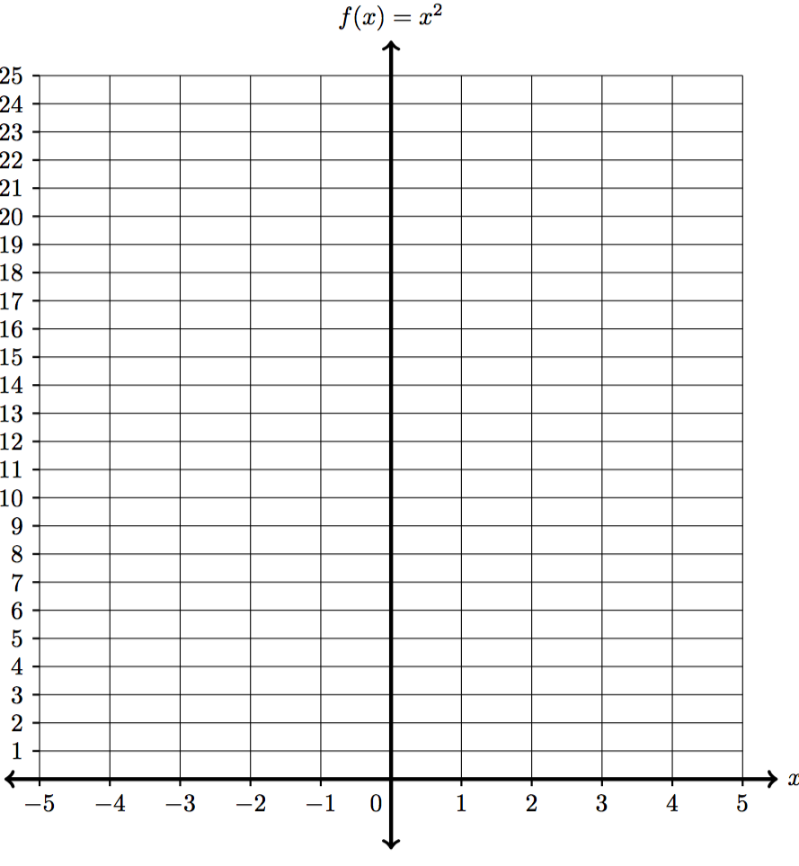
3. GRAPH A QUADRATIC RELATION

Consider the quadratic relationship given by

$$y^{2}=x$$

Fill out the table below. Then use that table to graph the quadratic relation on the axes given below.

Output | Input
$$x$$ | $$y$$
 | $$-5$$
 | $$-4$$
 | $$-3$$
 | $$-2$$
 | $$-1$$
 | $$0$$
 | $$1$$
 | $$2$$
 | $$3$$
 | $$4$$
 | $$5$$
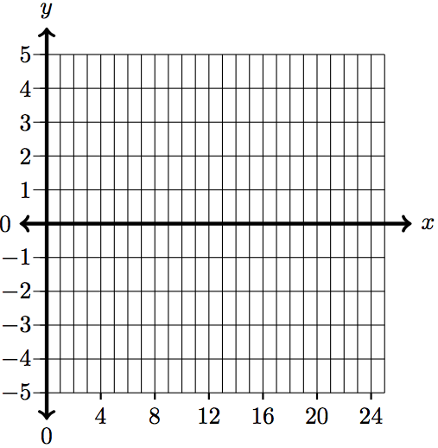
4A. Compare and contrast problem 2 with problem 3. What do you notice about the role of the input and output variables in the two problems?

4B. Redraw your graph of the quadratic relationship $y^{2}=x$ from problem 3 on the axes below. Does this graph represent a function? Why or why not? Explain your answer.

4C. Suppose you are looking at the quadratic relationship $y^{2}=x$.
Also, suppose that I tell you that on this relationship, I want to find $y$-values such that $x=16$. What y-value satisfies this relationship?
How easy is to give a unique “answer” to this question?

4D. Why do mathematicians (like you and me) prefer to work with functions?

4E. Redraw your graph of the quadratic relationship $y^{2}=x$ from problem 3 on the axes below. How could you turn this graph into a function?

5. SQUARE ROOT FUNCTION TYPE OF ROOT FUNCTION

5A. Consider the square root function

$$f(x)=\sqrt[2]{ x }$$

Fill out the table below. Then use that table to graph the square root function.

Input | Output
$$x$$ | $$f(x)=\sqrt[2]{ x }$$
$$-1$$
$$0$$
$$1$$
$$4$$
$$9$$
$$16$$
$$25$$

5B. Consider the square root function

$$g\left(x\right)=-\sqrt[2]{ x }$$

Fill out the table below. Then use that table to graph the square root function.

Input | Output
$$x$$ | $$g\left(x\right)=-\sqrt[2]{ x }$$
$$-1$$
$$0$$
$$1$$
$$4$$
$$9$$
$$16$$
$$25$$

5C. How are the graphs from problems 5A and 5B related to the work you did in problem 4A – 4E?

5D. What are the similarities and differences between the quadratic relation
$y^{2}=x$ and the square root function $y=\sqrt[2]{ x }$?
6. SOLVE RADICAL EQUATIONS

6A. Solve the following radical equation using a graphical method

$$\sqrt[2]{ x+5 }-1=2$$

Use the table and axes below to do this work.
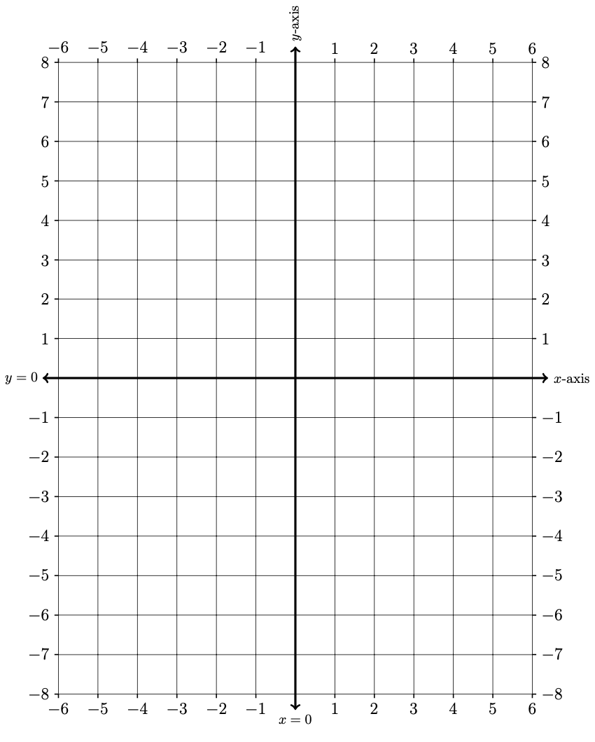
$$x$$ | LHS | RHS
$$-6$$
$$-5$$
$$-4$$
$$-3$$
$$-2$$
$$-1$$
$$0$$
$$1$$
$$2$$
$$3$$
$$4$$
$$5$$
$$6$$

6B. Solve the following radical equation using a graphical method

$$\sqrt[2]{ x+5 }-1=2$$

7. OPTIONAL CHALLENGE PROBLEM: SOLVE RADICAL EQUATIONS

7A. Solve the following radical equation using a graphical method

$$3+\sqrt[2]{ 5-x }=x+4$$

Use the table and axes below to do this work.
$$x$$ | LHS | RHS
$$-6$$
$$-5$$
$$-4$$
$$-3$$
$$-2$$
$$-1$$
$$0$$
$$1$$
$$2$$
$$3$$
$$4$$
$$5$$
$$6$$

7B. Solve the following radical equation using a graphical method

$$3+\sqrt[2]{ 5-x }=x+4$$

