Math 48A, Lesson 8: Absolute Value Functions

1. THE ABSOLUTE VALUE OPERATION
1A. Suppose you’re talking to your abuelita (grandma) and she is not familiar with the idea of an “absolute value”. Explain to your abuelita what it means to find the “absolute value” of a number. Put your description into words.

1B. Show how to calculate the absolute value of at least two numbers (find the absolute value of at least one positive and one negative number)

1C. Consider the following diagram of a small section of the real number line:
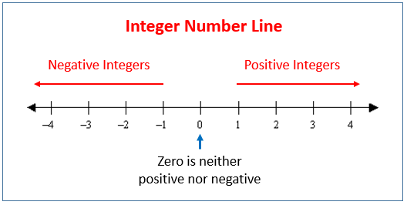

Use this type of diagram to explain using visual imagery what it means to take the absolute value of a number relates to the real number line. Make sure to demonstrate your ideas using examples of positive AND negative numbers.

2. GRAPH THE ABSOLUTE VALUE FUNCTION

2A. Consider the following piecewise function:
$$f(x)=\left\{\begin{matrix}x & \begin{matrix}\text{if} & x<0\end{matrix} \\ 0 & \begin{matrix}\text{if} & x=0\end{matrix} \\ -x & \begin{matrix}\text{if} & x<0\end{matrix}\end{matrix}\right.$$
Create a table of values and graph the resulting lines on these axes below.
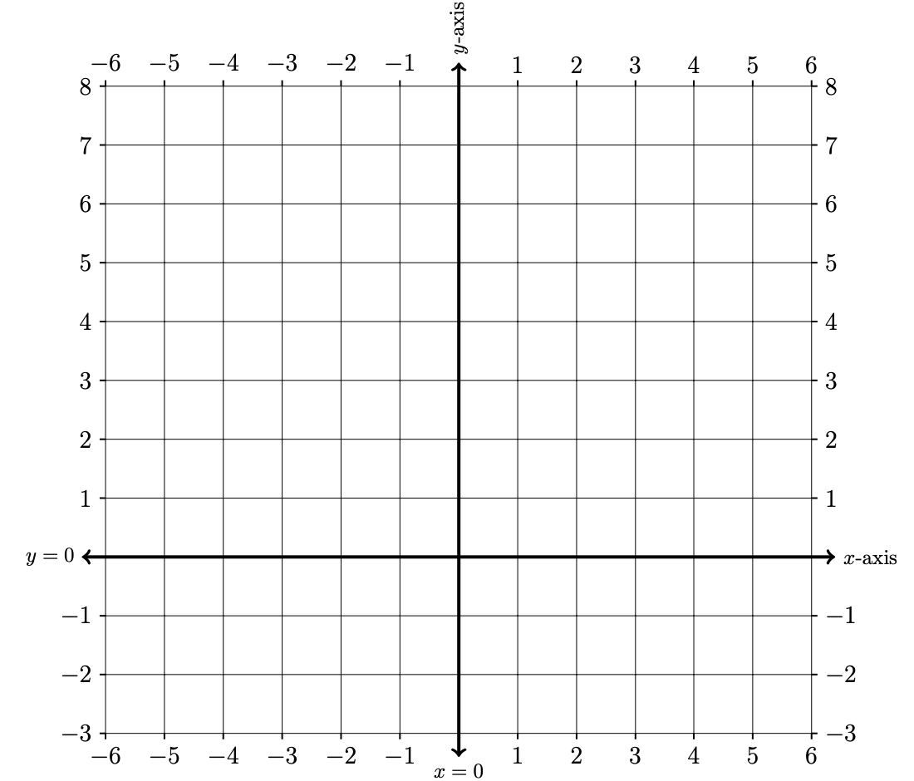
$$x$$ | $$f\left(x\right)$$
$$-6$$
$$-5$$
$$-4$$
$$-3$$
$$-2$$
$$-1$$
$$0$$
$$1$$
$$2$$
$$3$$
$$4$$
$$5$$
$$6$$

2B. Consider the following absolute value function:
$$f(x)=\left| x \right|$$
Create a table of values and draw the resulting graph on the axes below.
$$x$$ | $$f\left(x\right)$$
$$-6$$
$$-5$$
$$-4$$
$$-3$$
$$-2$$
$$-1$$
$$0$$
$$1$$
$$2$$
$$3$$
$$4$$
$$5$$
$$6$$

2C. Look back at your graphs from problem 3A and problem 3B. What do you notice about those two graphs? Make a conjecture (a mathematical guess) that captures your observations.

2D. What does it mean to discover an equivalent representation for a function?

3. SOLVE AN ABSOLUTE VALUE EQUATION

Use what you learned in problems 1 and 2 above to solve the following absolute value equation. How does your solution relate to the idea of a piecewise function?

$\left|3y-7\right|-6=-2$
4. FIND EQUIVALENT REPRESENTATION FOR ABSOLUTE VALUES
4A. Consider the following absolute value function:

$$g\left(x\right)=\left| 2x+2 \right|$$

Make a conjecture (a mathematical guess) for an equivalent piecewise representation of this function. Call your piecewise guess function $h\left(x\right).$

4B. Test the conjecture you made in problem 4A by creating a graph of your test piecewise function $h\left(x\right)$ and also the absolute value function

$$g\left(x\right)=\left| 2x+2 \right|$$

Try to adapt your conjecture until you get your guess for $h\left(x\right)$ to match identically the graph of $h\left(x\right).$ Capture this equivalent representation.
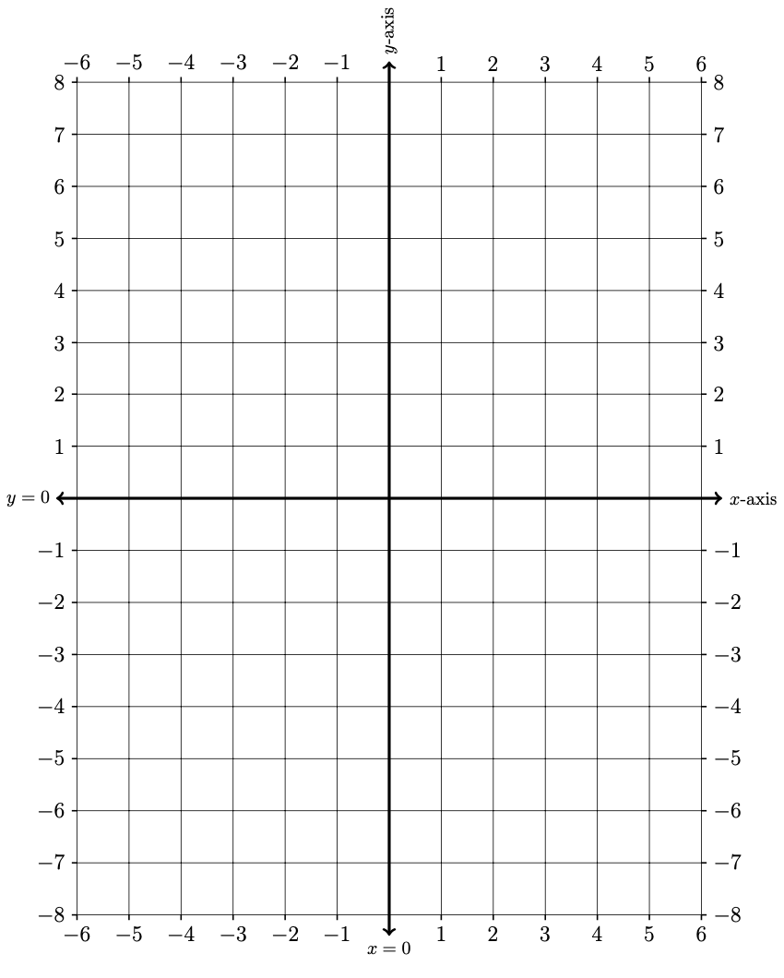
$$x$$ | $$g\left(x\right).$$ | $$h\left(x\right).$$
$$-6$$
$$-5$$
$$-4$$
$$-3$$
$$-2$$
$$-1$$
$$0$$
$$1$$
$$2$$
$$3$$
$$4$$
$$5$$
$$6$$

5. SOLVE ABSOLUTE VALUE EQUATIONS
5A. Consider the following absolute value equation:
$$4-\left|2x+2\right|=\frac{1}{2}x$$
Use the left-hand side (LHS) and right-hand side of this equation to a table of values and draw the resulting graph on the axes below.
$$x$$ | LHS | RHS
$$-6$$
$$-5$$
$$-4$$
$$-3$$
$$-2$$
$$-1$$
$$0$$
$$\frac{ 4 }{5}$$
$$1$$
$$2$$
$$3$$
$$4$$
$$5$$
$$6$$

Graphical Technique to solve an algebraic equation
To find the solution to algebraic equations using a graphical technique, we use the following five step program for salvation:
Step 1: Graph the function $y_{1}$ on the left-hand side of the equals sign.
Step 2: Graph the function $y_{2}$ on the right-hand side of the equals sign.
Step 3: Find the point(s) of intersection between the graphs of the two functions.
Step 4: Write each point of intersection as an ordered pair in the form: $(x, y)$
Step 5: Set the variable from the original algebraic equation equal to the 1st coordinate of each point of intersection. These “x”-values are the solution(s) to the algebraic equation.

5B. Use the graph you created in problem 5A to solve the equation:

$$4-\left|2x+2\right|=\frac{1}{2}x$$

5C. Now let’s solve the absolute value equation $$4-\left|2x+2\right|=\frac{1}{2}x$$
using an algebraic technique. Hint: Use your work in problems 4A – 4B.

5D. Use a graphical method to solve the inequality $$4-\left|2x+2\right|≤\frac{1}{2}x$$
Make sure to draw the graph below as you find your answer.

6. SOLVE MORE ABSOLUTE VALUE EQUATIONS

Solve each absolute value equation/inequality stated below:

6A. $\left|3y-7\right|-6≥-2$
6B. $7- \left|2x+3\right|>2$
6C. $3-\left|x+7\right|=10$

You can use any method you’d like (algebraic or graphical). If you want to challenge yourself, solve each of these questions using both a graphical method and also an algebraic method.

