Math 48A, Lesson 7: Linear Functions

1. LINEAR FUNCTIONS HAVE CONSTANT RATES OF CHANGE

1A. Consider the linear functions
$f\left(x\right)=-2x+23$ and $g\left(x\right)=3x+3$
Create a table of values and graph the resulting lines on these axes below.
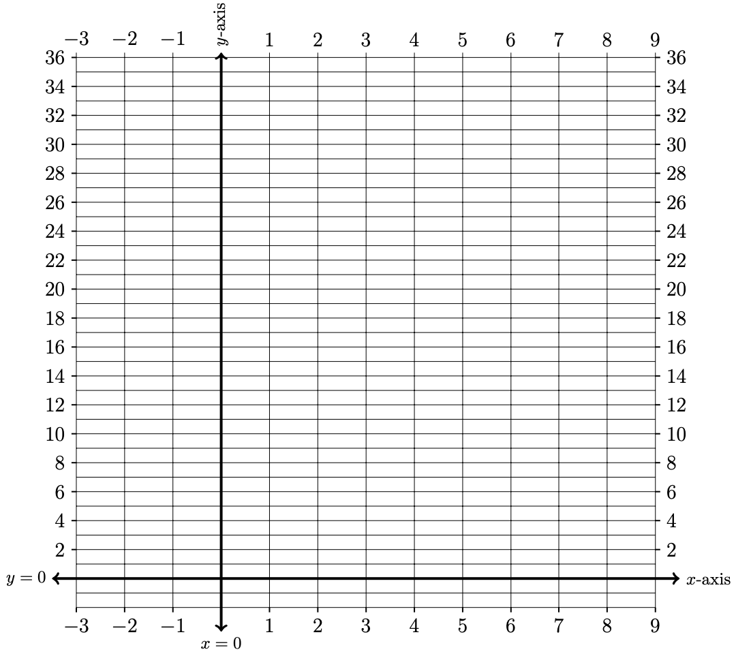
$$x$$ | $$f\left(x\right)$$ | $$g\left(x\right)$$
$$-4$$
$$-3$$
$$-2$$
$$-1$$
$$0$$
$$1$$
$$2$$
$$3$$
$$4$$
$$5$$
$$6$$
$$7$$
$$8$$
$$9$$
1B. Which function is increasing? Which function is decreasing? Explain why.

Calculate the average rate of change of $f\left(x\right)$ and $g\left(x\right)$ between the points

1C. between $x=1$ and $x=6$.
1D. between $x=a$ and $x=a+h$.

How are your answers related to your work on problem 1B?

2. GENERAL FORMS FOR A LINE

Write your 1st draft of your description for three different forms for the equation of a line including:

Slope-intercept form: $y=m x+b$

Point-slope form: $y-y_{1}=m \left(x-x_{1}\right)$

Polynomial form: $y=a_{1}x+a_{0}$

As you craft your descriptions of these equations, be sure to use both:

Abuelita language: Use language that your abuelita can understand.

Nerdy language: Write this out using nerdy language. See if you can include formal mathematical symbols. This is the formal concept definition found in your textbook.

3. EQUATION FOR SLOPE OF A LINE

Write your 1st draft of your description for the equation for the slope of a line. Identify how this relates to calculating average rates of change from Lesson 6.
As you craft your descriptions of these equations, be sure to use both:

Abuelita language: Use language that your abuelita can understand.

Nerdy language: Write this out using nerdy language. See if you can include formal mathematical symbols. This is the formal concept definition found in your textbook.

4. IDENTIFY LINEAR FUNCTIONS

Determine if the function given in each problem below is linear or not. If the function is linear, express this function in slope-intercept form.

4A. $f(x)=\frac{ 2x-3 }{x}$ 4B. $f\left(x\right)=\frac{1}{4}\left(2-3x\right)$

4C. $f(x)=\frac{ 4 - 3x}{5}$ 4D. $f\left(x\right)={\left(x-3\right)}^{2}$

5. EQUATION FOR HORIZONTAL LINES
Consider the functions below

$f\left(x\right)=6$ and $g\left(x\right)=-1$

Create a table of values and graph these functions.
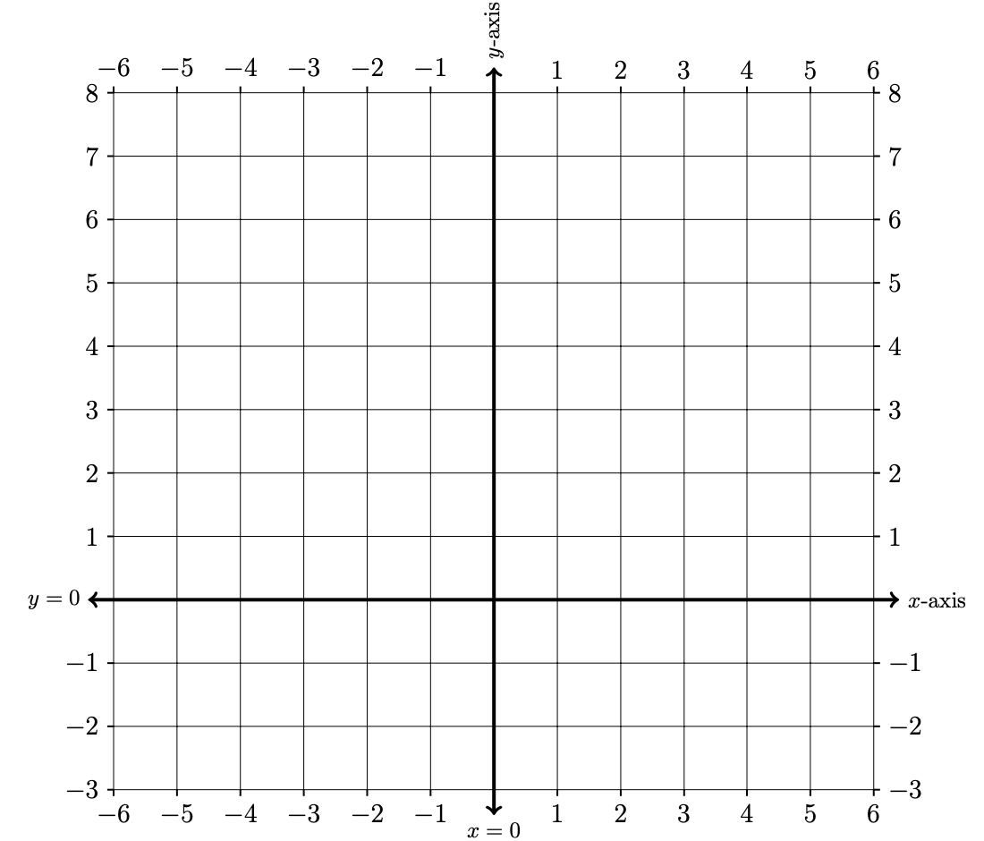
$$x$$ | $$f\left(x\right)$$ | $$g\left(x\right)$$
$$-6$$
$$-5$$
$$-4$$
$$-3$$
$$-2$$
$$-1$$
$$0$$
$$1$$
$$2$$
$$3$$
$$4$$
$$5$$
$$6$$

6. EQUATIONS FOR VERTICAL LINES
Consider the equation below

$x=-3$

Create a table of values and graph these equations.
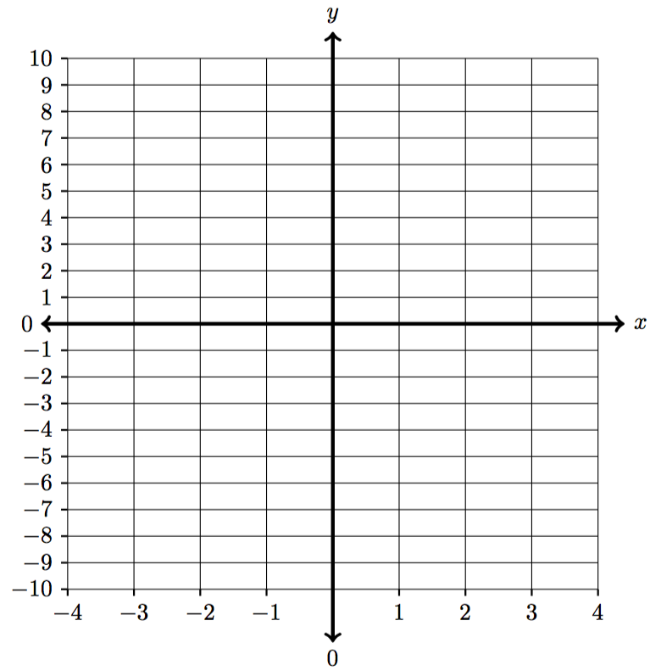
$x$ | $$y$$
 | $$-6$$
 | $$-5$$
 | $$-4$$
 | $$-3$$
 | $$-2$$
 | $$-1$$
 | $$0$$
 | $$1$$
 | $$2$$
 | $$3$$
 | $$4$$
 | $$5$$
 | $$6$$

7. EQUATIONS FOR X-AXIS AND Y-AXIS

Using the work you did in problems 6 and 7, determine the equations for the x-axis and the y-axis. Explain your reasoning.

8. GRAPH A PIECEWISE FUNCTION

Consider the piecewise function below:
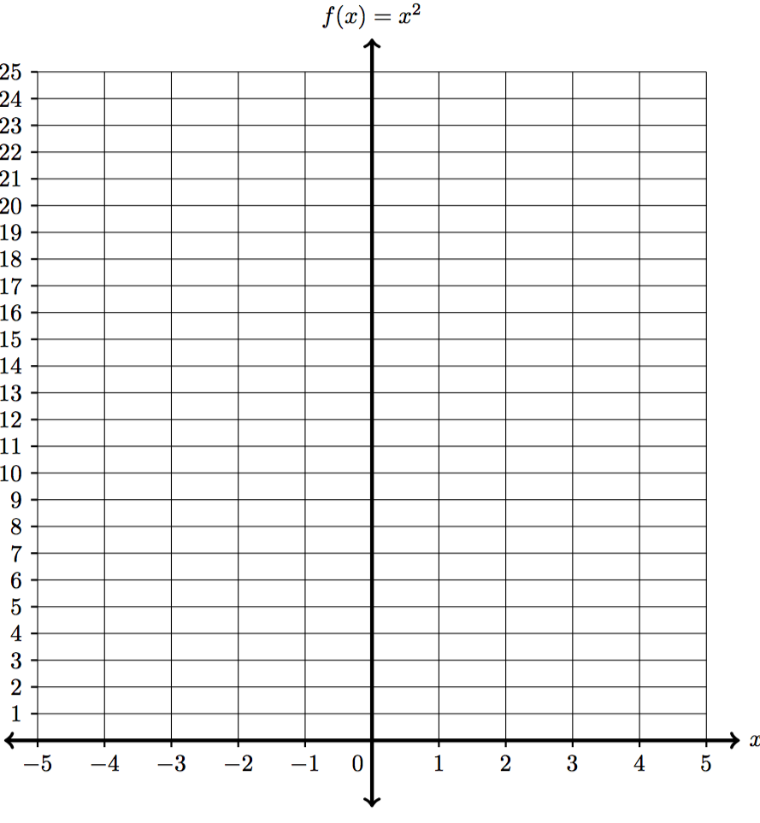
Input | Output
$$x$$
$$-5$$
$$-4$$
$$-3$$
$$-2$$
$$-1$$
$$0$$
$$1$$
$$2$$
$$3$$
$$4$$
$$5$$
$$f(x)=\left\{\begin{matrix}9 & \begin{matrix}\text{if} & x<-3\end{matrix} \\ x^{2} & \begin{matrix}\text{if} & -3≤x<1\end{matrix} \\ 2x+1 & \begin{matrix}\text{if } & 1≤x\end{matrix}\end{matrix}\right.$$

