Math 48A, Lesson 6: Average Rate of Change

1. SOLVE RADICAL EQUATIONS USING GRAPHS

1A. Consider the radical equation below:

$$\sqrt[2]{x+2}=4-x$$

Create a table of values and graph the resulting curves on these axes below. Using that work, solve each of the following problems. For each problem, graph the solution interval on the axis provided. Make explicit connections between your solution and the graphs that you draw.

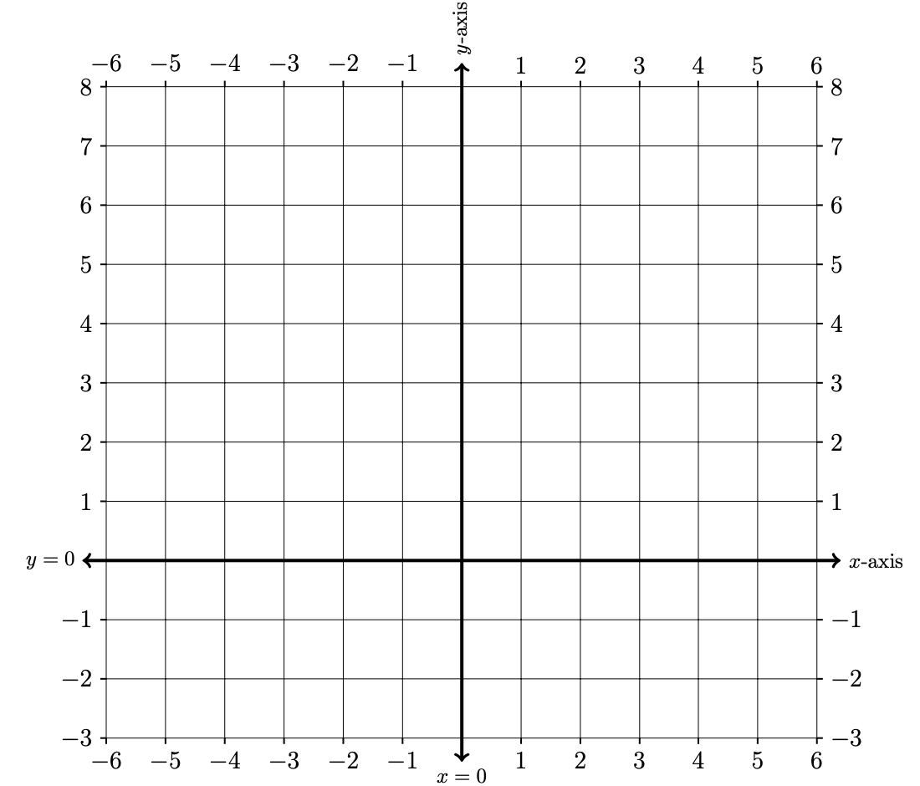
 | Left-hand side: | Right-hand side:
$$x$$
$$-4$$
$$-3$$
$$-2$$
$$-1$$
$$0$$
$$1$$
$$2$$
$$3$$
$$4$$
$$5$$

1B. Find all $x$-values such that: $\sqrt[2]{x+2}≥4-x$

2. AVERAGE RATES OF CHANGE ON A QUADRATIC FUNCTION

2A. Use the table and axes provided below to graph the quadratic function

$$f\left(x\right)={\left(x-3\right)}^{2}$$
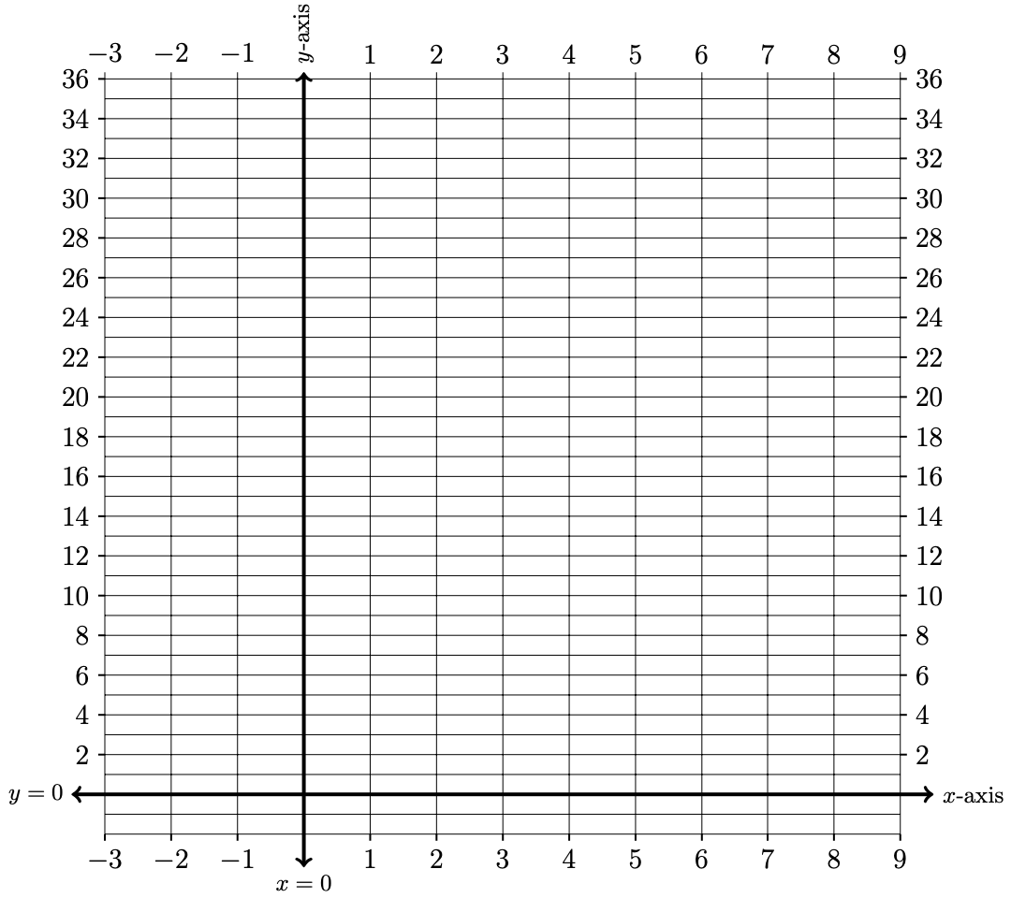
$$x$$ | $$f\left(x\right)$$
$$-4$$
$$-3$$
$$-2$$
$$-1$$
$$0$$
$$1$$
$$2$$
$$3$$
$$4$$
$$5$$
$$6$$
$$7$$
$$8$$
$$9$$

2B. Use the work you did in Problem 2A and re-draw your graph below.

2C. Draw a line between the two points on the graph $\left(1, f(1)\right)$ and $\left(3, f(3)\right)$.

2D. Find the slope of the line between points $\left(1, f(1)\right)$ and $\left(3, f(3)\right)$.

2E. Write your first draft of a definition for what it means to calculate an average rate of change of a function $y=f\left(x\right)$ between $x=a$ and $x=b$. Include:

Abuelita language: Use language that your abuelita can understand.

Nerdy language: Write this out using nerdy language. See if you can include formal mathematical symbols. This is the formal concept definition found in your textbook.

2F. Use the work you did in Problem 2A and re-draw your graph below.

2G. Draw a line between the two points on the graph $\left(4, f(4)\right)$ and $\left(7, f(7)\right)$.

2H. Calculate the average rate of change of function

$$f\left(x\right)={\left(x-3\right)}^{2}$$

between $x=4$ and $x=7$.

2I. Calculate the average rate of change of function

$$f\left(x\right)={\left(x-3\right)}^{2}$$

between $x=a$ and $x=a+h$.

3. AVERAGE RATES OF CHANGE ON A RADICAL FUNCTION

Calculate the average rate of change of function

$$f\left(x\right)=4+x-2\sqrt{ x+4 }$$

on the interval $\left[-3, 5\right].$ Make sure to create a table of values, graph the function, and describe how your answer relates to your graph.
$$x$$ | $$f\left(x\right)$$
$$-5$$
$$-4$$
$$-3$$
$$-2$$
$$-1$$
$$0$$
$$1$$
$$2$$
$$3$$
$$4$$
$$5$$
$$6$$

4. AVERAGE RATES OF CHANGE ON A QUADRATIC FUNCTION

Calculate the average rate of change of function

$$g\left(t\right)=t^{2}+3t+1$$

on the interval $\left[0, a\right]$ where parameter $a$ represents a real number. If you can, come up with a graphic representation for this algebra.

