Math 48A, Lesson 5: Analyze Graphs

Problem 0: Expand on our idea of what it means to learn math deeply.

0A. Take a look at our Math 48A Course Syllabus. Go to page 10 and find the section titled “What is a Concept Definition?” Starting with that section, read pages 10 – 12 (through the end of page 12) of our Math 48A course syllabus.

0B. In your own words, what is a concept definition? (See page 10 of syllabus)

0C. In your own words, what is a concept image? (See page 11 of syllabus)

0D. What are the seven different categories of ideas that we can use to think flexibly and creatively about mathematics (see page 12 of syllabus). Next to each category, write a sentence to describe that category in your own words.

1. SOLVE QUADRATIC EQUATIONS USING GRAPHS

1A. Look back on your work on problems 6A – 6C on Lesson 4 handout. Recall that we tried to solve the quadratic equation:

$$2x^{2}-8x-1=3-x$$

Create a table of values and graph the resulting curves on this axes below. Using that work, solve each of the following problems. For each problem, graph the solution interval on the axis provided. Make explicit connections between your solution and the graphs that you draw.

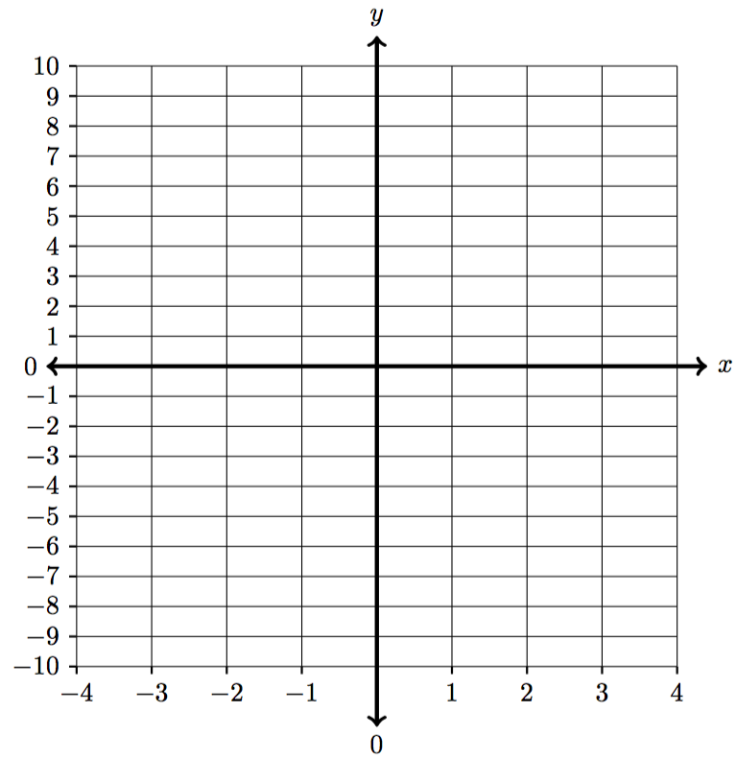
 | Left-hand side: | Right-hand side:
$$x$$
$$-2$$
$$-1$$
$$-0.5$$
$$0$$
$$1$$
$$2$$
$$3$$
$$4$$
$$5$$

1B. Find all $x$-values such that: $2x^{2}-8x-1 > 3-x$

1C. Find all $x$-values such that: $2x^{2}-8x-1 ≤ 3-x$

1D. Find all $x$-values such that: $2x^{2}-8x-1 < 3-x$

2. SOLVE ABSOLUTE VALUE EQUATION USING GRAPHS

Graphical Technique to solve an algebraic equation
To find the solution to algebraic equations using a graphical technique, we use the following five step program for salvation:
Step 1: Graph the function $y_{1}$ on the left-hand side of the equals sign.
Step 2: Graph the function $y_{2}$ on the right-hand side of the equals sign.
Step 3: Find the point(s) of intersection between the graphs of the two functions.
Step 4: Write each point of intersection as an ordered pair in the form: $(x, y)$
Step 5: Set the variable from the original algebraic equation equal to the 1st coordinate of each point of intersection. These “x”-values are the solution(s) to the algebraic equation.

2A. Consider the following equation : $2∙\left|x-2\right|-4=1-x$.

  - Identify and graph the function on the left-hand side of the equals sign:

  - Identify and graph the function on the right-hand side of the equals sign:

  - Find and label the points of intersection on the graph below. Make sure to write each point of intersection as an ordered pair in the form $\left(x, y\right).$

  - Identify the x – value for each point of intersection.

  - Identify the solution(s) to this equation:

 | Left-hand side: | Right-hand side:
$$x$$
$$-4$$
$$-3$$
$$-2$$
$$-1$$
$$0$$
$$1$$
$$2$$
$$3$$
$$4$$

2B. Use the table you drew in Problem 2A and re-draw your graph below. Then using this graph to for the x-values that satisfy the inequality:

$$2∙\left|x-2\right|-4>1-x$$

3. ANALYZE THE GRAPH OF A CUBIC POLYNOMIAL

$$x$$ | $$f\left(x\right)=x^{3}-2x^{2}-5x+6$$
$$-5$$
$$-4$$
$$-3$$
$$-2$$
$$-1$$
$$0$$
$$1$$
$$2$$
$$3$$
$$4$$
$$5$$
3A. Use any method you’d like to fill out the table of value and graph the cubic polynomial function:

$$f\left(x\right)=x^{3}-2x^{2}-5x+6$$

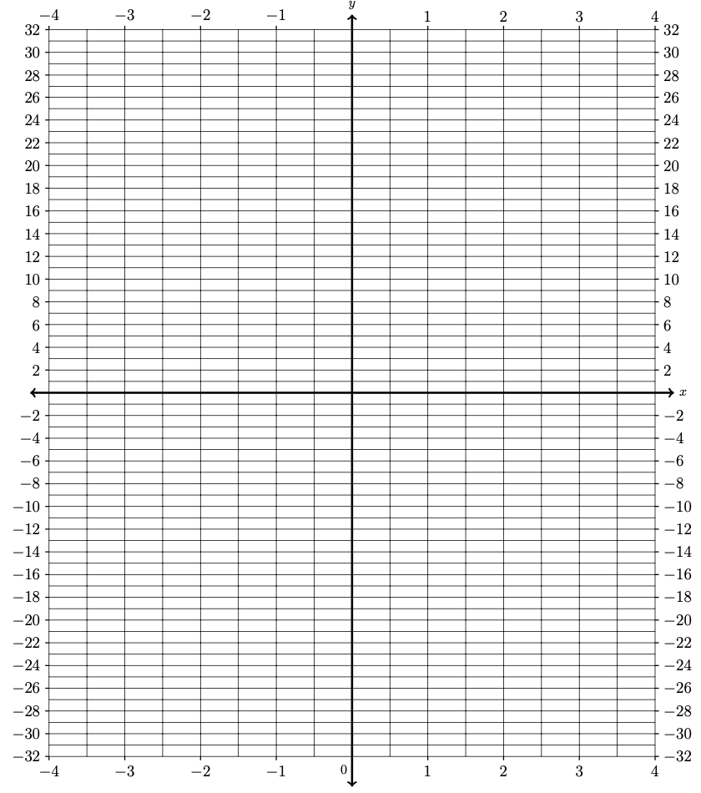

3B. Write your first draft of a definition for what it means for a function to be increasing.

Make sure to include:

First priority: A definition in your own language using street knowledge

Use abuelita language to describe the idea. In other words, use language that even your abuelita can understand.

Second priority: Write this out using nerdy language. See if you can include formal mathematical symbols. This is the formal concept definition found in your textbook.

3C. Where is the function $f\left(x\right)=x^{3}-2x^{2}-5x+6$ increasing? Why? Please specifically identify the location(s) on the graph below.

3D. Write your first draft of a definition for what it means for a function to be decreasing.

Make sure to include:

First priority: A definition in your own language using street knowledge

Use abuelita language to describe the idea. In other words, use language that even your abuelita can understand.

Second priority: Write this out using nerdy language. See if you can include formal mathematical symbols. This is the formal concept definition found in your textbook.

3E. Where is the function $f\left(x\right)=x^{3}-2x^{2}-5x+6$ decreasing? Why? Please specifically identify the location(s) on the graph below.

3F. Write your first draft of a definition for what it means for an output value $f\left(a\right)$ to be a local maximum value of a function $f\left(x\right)$.

Make sure to include:

First priority: A definition in your own language using street knowledge

Use abuelita language to describe the idea. In other words, use language that even your abuelita can understand.

Second priority: Write this out using nerdy language. See if you can include formal mathematical symbols. This is the formal concept definition found in your textbook.

3G. Where are the local maximum values of the function $f\left(x\right)=x^{3}-2x^{2}-5x+6$? Please specifically identify the location(s) on the graph below.

