Math 48A, Lesson 4: Read Graphs to Solve Equations

1. EVALUATE LINEAR FUNCTIONS

Recall our discussion of function notation:
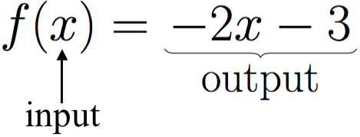

1. Let $f\left(x\right)=-2x-3$. Evaluate each of the following:

$f\left(-4\right)$, $f\left(-\frac{1}{2}\right)$, $f\left(\frac{1}{2}\right)$, and $f\left(4\right)$

Algebraic Technique to solve algebraic equations

To find the solution of an algebraic equation using an algebraic method, isolate the unknown variable by using inverse operations.

2. Solve the equation $-2x-3=\frac{1}{2}x+2$ using an algebraic technique. Show your steps. If possible, please solve this equation in more than one way.

Graphical Technique to solve algebraic equations

To find the solution(s) to an algebraic equation using a graphical technique, complete the five steps:

Step 1: Identify and graph the function on the left-hand side of the equals sign.
Step 2: Identify the function on the right-hand side of the equals sign and graph this function on the same axis you used in step 1.
Step 3: Find the point(s) of intersection between the graphs of the two functions.
Step 4: Write each point of intersection as an ordered pair in the form $( x , y )$. Then, identify the 1st coordinate (the “x” value) of the points of intersection.
Step 5: Set the variable from the equation equal to the 1st coordinate of each point of intersection. This represents the solution(s) to the algebraic equation.

3A. Complete the 5 steps outlined above to solve the equation $-2x-3=\frac{1}{2}x+2$ using a graphical technique.
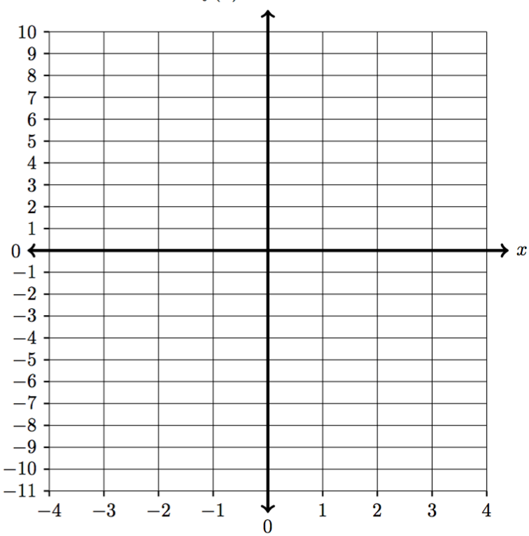

 | Left-hand side: | Right-hand side:
$$x$$ | $$y_{1}=-2x-3$$ | $y_{2}=\frac{1}{2}x+2$
$$-4$$
$$-3$$
$$-2$$
$$-1$$
$$0$$
$$1$$
$$2$$
$$3$$
$$4$$

3B. At what point do the two graphs in Problem 3A above intersect? Specifically identify this point on the graph and write it as an ordered pair below.

3C. What is the x-coordinate of the point of intersection you found in Problem 3B? In other words, what does x equal when the two lines cross in the graph you found in Problem 3A.

3D. What is the solution to the equation $-2x-3=\frac{1}{2}x+2$ that you found in Problem 2? How does that answer compare to your answer to problem 3C?

3E. Use the graph you drew in Problem 5A to solve the inequality: $-2x-3≤\frac{1}{2}x+2$

Algebraic Technique to solve algebraic equations

To find the solution of an algebraic equation using an algebraic method, isolate the unknown variable by using inverse operations.

4. Use an algebraic technique to solve the equation: $2∙\left(x-1\right)=4x+2$

Show your steps. If possible, please solve this equation in more than one way.

5A. Use a graphical technique to solve the equation:

$2∙\left(x-1\right)=4x+2$.

Make sure to demonstrate all five steps of this process. You are welcome to use your calculator.

Step 1: Identify and graph the function on the left-hand side of the equals sign.

Step 2: Identify the function on the right-hand side of the equals sign and graph this
function on the same axis you used in step 1.

Step 3: Find the point(s) of intersection between the graphs of the two functions.

Step 4: Write each point of intersection as an ordered pair in the form $( x , y )$.

Step 5: Set the variable from the equation equal to the 1st coordinate of each point of intersection. Your final solution should be in the form $\text{variable}= \text{number}$

Please specifically identify each point of intersection on your graph. Also, please write each of these points as an ordered pair with an x-coordinate and y-coordinate. Use this information to find a solution to this algebraic equation.

 | Left-hand side: | Right-hand side:
$$x$$
$$-4$$
$$-3$$
$$-2$$
$$-1$$
$$0$$
$$1$$
$$2$$
$$3$$
$$4$$
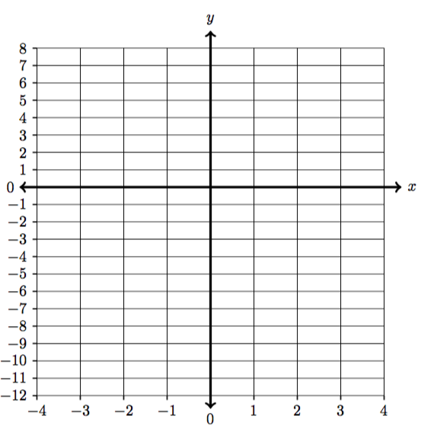

5B. At what point do the two graphs in Problem 5A above intersect? Specifically identify this point on the graph and write it as an ordered pair below.

5C. What is the x-coordinate of the point of intersection you found in Problem 5B? In other words, what does x equal when the two lines cross in the graph you found in Problem 5A.

5D. What is the solution to the equation $2∙\left(x-1\right)=4x+2$ that you found in Problem 4? How does that answer compare to your answer to problem 5C?

5E. Use the graph you drew in Problem 5A to solve the inequality: $2∙\left(x-1\right)>4x+2$

Graphical Technique to solve an algebraic equation
To find the solution to algebraic equations using a graphical technique, we use the following five step program for salvation:
Step 1: Graph the function $y_{1}$ on the left-hand side of the equals sign.
Step 2: Graph the function $y_{2}$ on the right-hand side of the equals sign.
Step 3: Find the point(s) of intersection between the graphs of the two functions.
Step 4: Write each point of intersection as an ordered pair in the form: $(x, y)$
Step 5: Set the variable from the original algebraic equation equal to the 1st coordinate of each point of intersection. These “x”-values are the solution(s) to the algebraic equation.

6A. Consider the equation $2x^{2}-8x-1=3-x$.

  - Identify and graph the function on the left-hand side of the equals sign:

  - Identify and graph the function on the right hand side of the equals sign:

  - Find and label the points of intersection on the graph below. Make sure to write each point of intersection as an ordered pair in the form $\left(x, y\right).$

  - Identify the x – value for each point of intersection.

  - Identify the solution(s) to this equation:

 | Left-hand side: | 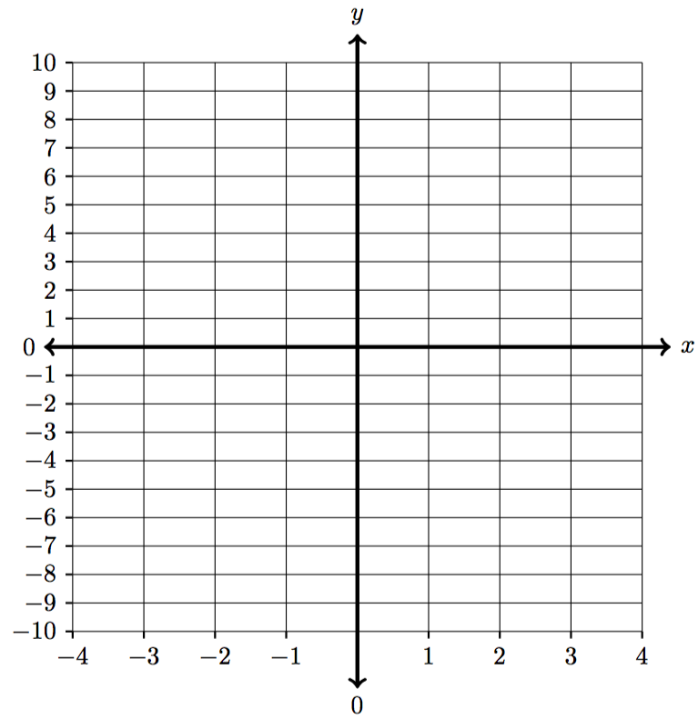  Right-hand side:
$$x$$
$$-2$$
$$-1$$
$$-0.5$$
$$0$$
$$1$$
$$2$$
$$3$$
$$4$$
$$5$$

6B. Use the graph you drew in Problem 6A to solve the inequality: $2x^{2}-8x-1≥3-x$

7A. Consider the equation $2x^{2}+5x-4=8$.

- Identify and graph the function on the left-hand side of the equals sign:

- Identify and graph the function on the right hand side of the equals sign:

  - Find and label the points of intersection on the graph below. Make sure to write each point of intersection as an ordered pair in the form $\left(x, y\right).$

- Identify the x – value for each point of intersection.

- Identify the solution(s) to this equation:

 | Left-hand side: | Right-hand side:
$$x$$
$$-5$$
$$-4$$
$$-3$$
$$-2$$
$$-1$$
$$0$$
$$1$$
$$1.5$$
$$2$$

7B. Use the graph you drew in Problem 7A to solve the inequality: $2x^{2}+5x-4<8$

8. In your own words, summarize some of the main ideas, techniques, and skills you learned in this handout.

