Math 48A, Lesson 3: Graph More Popular Functions

5. GRAPH CUBIC FUNCTION (TYPE OF POWER FUNCTION)
Consider the quadratic function
$$f(x)=x^{3}$$
Fill out the table below. Then use that table to graph the quadratic function.
- Fill in the table below
- Plot these points on the axis provided
- Interpolate between the points you plotted to create the graph of this function
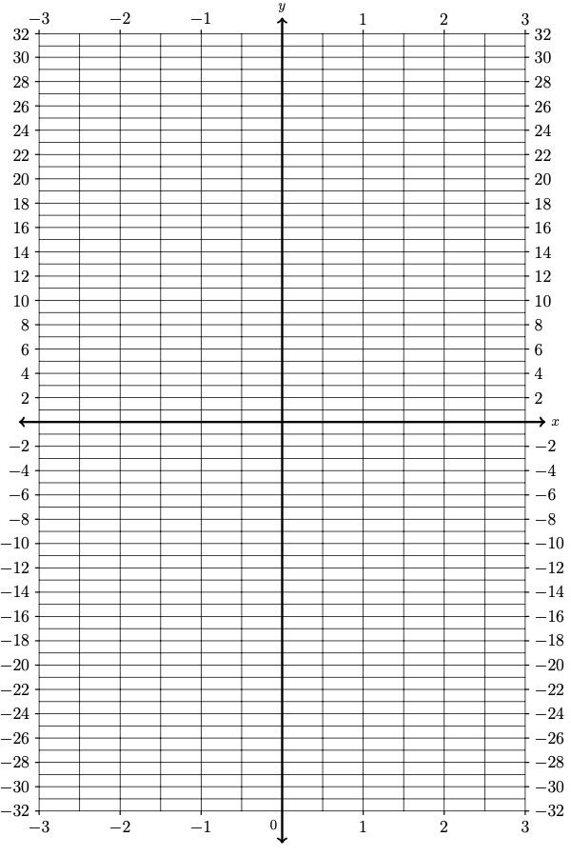

Input | Output values
$$x$$ | $$f(x)=x^{3}$$
$$-4$$
$$-3$$
$$-2$$
$$-1$$
$$-\frac{1}{ 2 }$$
$$0$$
$$\frac{1}{ 2 }$$
$$1$$
$$2$$
$$3$$
$$4$$

5D. What is the x–intercept of the cubic function $f(x)=x^{3}$?
(Write about how the x-intercept shows up in your graph from parts 5A – 5C).

5E. What is the y–intercept of the cubic function $f(x)=x^{3}$?
(Write about how the y-intercept shows up in your graph from parts 5A – 5C).

5F. What is the domain of the cubic function $f(x)=x^{3}$ ?
(Write about how the domain shows up in your graph from parts 5A – 5C).

5G. What is the range of the cubic function $f(x)=x^{3}$ ?
(Write about how the range shows up in your graph from parts 5A – 5C).

5H. What does the graph of the cubic function $f(x)=x^{3}$ look like?

6. RATIONAL FUNCTION
Consider the absolute value function
$$f\left(x\right) = \frac{1}{ x }$$

Fill out the table below. Then use that table to graph the absolute value function.
- Fill in the table below
- Plot these points on the axis provided
- Interpolate between the points you plotted to create the graph of this function
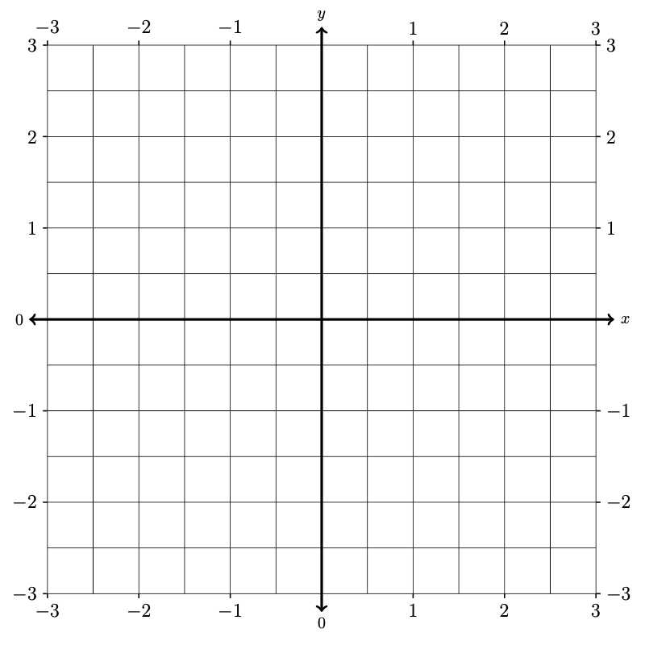
Input | Output
$$x$$ | $$f\left(x\right)=\frac{1}{ x }$$
$$-3$$ | .
$$-2$$
$$-1$$
$$-\frac{1}{ 2 }$$
$$-\frac{1}{ 3 }$$
$$0$$
$$\frac{1}{ 3 }$$
$$\frac{1}{ 2 }$$
$$1$$
$$2$$
$$3$$

6D. What is the x–intercept of the rational function $f\left(x\right)=\frac{1}{ x }$ ?
(Write about how the x-intercept shows up in your graph from parts 6A – 6C).

6E. What is the y–intercept of the rational function $f\left(x\right)=\frac{1}{ x }$ ?
(Write about how the y-intercept shows up in your graph from parts 6A – 6C).

6F. What is the domain of the rational function $f\left(x\right)=\frac{1}{ x }$ ?
(Write about how the domain shows up in your graph from parts 6A – 6C).

6G. What is the range of the rational function $f\left(x\right)=\frac{1}{ x }$ ?
(Write about how the range shows up in your graph from parts 6A – 6C).

6H. What does the graph of $f\left(x\right)=\frac{1}{ x }$ look like?

7. RATIONAL FUNCTION
Consider the absolute value function
$$f\left(x\right) = \frac{1}{ x^{2} }$$

Fill out the table below. Then use that table to graph the absolute value function.
- Fill in the table below
- Plot these points on the axis provided
- Interpolate between the points you plotted to create the graph of this function

Input | Output
$$x$$ | $$f\left(x\right)=\frac{1}{ x^{2} }$$
$$-3$$ | .
$$-2$$
$$-1$$
$$-\frac{1}{ 2 }$$
$$-\frac{1}{ 4 }$$
$$0$$
$$\frac{1}{ 3 }$$
$$\frac{1}{ 2 }$$
$$1$$
$$2$$
$$3$$
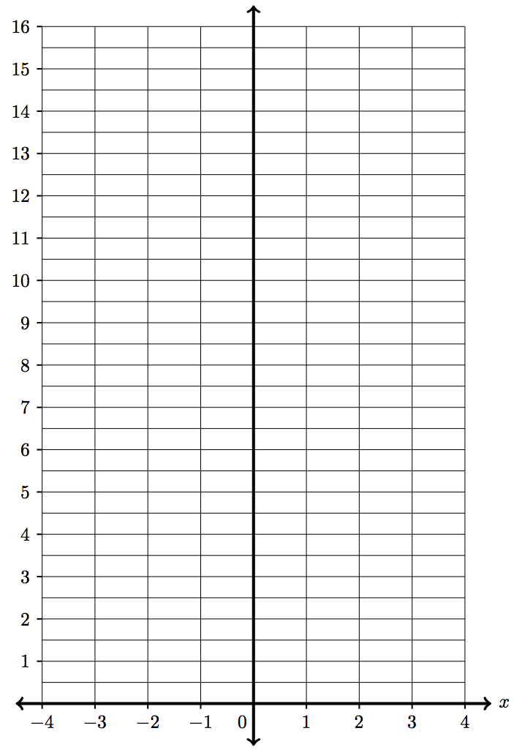

7D. What is the x–intercept of the rational function $f\left(x\right)=\frac{1}{ x^{2} }$ ?
(Write about how the x-intercept shows up in your graph from parts 7A – 7C).

7E. What is the y–intercept of the rational function $f\left(x\right)=\frac{1}{ x^{2} }$ ?
(Write about how the y-intercept shows up in your graph from parts 7A – 7C).

7F. What is the domain of the rational function $f\left(x\right)=\frac{1}{ x^{2} }$ ?
(Write about how the domain shows up in your graph from parts 7A – 7C).

7G. What is the range of the rational function $f\left(x\right)=\frac{1}{ x^{2} }$ ?
(Write about how the range shows up in your graph from parts 7A – 7C).

7H. What does the graph of $f\left(x\right)=\frac{1}{ x^{2} }$ look like?

8. EXPONENTIAL FUNCTION
Consider the quadratic function
$$f(x)=2^{x}$$
Fill out the table below. Then use that table to graph the quadratic function.
- Fill in the table below
- Plot these points on the axis provided
- Interpolate between the points you plotted to create the graph of this function
$$x$$ | $$f(x)=2^{x}$$
$$-4$$
$$-3$$
$$-2$$
$$-1$$
$$0$$
$$1$$
$$2$$
$$3$$
$$4$$
$$5$$
$$6$$
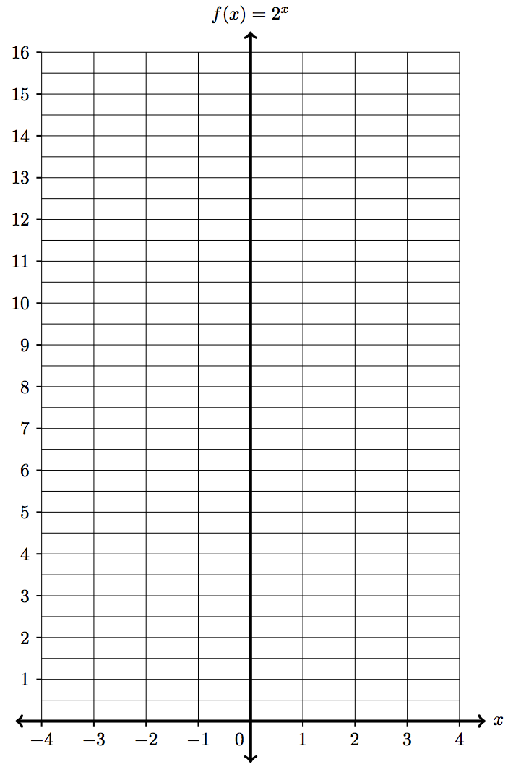

8D. What is the x–intercept of the exponential function $f(x)=2^{x}$ ?
(Write about how the x-intercept shows up in your graph from parts 8A – 8C).

8E. What is the y–intercept of the exponential function $f(x)=2^{x}$ ?
(Write about how the y-intercept shows up in your graph from parts 8A – 8C).

8F. Why does the graph of $f(x)=2^{x}$ never go below the x-axis?

8G. What is the domain of the exponential function $f(x)=2^{x}$ ?
(Write about how the domain shows up in your graph from parts 8A – 8C).

8H. What is the range of the exponential function $f(x)=2^{x}$ ?
(Write about how the range shows up in your graph from parts 8A – 8C).

8H. What does the graph of the exponential function $f(x)=2^{x}$ look like?

9. LOGARITHMIC FUNCTION
Consider the quadratic function
$$f(x)=\log_{2}{(x)}$$
Fill out the table below. Then use that table to graph the quadratic function.
- Fill in the table below
- Plot these points on the axis provided
- Interpolate between the points you plotted to create the graph of this function
$$x$$ | $$f(x)=\log_{2}{(x)}$$
$$\frac{1}{16}$$
$$\frac{1}{8}$$
$$\frac{1}{4}$$
$$\frac{1}{2}$$
$$1$$
$$2$$
$$4$$
$$8$$
$$16$$
$$32$$
$$64$$

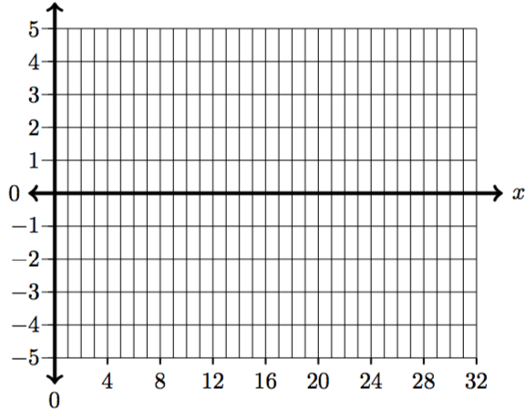

9D. What is the x–intercept of the logarithm function $f(x)=\log_{2}{(x)}$ ?
(Write about how the x-intercept shows up in your graph from parts 9A – 9C).

9E. What is the y–intercept of the logarithm function $f(x)=\log_{2}{(x)}$ ?
(Write about how the y-intercept shows up in your graph from parts 9A – 9C).

9G. What is the domain of the logarithm function $f(x)=\log_{2}{(x)}$ ?
(Write about how the domain shows up in your graph from parts 9A – 9C).

9H. What is the range of the logarithm function $f(x)=\log_{2}{(x)}$ ?
(Write about how the range shows up in your graph from parts 9A – 9C).

9H. What does the graph of the $f(x)=\log_{2}{(x)}$ look like?

