Math 48A, Lesson 2: Graphs Popular Functions

1. GRAPH LINEAR FUNCTION (TYPE OF POWER FUNCTION)
Consider the linear function
$$f\left(x\right)=-1-\frac{5}{2}x$$

Fill out the table below. Then use that table to graph the given linear function.
- Fill in the table below
- Plot these points on the axis provided
- Interpolate between the points you plotted to create the graph of this function
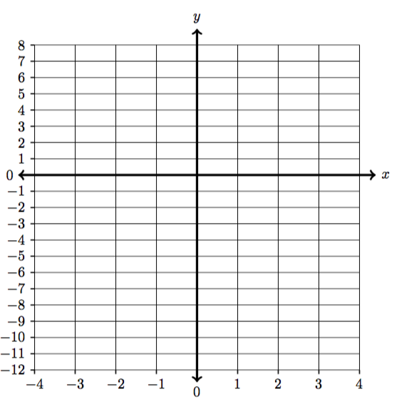
Input | Output values
$$x$$ | $$f\left(x\right)=-1-\frac{5}{2}x$$
$$-4$$
$$-3$$
$$-2$$
$$-1$$
$$0$$
$$1$$
$$2$$
$$3$$
$$4$$

1D. What is the slope of the line $f\left(x\right)=-1-\frac{5}{2}x$ ?
(Write more about how the slope shows up in your graph from parts 1A – 1C).

1E. What is the x–intercept of the line $f\left(x\right)=-1-\frac{5}{2}x$ ?
(Write about how the x-intercept shows up in your graph from parts 1A – 1C).

1E. What is the y–intercept of the line $f\left(x\right)=-1-\frac{5}{2}x$ ?
(Write about how the y-intercept shows up in your graph from parts 1A – 1C).

1G. What is the domain of the line $f\left(x\right)=-1-\frac{5}{2}x$ ?
(Write about how the domain shows up in your graph from parts 1A – 1C).

1H. What is the range of the line $f\left(x\right)=-1-\frac{5}{2}x$ ?
(Write about how the range shows up in your graph from parts 1A – 1C).

2. ABSOLUTE VALUE FUNCTIONS
Consider the absolute value function
$$f\left(x\right)=\left| x \right|$$

Fill out the table below. Then use that table to graph the absolute value function.

- Fill in the table below
- Plot these points on the axis provided
- Interpolate between the points you plotted to create the graph of this function

Input | Output
$$x$$ | $$f\left(x\right)=\left| x \right|$$
$$-5$$
$$-4$$
$$-3$$
$$-2$$
$$-1$$
$$0$$
$$1$$
$$2$$
$$3$$
$$4$$
$$5$$
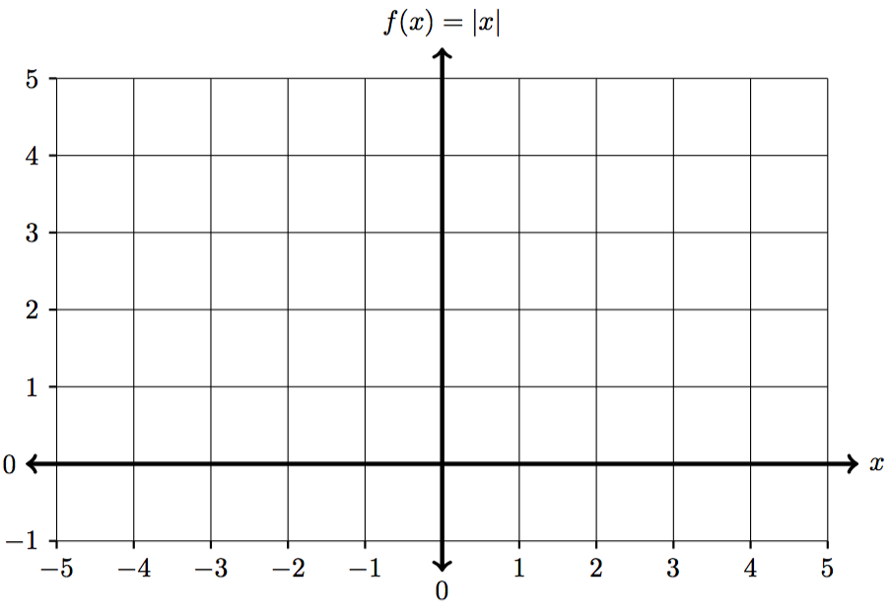

2D. What is the x–intercept of the absolute value function $f\left(x\right)=\left| x \right|$?
(Write about how the x-intercept shows up in your graph from parts 2A – 2C).

2E. What is the y–intercept of the absolute value function $f\left(x\right)=\left| x \right|$?
(Write about how the y-intercept shows up in your graph from parts 2A – 2C).

2F. Why does the graph of $f\left(x\right)=\left| x \right|$ never go below the x-axis?

2G. What is the domain of the absolute value function $f\left(x\right)=\left| x \right|$?
(Write about how the domain shows up in your graph from parts 2A – 2C).

2H. What is the range of the absolute value function $f\left(x\right)=\left| x \right|$?
(Write about how the range shows up in your graph from parts 2A – 2C).

3. QUADRATIC FUNCTIONS TYPE OF POWER FUNCTION
Consider the quadratic function
$$f(x)=x^{2}$$

Fill out the table below. Then use that table to graph the quadratic function.

- Fill in the table below
- Plot these points on the axis provided
- Interpolate between the points you plotted to create the graph of this function

Input | Output
$$x$$ | $$f(x)=x^{2}$$
$$-5$$
$$-4$$
$$-3$$
$$-2$$
$$-1$$
$$0$$
$$1$$
$$2$$
$$3$$
$$4$$
$$5$$
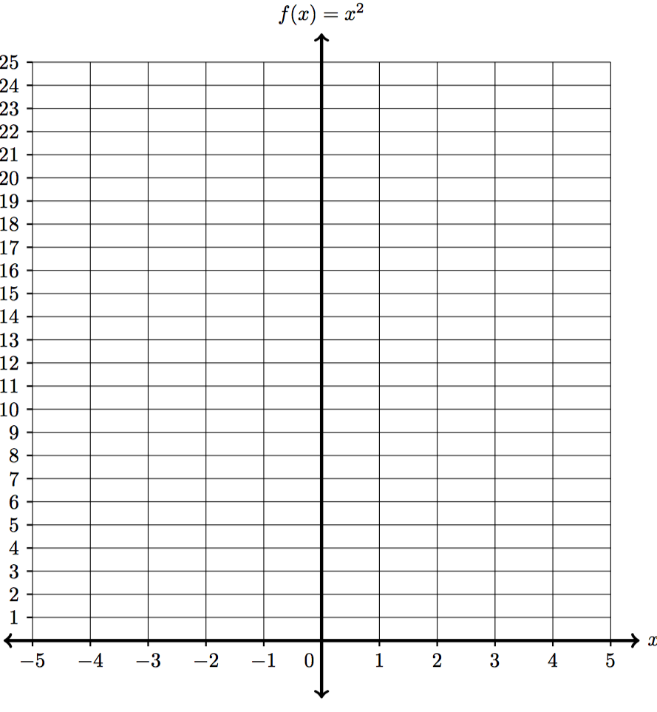

3D. What is the x–intercept of the quadratic function $f(x)=x^{2}$?
(Write about how the x-intercept shows up in your graph from parts 3A – 3C).

3E. What is the y–intercept of the quadratic function $f(x)=x^{2}$?
(Write about how the y-intercept shows up in your graph from parts 3A – 3C).

3F. Why does the graph of $f(x)=x^{2}$ never go below the x-axis?

3G. What is the domain of the quadratic function $f(x)=x^{2}$?
(Write about how the domain shows up in your graph from parts 3A – 3C).

3H. What is the range of the quadratic function $f(x)=x^{2}$?
(Write about how the range shows up in your graph from parts 3A – 3C).

4. SQUARE ROOT FUNCTION TYPE OF ROOT FUNCTION
Consider the absolute value function
$$f(x)=\sqrt[2]{ x }$$

Fill out the table below. Then use that table to graph the quadratic function.

- Fill in the table below
- Plot these points on the axis provided
- Interpolate between the points you plotted to create the graph of this function

Input | Output
$$x$$ | $$f(x)=\sqrt[2]{ x }$$
$$-1$$
$$0$$
$$1$$
$$4$$
$$9$$
$$16$$
$$25$$
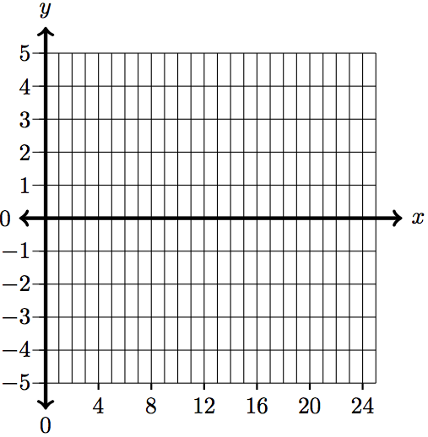

4D. What is the x–intercept of the square root function $f(x)=\sqrt[2]{ x }$?
(Write about how the x-intercept shows up in your graph from parts 4A – 4C).

4E. What is the y–intercept of the square root function $f(x)=\sqrt[2]{ x }$?
(Write about how the y-intercept shows up in your graph from parts 4A – 4C).

4F. Why does the graph of $f(x)=\sqrt[2]{ x }$ never go below the x-axis?

4G. What is the domain of the square root function $f(x)=\sqrt[2]{ x }$?
(Write about how the domain shows up in your graph from parts 3A – 3C).

4H. What is the range of the square root function $f(x)=\sqrt[2]{ x }$?
(Write about how the range shows up in your graph from parts 4A – 4C).

