Math 48A, Lesson 16: Quadratic Functions

1. Make Connections between the Two Forms of a Quadratic Function

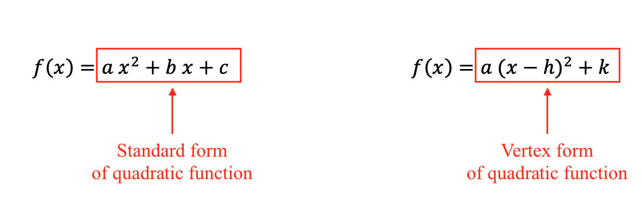
Consider the two forms for a quadratic function:
Look back on our Lesson 15 handout. Write equations for the values of $h$, and $k$ in terms of the values of $a$, $b$, and $c$. Write two different algebraic approaches you can use to discover this connection.

2. Practice Identifying the Two Forms of a Quadratic Function
Write each of functions below in BOTH standard and vertex form. In other words, specifically identify the values of $a$, $b$, and $c$ as well as the values of $a$, $h$, and $k$.

2A. $f\left(x\right)=5 x^{2}-30 x+49$ 2D. $j(x)=2 x^{2}+4 x-6$

2B. $g\left(x\right)=-x^{2}+x-2$ 2E. $k(x)=-2 x^{2}+12 x-16$

2C. $h\left(x\right)=4-x^{2}$

3. Graphical Interpretation of Vertex Form
3A. Consider the standard form for a quadratic function:

$$j\left(x\right)=2 x^{2}+4 x-6$$

Sketch a graph of this function on the axis below.
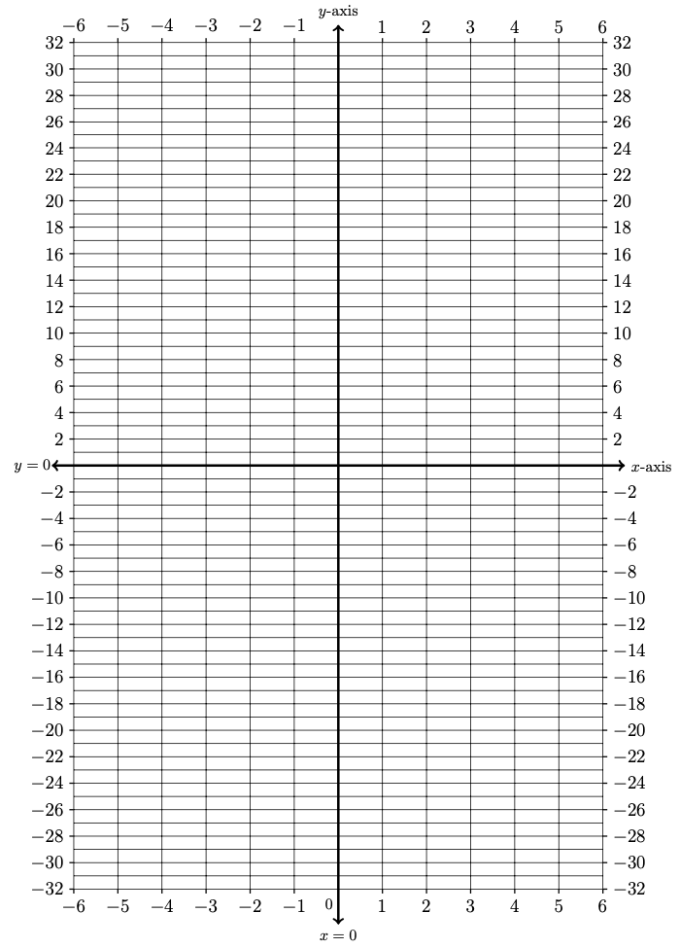
Input | Output
$$x$$ | $$j(x)$$
$$-6$$
$$-5$$
$$-4$$
$$-3$$
$$-2$$
$$-1$$
$$0$$
$$1$$
$$2$$
$$3$$
$$4$$
$$5$$
$$6$$

3B. Express $j\left(x\right)=2 x^{2}+4 x-6$ in vertex form.

3C. What is the minimum value of our function? What is the range of $j\left(x\right)$?

3D. What connections do you see between the vertex form of our function

$$j\left(x\right)=2 x^{2}+4 x-6$$

and the corresponding graph of the parabola that you created in problem 3A.

4. Graphical Interpretation of Vertex Form
4A. Consider the standard form for a quadratic function:

$$k(x)=-2 x^{2}+12 x-16$$

Sketch a graph of this function on the axis below.
Input | Output
$$x$$ | $$k(x)$$
$$-6$$
$$-5$$
$$-4$$
$$-3$$
$$-2$$
$$-1$$
$$0$$
$$1$$
$$2$$
$$3$$
$$4$$
$$5$$
$$6$$

4B. Express $k\left(x\right)=-2 x^{2}+12 x-16$ in vertex form.

4C. What is the minimum value of our function? What is the range of $k\left(x\right)$?

4D. What connections do you see between the vertex form of our function

$$k(x)=-2 x^{2}+12 x-16$$

and the corresponding graph of the parabola that you created in problem 4A.

5. Use Vertex Form to Find Maximum or Minimum Values
Take a look at the image below.
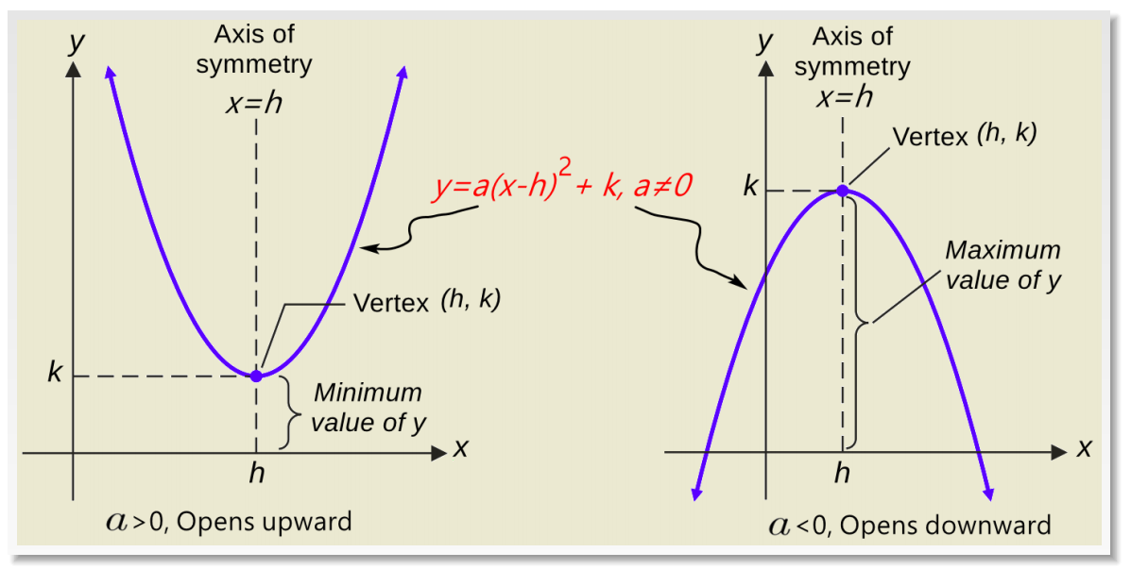

Image Source: https://www.targetmathematics.com/2020/06/g10-chap5-quadratic-functions-exercise-52.html

For each parabola that you see, explain using simple abuelita language what this image is saying. Make connections between the image that you see here and the work you did on Problems 1 – 4 in this Lesson 16 worksheet.

6. Formula for Maximum or Minimum Values
Look back at the work you did on Problems 1 and 2 of this Lesson 16 handout. Come up with a general formula to find the minimum or maximum value of a quadratic function in the form

$$f\left(x\right)=a x^{2}+b x+c$$

7. Use Your Formula for Maximum or Minimum Values
Use the formula you generated in Problem 6 above to find the minimum or maximum value for each of the quadratic functions below. Be sure you can explain your steps. Do your best to make connections between the max/min values you find in this problem and the vertex forms for these quadratic functions you found in Problem 2 from this Lesson 16 handout.

7A. $f\left(x\right)=5 x^{2}-30 x+49$

7B. $g\left(x\right)=-x^{2}+x-2$

7C. $h\left(x\right)=4-x^{2}$

