Math 48A, Lesson 15: Quadratic Functions

1. Find the Standard Form of a Quadratic Function
Consider the standard form for a quadratic function:

$$f\left(x\right)=a x^{2}+b x+c$$

Put each of functions below in standard form. In other words, specifically identify the values of $a$, $b$, and $c$.

1A. $f\left(x\right)=5 x^{2}-30 x+49$ 1D. $j\left(w\right)=-5+3w$

1B. $g\left(x\right)=-x^{2}+x-2$ 1E. k$\left(t\right)=t^{2}+4t$

1C. $h\left(y\right)=4-y^{2}$

2. Explore the Standard Form of a Quadratic Function
Consider the standard form for a quadratic function:

$$f\left(x\right)=a x^{2}+b x+c$$

Using simple language, identify the role of each individual part of this function. Do your best to come up with descriptions for each of the following: $x$, $x^{2}$, $a$, $b$, and $c$.

3. Explore the anatomy of perfect-square trinomials
Expand each of the following perfect squares and write as a trinomial in the form
$x^{2}+b x+c$.
Show your steps and specifically identify values for coefficients$b$ and $c$. The first one is done for you.

3A. ${\left(x-4\right)}^{2}$

Let’s consider the perfect square ${\left(x-4\right)}^{2}$ :

${\left(x-4\right)}^{2}$ $= \left(x-4\right)∙(x-4)$

$= x∙\left(x-4\right)-4∙(x-4)$

$= x^{2}-4x-4x+16$

$= x^{2}-8x+16$ $b= -8, c=16$

3B. ${\left(x+3\right)}^{2}$

3C. ${\left(x+11\right)}^{2}$

3D. ${\left(x-\frac{7}{2}\right)}^{2}$

4. For each of the problems above, write the equivalent expressions in the form

$${\left(x+d\right)}^{2}= x^{2}+bx+c$$

Then, specifically identify the values of the coefficients $d, b$ and $c$. The first one is done for you.

4A. ${\left(x-4\right)}^{2}$

We notice from our work on problem 3A above that we have:

${\left(x-4\right)}^{2}$ $= x^{2}-8x+16$ $d= -4, b= -8, c=16$

4B. ${\left(x+3\right)}^{2}$

4C. ${\left(x+11\right)}^{2}$

4D. ${\left(x-\frac{7}{2}\right)}^{2}$

5. Look back on the work you finished in problem 4 above. What pattern do you notice? Specifically, how are the coefficients $d, b$ and $c$ related to each other? Make a conjecture about how this will work in general.

6. Your definition of a perfect square trinomial

We say that a perfect-square trinomial is a three-term expression that can be factored as a perfect square. We’ve seen this in our work in problems 1 – 5. Below is a diagram that shows the connection:
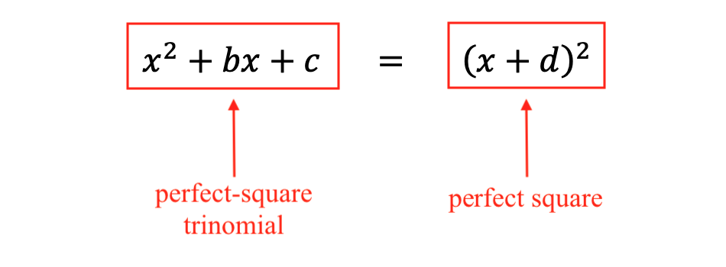

Come up with your own description for a perfect-square trinomial. Use simple, abuelita language and make this as clear as you can for yourself.

7. LEARN TO COMPLETE THE SQUARE
Consider each incomplete expression below. Add a constant to make the expression a perfect-square trinomial. Then write the factored form of the expression as a perfect square. Identify each step you take in the solution. Please make sure you can explain to yourself why you are taking each step.

7A. $x^{2}+10x$

7B. $t^{2}-7t$

7C. $x^{2}-\frac{11}{2}x$

7D. $m^{2}+\frac{5}{4}m$

7E. $5 x^{2}-30 x$

8. GENERATE THE VERTEX FORM FOR A QUADRATIC FUNCTION
Use the method of completing the square (from problems 1 – 7) to transform the quadratic function in standard form into an expression that contains a perfect square

8A. $f\left(x\right)=5x^{2}+8x+3$ 8B. $f\left(x\right)= ax^{2}+bx+c$

