Math 48A, Lesson 14: More About Inverse Functions

1. Identifying when the backward problem is a function

Look back at your work on Lesson 13, Problems 4 – 7. In your own words, describe the differences between the backward problem from Problem 5 and the backward problem from Problem 7. Which of these backward problems represents a function? Try to make connections between the graphs you drew and the idea of the vertical line test.

2. CONDITIONS FOR EXISTENCE OF INVERSE FUNCTION

Consider a general function:

$$f\left(x\right)=y$$

Using the patterns you uncovered in your work on problem 1, please write your ideas about the following questions:

2A. When can we describe the backward problem using a function?
2B. When is the backward problem a relation and NOT a function (i.e. when does
the graph of the backward problem fail the vertical line test).

3. ONE-TO-ONE FUNCTIONS AND THE HORIZONTAL LINE TEST

3A. Take a look at the definition and the corresponding image given below
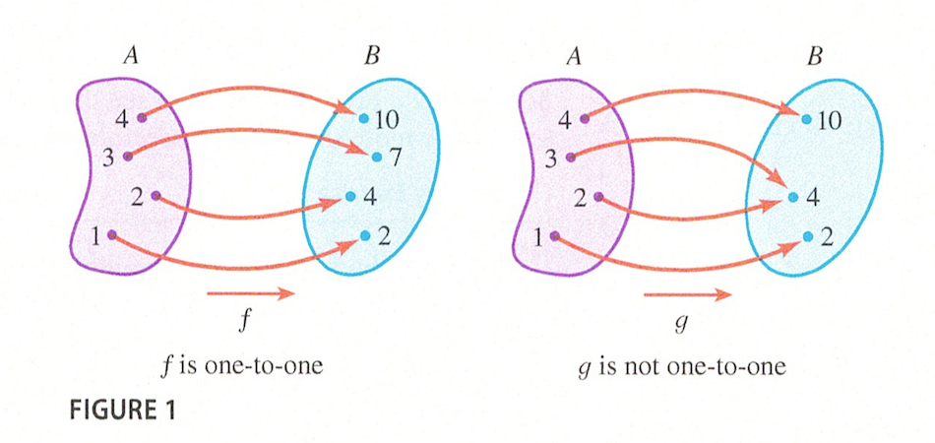
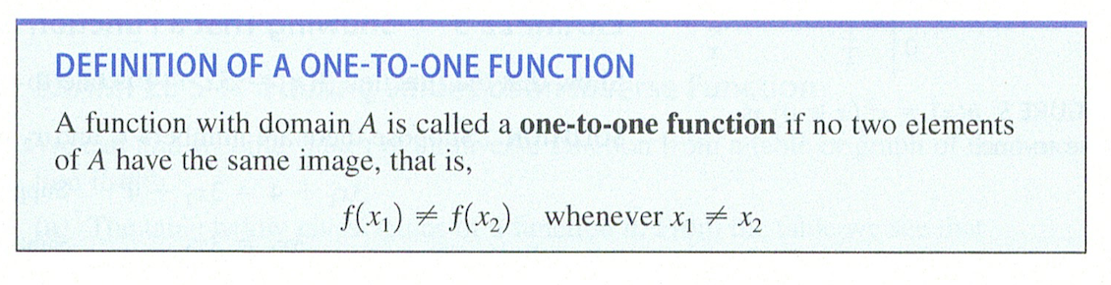

Create your own definition of what it means for a function to be one-to-one. Do your best to use abuelita language to capture this idea. Also, make explicit connections to the figure 1 above.

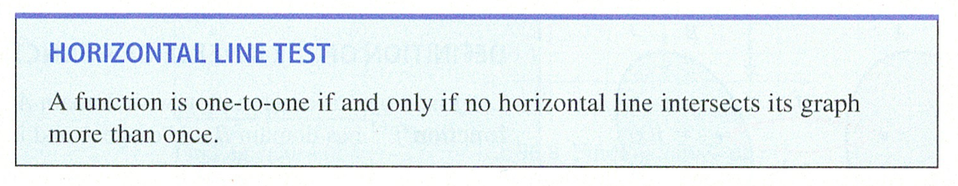
3B. Take a look at the statement of the horizontal line test below.

Now look back at your work from Lesson 13, Problems 4 – 7 and your work on Lesson 14, Problems 1 – 3A. Explain what the horizontal line test is designed to do. How is this Horizontal Line Test related to inverse functions? How is the horizontal line test related to the vertical line test?

3C. Identifying One-to-One Functions

Which of the following are graphs of one-to-one functions?

___ one-to-one function ___ one-to-one function

___ not a one-to-one function ___ not a one-to-one function

___ one-to-one function ___ one-to-one function

___ not a one-to-one function ___ not a one-to-one function

4. DEFINITION OF INVERSE FUNCTIONS

Take a look at the definition and the image below:
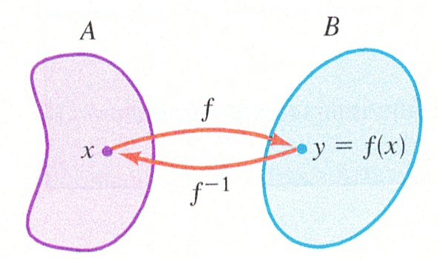

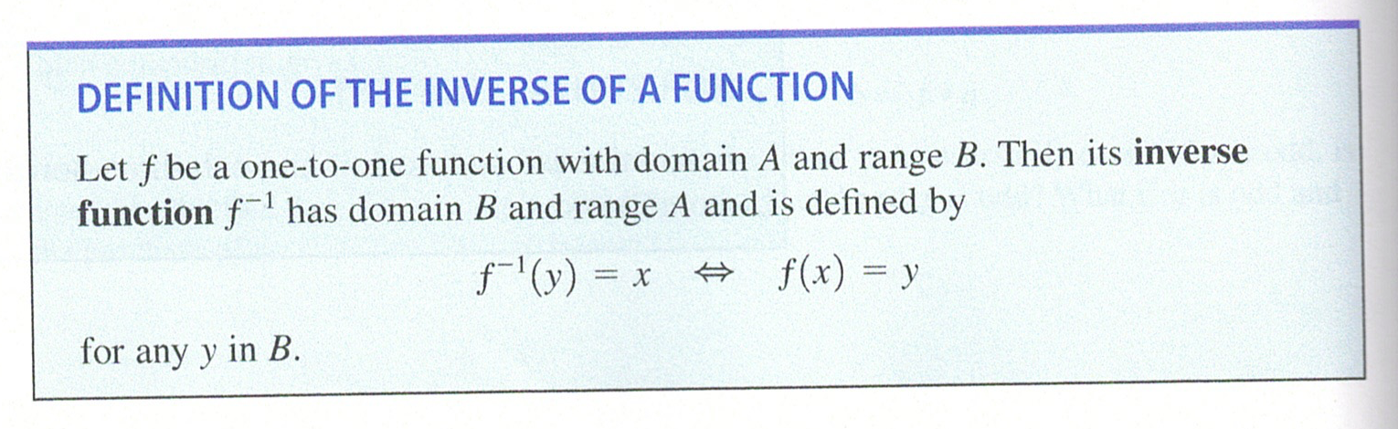

Translate this definition and image into your own, simple language. Explain what an inverse function is and how this relates to forward and backward problems.

5. FIND INVERSE FUNCTIONS

Use algebra to find the inverse of the following function.

5A. $f\left(x\right)= 5x+2$

5B. $f\left(x\right)= \frac{4x-2}{3x+1}$

5C. $f\left(x\right)= \frac{x^{5}-3}{2}$

