Math 48A, Lesson 13: Inverse Functions

1. MORE PRACTICE COMBINING FUNCTIONS
Consider the following functions

$f\left(x\right)=x-3$ and $g\left(x\right)=x^{2}-9$

Please find each of the following:

1A. $(g-f)(x)$ 1B. ($f÷g)(x)$

1C. $f∘g\left(x\right)=f(g\left(x\right))$ 1D. $g∘f\left(x\right)=g(f\left(x\right))$

Show your work and simplify whenever you can.

2. EXAMPLES OF FORWARD AND BACKWARD PROBLEMS

For each function below, consider solve each of the pairs of problems. As you solve each problem, specifically identify:

- What is the input and what is the output?
- What are the known values?
- What are the unknown values?
- How many solutions are there?
- How are the forward and backward problems related?

FUNCTION | FORWARD PROBLEM | BACKWARD PROBLEM
$$f\left(x\right)=5+x$$ | $$5 + 7=y$$ | $$5 + x=12$$
$$g\left(x\right)=4 ∙x$$ | $$4 ∙ 5=y$$ | $$4 ∙ x=20$$
$$h\left(x\right)=x^{2}$$ | $$9^{2}=y$$ | $$x^{2}=81$$
$$j\left(x\right)=x^{3}$$ | $${(-3)}^{3}=y$$ | $$x^{3}=-27$$
$$k\left(x\right)=\left|x\right|$$ | $$\left|-5\right|=y$$ | $$\left|x\right|=5$$
$$m\left(x\right)=2^{x}$$ | $$2^{6}=y$$ | $$2^{x}=64$$

3. WHAT ARE FORWARD AND BACKWARD PROBLEMS

Look back at your work in problem 1 above. Consider a general function:

$$f\left(x\right)=y$$

Using the patterns you uncovered in your work on problem 1, please write your ideas about the following questions:

3A. What is a forward problem?
3B. What is a backward problem?
3C. How are forward and backward problems related?

4. VISUALIZE A FORWARD PROBLEMS USING A GRAPH
4A. Consider the function
$$f\left(x\right)=2^{x}=y$$

Fill out the table below to graph the forward problem for this function.
$$x$$ | $$f(x)=2^{x}$$
$$-4$$
$$-3$$
$$-2$$
$$-1$$
$$0$$
$$1$$
$$2$$
$$3$$
$$4$$
$$5$$
$$6$$
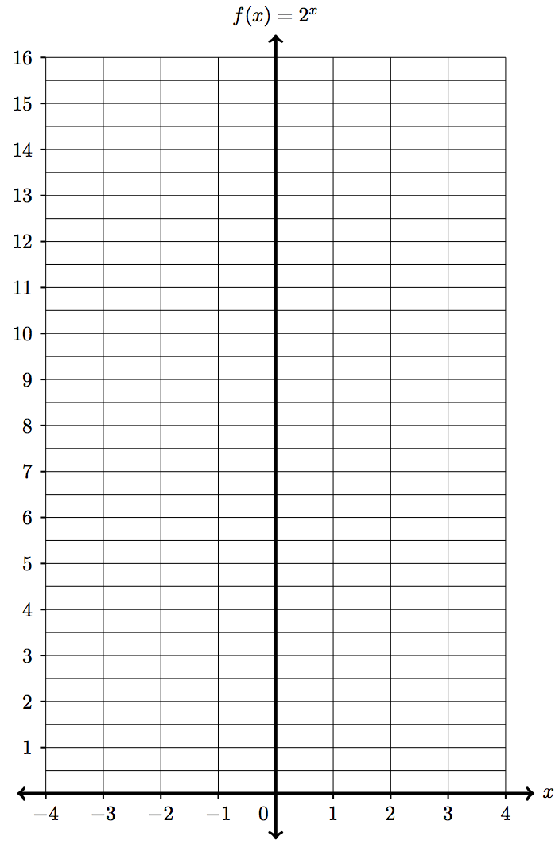

4B. In your own, simple language, explain why the work you did in Problem 4A represents a forward problem.

4C. Look back at Problem 4A. Make a conjecture (a mathematical guess) about
what the backward problem for the function $f\left(x\right)=2^{x}=y$ would look like. Write the symbols and verbal description so that you describe this using both words and mathematical notation.
5. VISUALIZE A BACKWARD PROBLEMS USING A GRAPH
5A. Consider the function
$$f\left(x\right)=2^{x}=y$$

Fill out the table below to graph the backward problem for this function.

$$y=2^{x}$$ | $$x$$
$$\frac{1}{ 16 }$$
$$\frac{1}{ 8 }$$
$$\frac{1}{ 4 }$$
$$\frac{1}{ 2 }$$
$$1$$
$$2$$
$$4$$
$$8$$
$$16$$
$$32$$
$$64$$
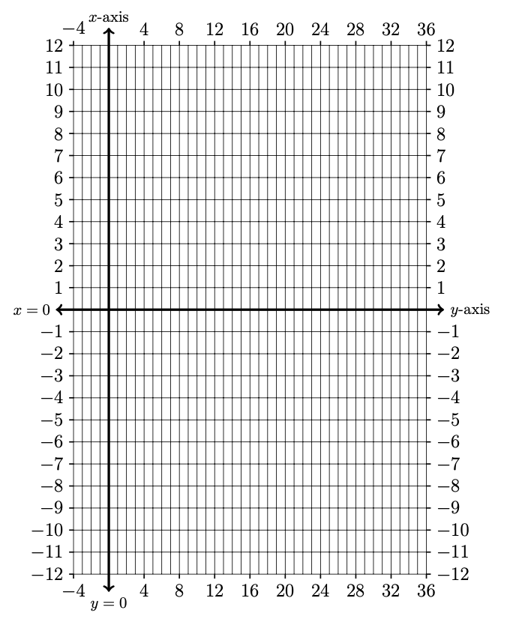

5B. In your own, simple language, explain why the work you did in Problem 5A represents a backward problem.

5C. Look back at Problem 4 and 5. What is the relationship between the forward and backward problems for the function $f\left(x\right)=2^{x}=y$. Write your response in both symbols and verbal description so that you describe this using both words and mathematical notation.

6. VISUALIZE A FORWARD PROBLEMS USING A GRAPH
6A. Consider the following function

$$f\left(x\right)=x^{2}=y$$

Create a table of values and graph the resulting curve on these axes below.

Input | Output
$$x$$ | $$y$$
$$-5$$
$$-4$$
$$-3$$
$$-2$$
$$-1$$
$$0$$
$$1$$
$$2$$
$$3$$
$$4$$
$$5$$
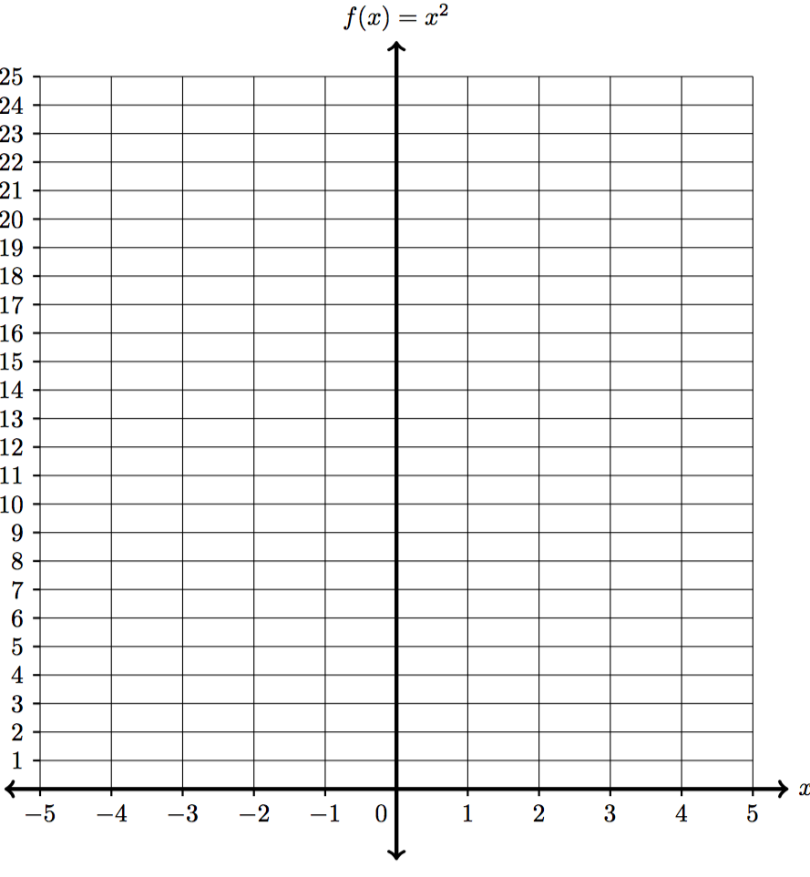
6B. In your own, simple language, explain why the work you did in Problem 6A represents a forward problem.

6C. Look back at Problem 6A. Make a conjecture (a mathematical guess) about
what the backward problem for the function $f\left(x\right)=x^{2}=y$ would look like. Write the symbols and verbal description so that you describe this using both words and mathematical notation.

7. VISUALIZE A BACKWARD PROBLEMS USING A GRAPH
7A. Consider the function
$$f\left(x\right)=x^{2}=y$$

Fill out the table below to graph the backward problem for this function.

$$y=x^{2}$$ | $$x$$
$$-1$$
$$0$$
$$1$$
$$4$$
$$9$$
$$16$$
$$25$$
$$36$$
$$49$$
$$64$$
$$81$$

7B. In your own, simple language, explain why the work you did in Problem 7A represents a backward problem.

7C. Look back at Problem 6 and 7. What is the relationship between the forward and backward problems for the function $f\left(x\right)=x^{2}=y$. Write your response in both symbols and verbal description so that you describe this using both words and mathematical notation.

