Math 48A, Lesson 12: Combining of Functions

1. COMPOSITION OF FUNCTIONS
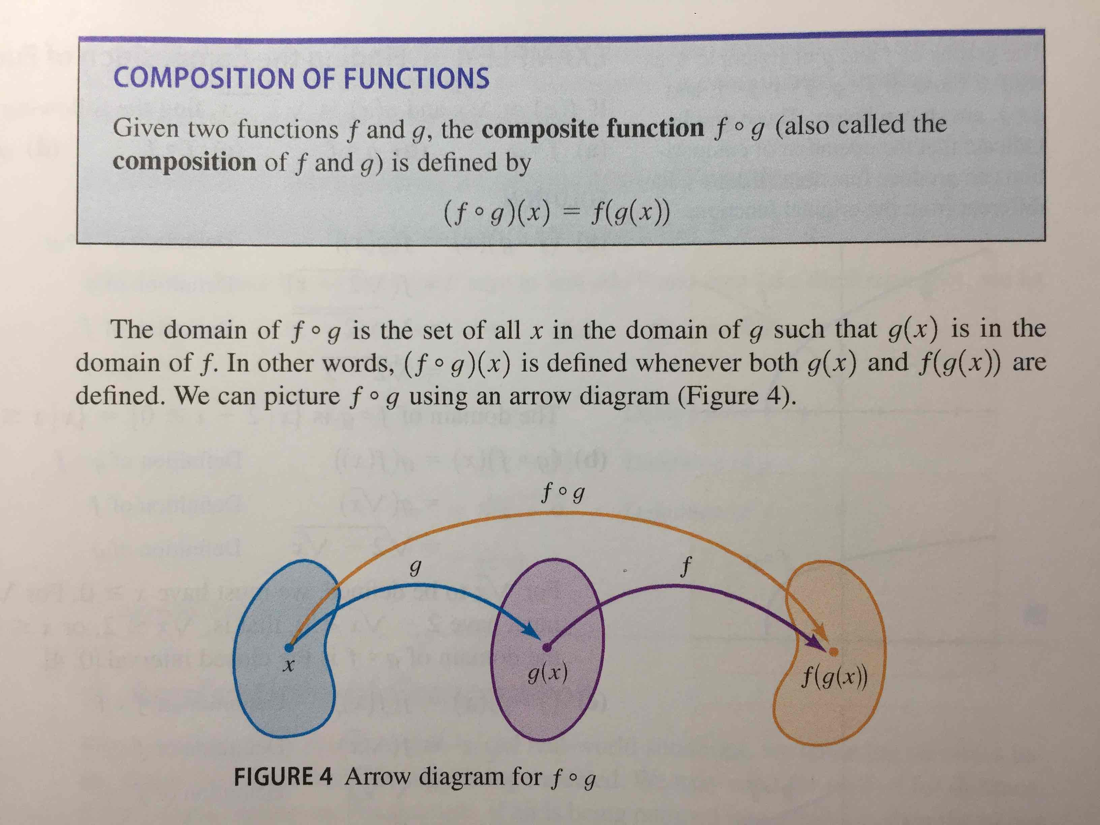

1A. Please translate this into abuelita language. In other words, translate this idea into language that your grandmother (abuelita) can understand.
1B. Consider the following functions

$f\left(x\right)=\sqrt{ x }$ and $g\left(x\right)=x^{2}+1$

We’re going to study composition of functions in the form

$$f∘g\left(x\right)=f(g\left(x\right))$$

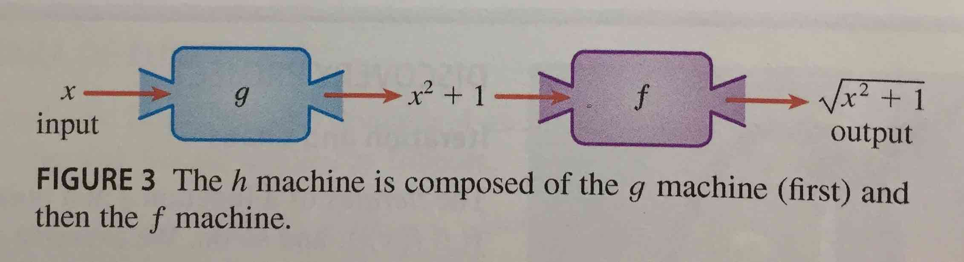
2. COMPOSITIONS OF FUNCTIONS
Consider the following functions

$f\left(x\right)=x^{2}$ and $g\left(x\right)=x+3$

Find each of the following functions:

2A. $f∘g\left(x\right)=f(g\left(x\right))$ 2B. $g∘f\left(x\right)=g(f\left(x\right))$

3. SUM AND DIFFERENCE OF FUNCTIONS
3A. Consider the following functions

$f\left(x\right)=\left|x\right|$ , $g\left(x\right)=-x$, $h\left(x\right)=\left(f+g\right)\left(x\right)= f\left(x\right)+g(x)$

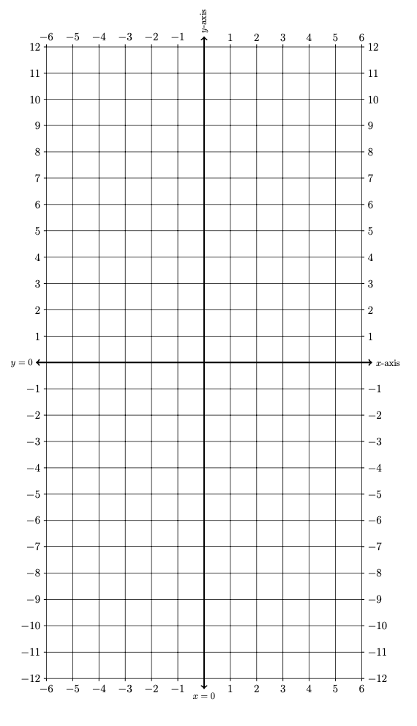
Create a table of values and graph the resulting parabolas on these axes below.

Input | Output
$$x$$ | $$f(x)$$ | $$g(x)$$ | $$h(x)$$
$$-6$$
$$-5$$
$$-4$$
$$-3$$
$$-2$$
$$-1$$
$$0$$
$$1$$
$$2$$
$$3$$
$$4$$
$$5$$
$$6$$
3B. Consider the following functions

$f\left(x\right)=x^{2}$ , $g\left(x\right)=3x+4$, $h\left(x\right)=\left(f-g\right)\left(x\right)= f\left(x\right)-g(x)$

Create a table of values and graph the resulting parabolas on these axes below.
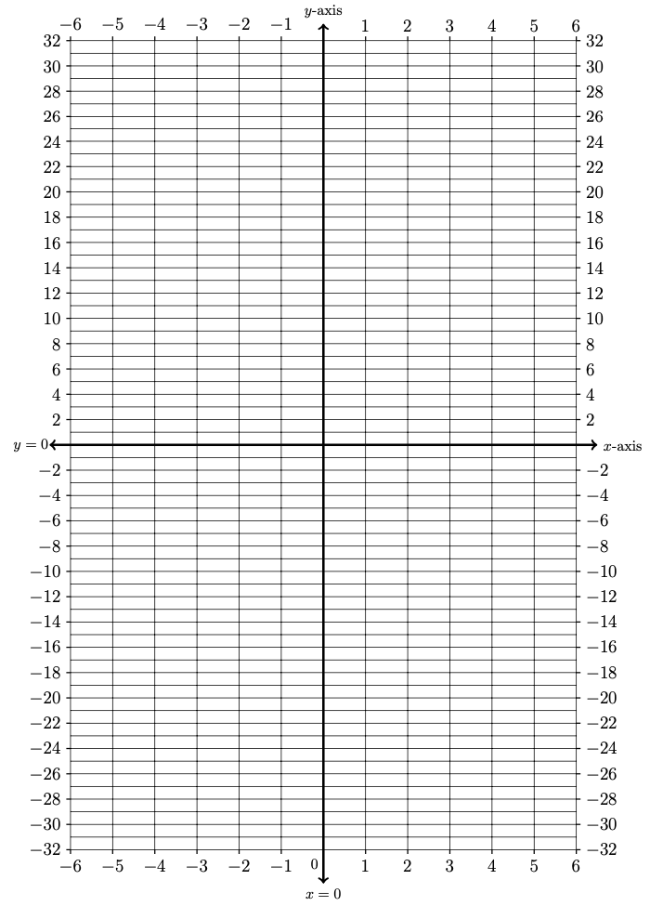
Input | Output
$$x$$ | $$f(x)$$ | $$g(x)$$ | $$h(x)$$
$$-6$$
$$-5$$
$$-4$$
$$-3$$
$$-2$$
$$-1$$
$$0$$
$$1$$
$$2$$
$$3$$
$$4$$
$$5$$
$$6$$

4. PRODUCT AND QUOTIENT OF FUNCTIONS
4A. Consider the following functions

$f\left(x\right)=x^{2}$ , $g\left(x\right)=x^{2}+1$, $h\left(x\right)=\left(f÷g\right)\left(x\right)= \frac{f\left(x\right)}{ g\left(x\right) }$

Create a table of values and graph the resulting curves on these axes below. Use Desmos.com to confirm your results

Input | Output
$$x$$ | $$f(x)$$ | $$g(x)$$ | $$h(x)$$
$$-6$$
$$-5$$
$$-4$$
$$-3$$
$$-2$$
$$-1$$
$$0$$
$$1$$
$$2$$
$$3$$
$$4$$
$$5$$
$$6$$
4B. Consider the following functions

$f\left(x\right)=\left|x-4\right|$ , $g\left(x\right)=x-4$, $h\left(x\right)=\left(f÷g\right)\left(x\right)= \frac{f\left(x\right)}{ g\left(x\right) }$

Create a table of values and graph the resulting curves on these axes below. Use Desmos.com to confirm your results

Input | Output
$$x$$ | $$f(x)$$ | $$g(x)$$ | $$h(x)$$
$$-6$$
$$-5$$
$$-4$$
$$-3$$
$$-2$$
$$-1$$
$$0$$
$$1$$
$$2$$
$$3$$
$$4$$
$$5$$
$$6$$

4C. Consider the following functions

$f\left(x\right)=x^{2}-4$ , $g\left(x\right)=x$, $h\left(x\right)=\left(f∙g\right)\left(x\right)= f(x)∙g(x)$

Create a table of values and graph the resulting curves on these axes below. Use Desmos.com to confirm your results
Input | Output
$$x$$ | $$f(x)$$ | $$g(x)$$ | $$h(x)$$
$$-6$$
$$-5$$
$$-4$$
$$-3$$
$$-2$$
$$-1$$
$$0$$
$$1$$
$$2$$
$$3$$
$$4$$
$$5$$
$$6$$

5. PRACTICE COMBINING FUNCTIONS
Consider the following functions

$f\left(x\right)=x-1$ and $g\left(x\right)=x^{2}-1$

Please find each of the following:

5A. $(f+g)(x)$ 5B. $(f-g)(x)$
5C. $(f∙g)(x)$ 5D. ($f÷g)(x)$

5E. $f∘g\left(x\right)=f(g\left(x\right))$ 5F. $g∘f\left(x\right)=g(f\left(x\right))$

Show your work and simplify whenever you can.

6. MORE PRACTICE COMBINING FUNCTIONS
Below are graphs of functions $f(x)$ and $g(x)$.

$f(x)$ $g(x)$

Use the graphs above to evaluate each of the following.

6A. $f(g\left(1\right))$ 6B. $\left(g∘f\right)\left(2\right)$

6C. $\left(f+g\right)\left(-1\right)$ 6D. $\left(\frac{f}{g}\right)\left(0\right)$

7. PRACTICE WITH TRANSFORMATIONS
Below is a graph of a function $f\left(x\right)$
Using the work you did on Lessons 10 and 11, complete each of the following problems. Make your best educated guesses using your brain first. Then confirm your guesses using Desmos.com

7A. Sketch a graph of $2f\left(-x\right)$.
7B. Sketch a graph of $3-f\left(x+2\right)$.

