Math 48A, Lesson 11: Transformations of Functions (Part 2)

1. COMBINE HORIZONTAL AND VERTICAL SHIFTS
1A. Consider the following quadratic functions

$f\left(x\right)=x^{2}$ , $g\left(x\right)=f\left(x-3\right)+4$, $h\left(x\right)=f\left(x+2\right)-12$

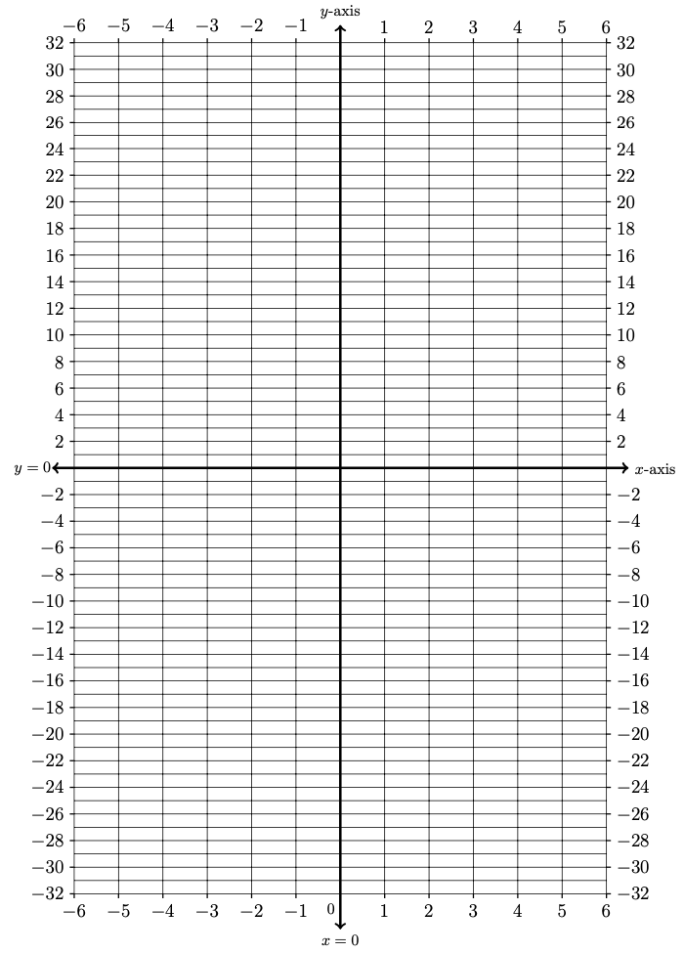
Create a table of values and graph the resulting parabolas on these axes below.

Input | Output
$$x$$ | $$f(x)$$ | $$g(x)$$ | $$h(x)$$
$$-6$$
$$-5$$
$$-4$$
$$-3$$
$$-2$$
$$-1$$
$$0$$
$$1$$
$$2$$
$$3$$
$$4$$
$$5$$
$$6$$

1B. Make a conjecture (a mathematical guess) about what happens in the following scenario:

Assume we have a function $f\left(x\right)$ and constants $h,k>0$.
Suppose we define functions

$$g\left(x\right)=f\left(x-h\right)+k$$

What is the relationship between $f\left(x\right)$ and $g\left(x\right)$? What happens if constant $h$ is positive or negative? What happens if constant $k$ is positive or negative?

2. REFLECTING GRAPHS ABOUT THE X-AXIS
2A. Let’s consider how to “reflect” the graph of a function about the $x-$axis. To do so, consider the following functions

$f\left(x\right)=\left|x\right|$ and $g\left(x\right)=-f\left(x\right)$.

Create a table of values and graph the resulting curves on these axes below.

Input | Output
$$x$$ | $$f(x)$$ | $$g(x)$$
$$-6$$
$$-5$$
$$-4$$
$$-3$$
$$-2$$
$$-1$$
$$0$$
$$1$$
$$2$$
$$3$$
$$4$$
$$5$$
$$6$$
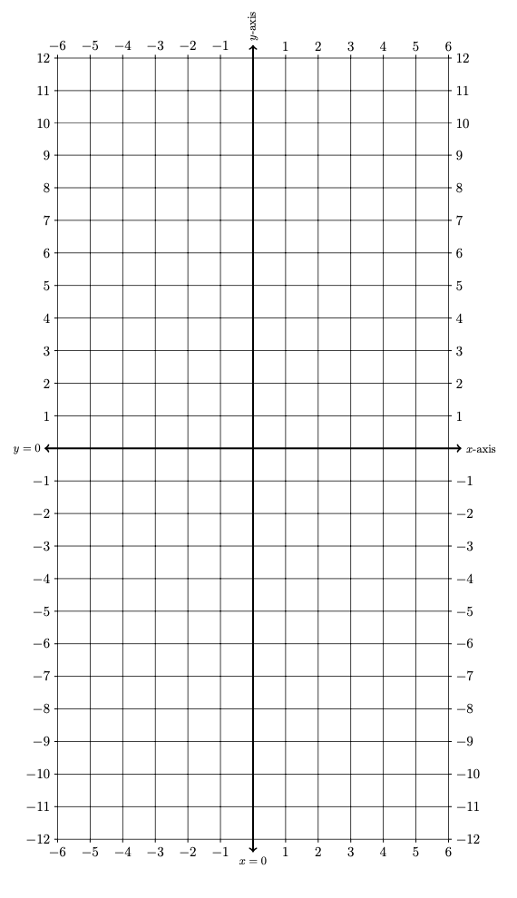

2B. Let’s consider how to “reflect” the graph of a function about the $x-$axis. To do so, consider the following functions

$f\left(x\right)=x^{2}$ and $g\left(x\right)=-f\left(x\right)$.

Create a table of values and graph the resulting curves on these axes below.
Input | Output
$$x$$ | $$f(x)$$ | $$g(x)$$
$$-6$$
$$-5$$
$$-4$$
$$-3$$
$$-2$$
$$-1$$
$$0$$
$$1$$
$$2$$
$$3$$
$$4$$
$$5$$
$$6$$

2C. Suppose we have a function $f\left(x\right)$ and we define a new function $g\left(x\right)=-f\left(x\right)$. Based on your work in Problems 2A and 2B, make a conjecture about the relationship between the graphs of $f\left(x\right)$ and $g\left(x\right)$. Explain why you think your conjecture might be true.

3. REFLECTION ABOUT VERTICAL AXIS

Consider the following shifts of the input variable
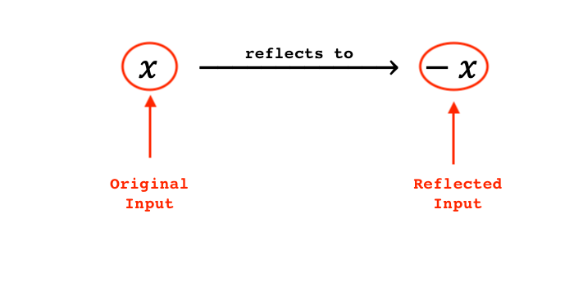

Draw the effect of this shift on the real number line ($x-$axis) below:

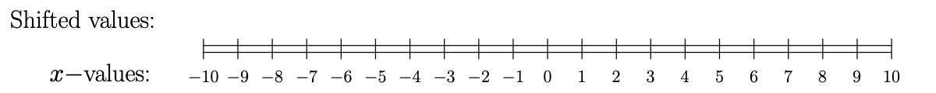

What do you notice about the reflexed input $-x$ versus the original input $x$?
4. REFLECTING GRAPHS ABOUT THE Y-AXIS
4A. Let’s consider how to “reflect” the graph of a function about the $x-$axis. To do so, consider the following functions

$f\left(x\right)=\sqrt{ x }$ and $g\left(x\right)=f\left(-x\right)$.

Create a table of values and graph the resulting curves using Desmos.com

4B. Let’s consider how to “reflect” the graph of a function about the $x-$axis. To do so, consider the following functions

$f\left(x\right)=x^{3}$ and $g\left(x\right)=f\left(-x\right)$.

Create a table of values and graph the resulting curves using Desmos.com

4C. Suppose we have a function $f\left(x\right)$ and we define a new function $g\left(x\right)=f\left(-x\right)$. Based on your work in Problems 4A and 4B, make a conjecture about the relationship between the graphs of $f\left(x\right)$ and $g\left(x\right)$. Explain why you think your conjecture might be true.

