Math 48A, Lesson 10: Transformations of Functions (Part 1)

1. VERTICAL SHIFTS OF A QUADRATIC FUNCTION
1A. Consider the following quadratic functions

$f\left(x\right)=x^{2}$ , $g\left(x\right)=f\left(x\right)+6$, $h\left(x\right)=f\left(x\right)-10$

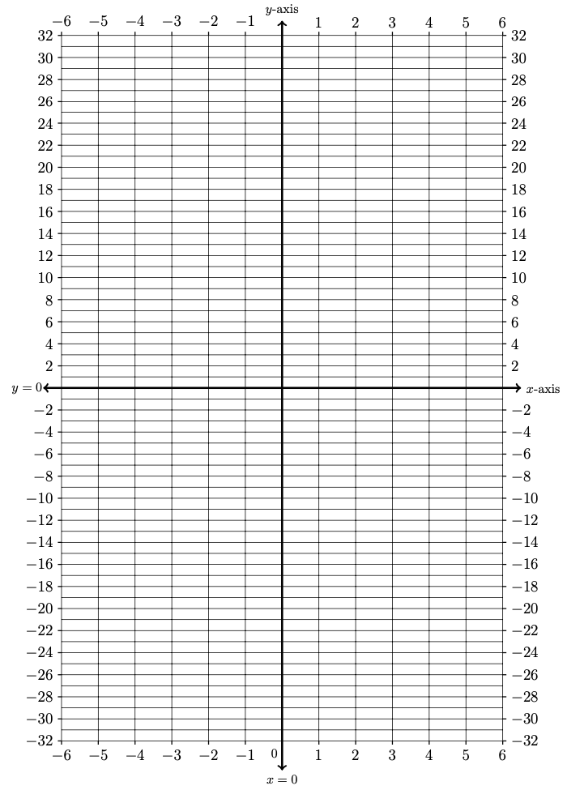
Create a table of values and graph the resulting parabolas on these axes below.

Input | Output
$$x$$ | $$f(x)$$ | $$g(x)$$ | $$h(x)$$
$$-6$$
$$-5$$
$$-4$$
$$-3$$
$$-2$$
$$-1$$
$$0$$
$$1$$
$$2$$
$$3$$
$$4$$
$$5$$
$$6$$

1B. Look back at both the graphs and the table of values from Problem 1A.
What do you notice about the relationship between the output values of the functions

$f\left(x\right)$, $g\left(x\right)=f\left(x\right)+6$, and $h\left(x\right)=f\left(x\right)-10$

1C. Make a conjecture (a mathematical guess) about what happens in the following scenario:

Assume we have a function $f\left(x\right)$ and a positive constant $c>0$.
Suppose we define functions

$g\left(x\right)=f\left(x\right)+c$ and $h\left(x\right)=f\left(x\right)-c$

What is the relationship between $f\left(x\right)$, $g\left(x\right)$, and $h\left(x\right)$?

2. VERTICAL SHIFTS OF AN ABSOLUTE VALUE FUNCTION
2A. Let’s test your conjecture from Problem 1C on a different type of function. Consider the following absolute value functions

$f\left(x\right)=\left|x\right|$ , $g\left(x\right)=f\left(x\right)+3$, $h\left(x\right)=f\left(x\right)-9$

For each function, specifically identify the value of positive constant $c>0$. Then, create a table of values and graph the resulting curves on these axes below
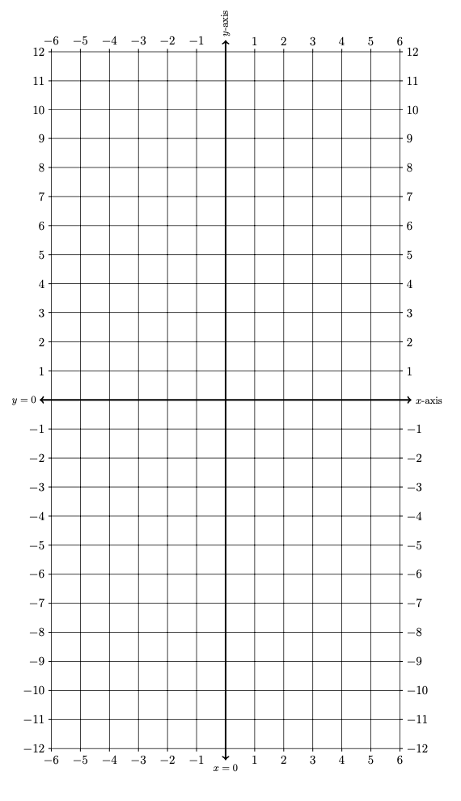
Input | Output
$$x$$ | $$f(x)$$ | $$g(x)$$ | $$h(x)$$
$$-6$$
$$-5$$
$$-4$$
$$-3$$
$$-2$$
$$-1$$
$$0$$
$$1$$
$$2$$
$$3$$
$$4$$
$$5$$
$$6$$
2B. Look back at both the graphs and the table of values from Problem 2A.
What do you notice about the relationship between the output values of the functions

$f\left(x\right)$ , $g\left(x\right)=f\left(x\right)+3$, $h\left(x\right)=f\left(x\right)-10$

2C. Revise and update your conjecture (a mathematical guess) about what happens in the following scenario:

Assume we have a function $f\left(x\right)$ and a positive constant $c>0$.
Suppose we define functions

$g\left(x\right)=f\left(x\right)+c$ and $h\left(x\right)=f\left(x\right)-c$

What is the relationship between $f\left(x\right)$, $g\left(x\right)$, and $h\left(x\right)$? Try to put this in both nerdy mathematical language and abuelita language

3. VERTICAL SHIFTS OF A ROOT FUNCTION
3A. Let’s test the second draft of your conjecture from Problem 2C on a different type of function. Consider the following absolute value functions

$f\left(x\right)=\sqrt{ x }$ , $g\left(x\right)=f\left(x\right)+8$, $h\left(x\right)=f\left(x\right)-6$

For each function, specifically identify the value of positive constant $c>0$. Then, create a table of values for $f\left(x\right)$. Without creating a table for $g\left(x\right)$ or $h\left(x\right)$ , see if you can graph the resulting root function on the axes below.
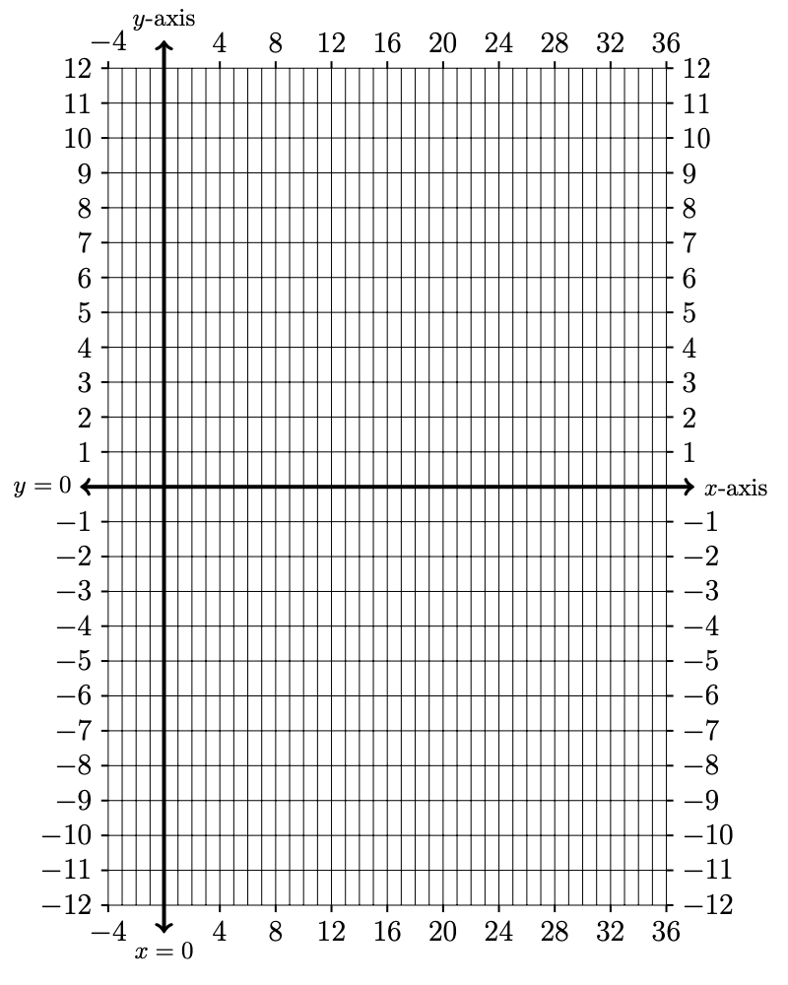
Input | Output
$$x$$ | $$f(x)$$
$$-1$$
$$0$$
$$1$$
$$4$$
$$9$$
$$16$$
$$25$$
$$36$$

3B. Now use a graphing calculator (like Desmos.com or a TI-Calculator) to graph the functions:

$f\left(x\right)=\sqrt{ x }$ , $g\left(x\right)=f\left(x\right)+8$, $h\left(x\right)=f\left(x\right)-6$

How accurate was your guess in Problem 3A?

3C. Take a look at the call out box below:
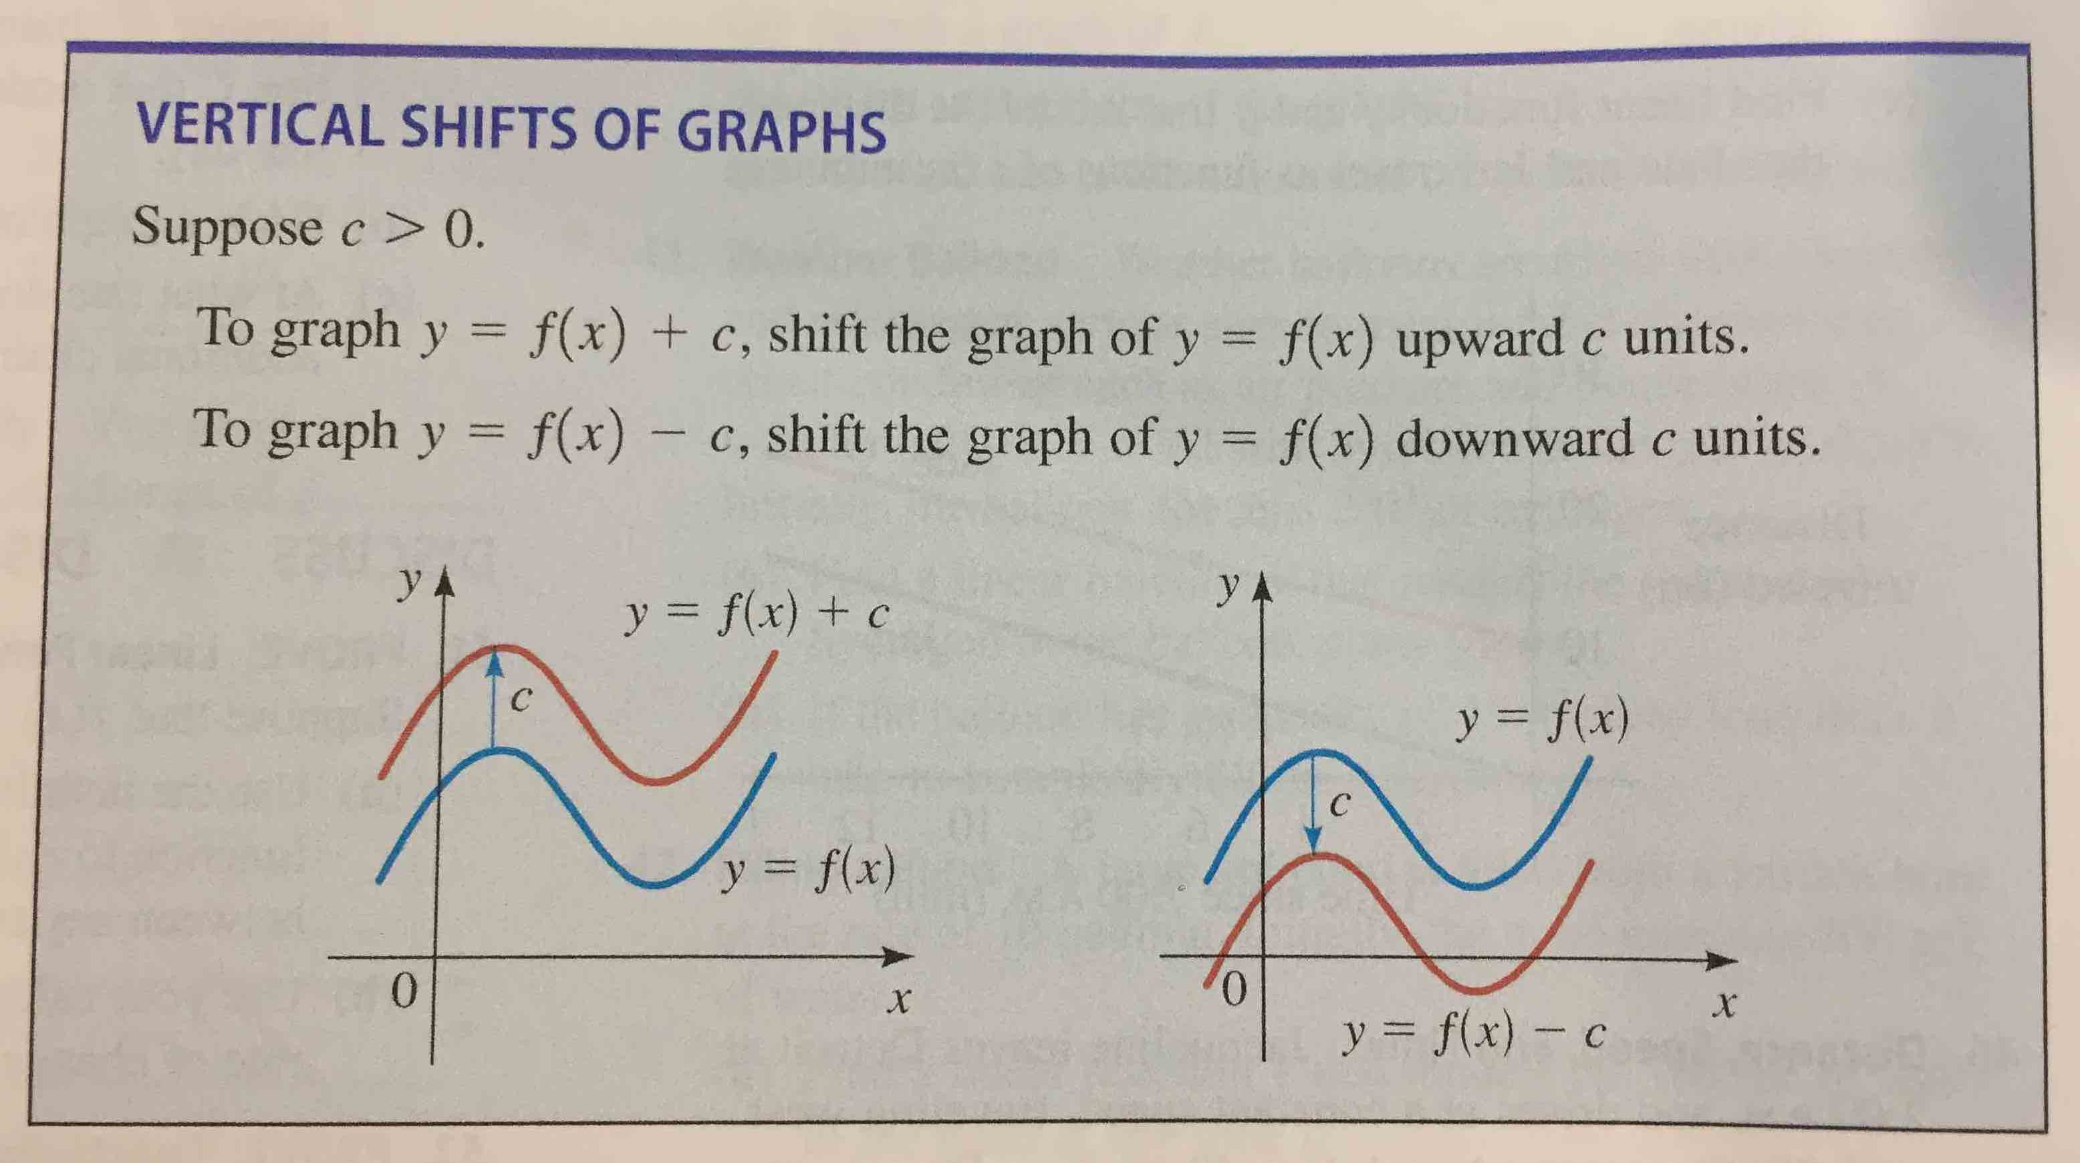

Translate this into abuelita language for yourself (simple non-technical language that describes what the math is saying so that your abuelita can understand). Really push yourself to make the description simple.

4. HORIZONTAL SHIFTS: SHIFT THE INPUT OF A FUNCTION

4A. Consider the following shifts of the input variable
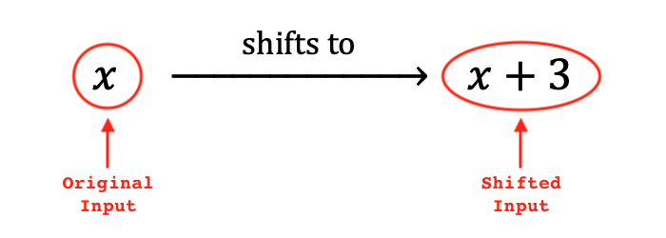

Draw the effect of this shift on the real number line ($x-$axis) below:

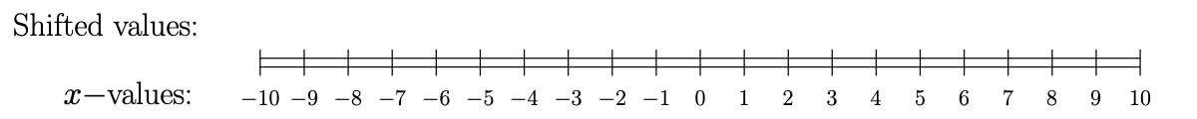

What do you notice about the zero position in the shifted input $(x+3)$ versus the zero position in the original input $x$?

4B. Suppose that $c>0$. Make a conjecture about the effect of the following shift:
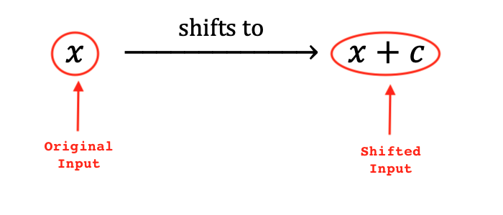

Draw the effect of this shift on the real number line ($x-$axis) below:

What does this shift do to the original input? In other words, What do you notice about the zero position in the shifted input $(x+c)$ versus the zero position in the original input $x$?

4C. Consider the following shifts of the input variable
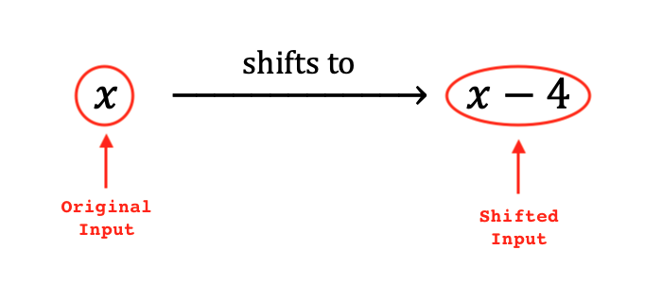

Draw the effect of this shift on the real number line ($x-$axis) below:

What do you notice about the zero position in the shifted input $(x-4)$ versus the zero position in the original input $x$?

$$x \underset{→}{\text{ shifts to }} x-c$$

4D. Suppose that $c>0$. Make a conjecture about the effect of the following shift:
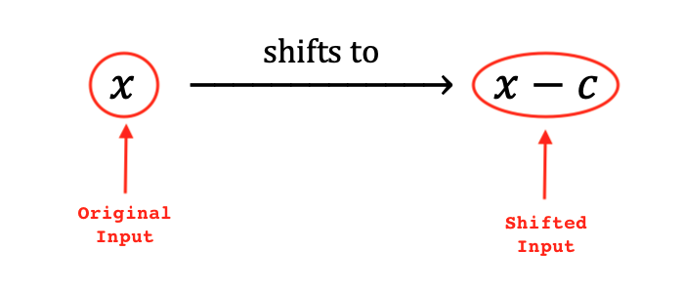

Draw the effect of this shift on the real number line ($x-$axis) below:

What does this shift do to the original input? In other words, What do you notice about the zero position in the shifted input $(x-c)$ versus the zero position in the original input $x$?

5. HORIZONTAL SHIFTS OF A QUADRATIC FUNCTION
1A. Consider the following quadratic functions

$f\left(x\right)=x^{2}$ , $g\left(x\right)=f\left(x+2\right)$, $h\left(x\right)=f\left(x-3\right)$

Create a table of values and graph the resulting parabolas on these axes below.

Input | Output
$$x$$ | $$f(x)$$ | $$g(x)$$ | $$h(x)$$
$$-6$$
$$-5$$
$$-4$$
$$-3$$
$$-2$$
$$-1$$
$$0$$
$$1$$
$$2$$
$$3$$
$$4$$
$$5$$
$$6$$

5B. Look back at both the graphs and the table of values from Problem 5A.
What do you notice about the relationship between the output values of the functions

$f\left(x\right)$, $g\left(x\right)=f\left(x+2\right)$, and $h\left(x\right)=f\left(x-3\right)$

5C. Make a conjecture (a mathematical guess) about what happens in the following scenario:

Assume we have a function $f\left(x\right)$ and a positive constant $c>0$.
Suppose we define functions

$g\left(x\right)=f\left(x+c\right)$ and $h\left(x\right)=f\left(x-c\right)$

What is the relationship between $f\left(x\right)$, $g\left(x\right)$, and $h\left(x\right)$?

2. HORIZONTAL SHIFTS OF AN ABSOLUTE VALUE FUNCTION
2A. Let’s test your conjecture from Problem 1C on a different type of function. Consider the following absolute value functions

$f\left(x\right)=\left|x\right|$ , $g\left(x\right)=f\left(x+4\right)$, $h\left(x\right)=f\left(x-3\right)$

For each function, specifically identify the value of positive constant $c>0$. Then, create a table of values and graph the resulting curves on these axes below
Input | Output
$$x$$ | $$f(x)$$ | $$g(x)$$ | $$h(x)$$
$$-6$$
$$-5$$
$$-4$$
$$-3$$
$$-2$$
$$-1$$
$$0$$
$$1$$
$$2$$
$$3$$
$$4$$
$$5$$
$$6$$
6B. Look back at both the graphs and the table of values from Problem 6A.
What do you notice about the relationship between the output values of the functions

$f\left(x\right)$ , $g\left(x\right)=f\left(x+4\right)$, $h\left(x\right)=f\left(x-3\right)$

6C. Revise and update your conjecture (a mathematical guess) about what happens in the following scenario:

Assume we have a function $f\left(x\right)$ and a positive constant $c>0$.
Suppose we define functions

$g\left(x\right)=f\left(x+c\right)$ and $h\left(x\right)=f\left(x-c\right)$

What is the relationship between $f\left(x\right)$, $g\left(x\right)$, and $h\left(x\right)$? Try to put this in both nerdy mathematical language and abuelita language

